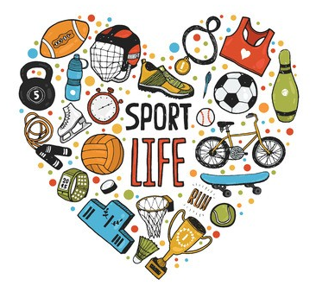
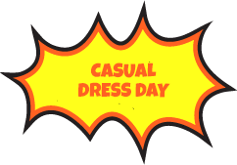
On Friday the 3rd July the last day of term, the school will be having a “Casual Clothes Day”. Students will be asked to bring a gold coin donation to school.

The charity that we have elected to support is the Childhood Cancer Association.

The Casual Clothes Day theme is “Sports Teams” so wear your favourite football, soccer, netball tops, scarves and beanies.

Further information about the Childhood Cancer Association can be read at the link below.
https://childhoodcancer.asn.au/.

Thank you for your participation and donation.

West Beach Primary School
School Leaders.

On Friday the 3rd July the last day of term, the school will be having a “Casual Clothes Day”. Students will be asked to bring a gold coin donation to school.

The charity that we have elected to support is the Childhood Cancer Association.

The Casual Clothes Day theme is “Sports Teams” so wear your favourite football, soccer, netball tops, scarves and beanies.

Further information about the Childhood Cancer Association can be read at the link below.
https://childhoodcancer.asn.au/.

Thank you for your participation and donation.

West Beach Primary School
School Leaders.

