Giaan Rooney

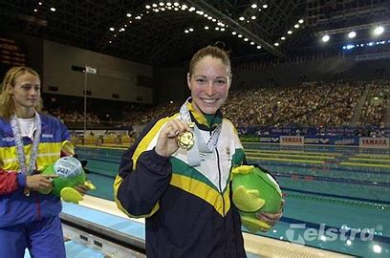Giaan Rooney is a passionate former Olympic swimmer for the Australian team. She was born in Brisbane, Queensland on November 15th 1982.

When Rooney was 8 she moved to the Gold Coast where she went to Miami State primary school and All Saints Anglican School. Her swimming career started when she was 11 at Miami club in Queensland where she was coached by Denis Cotterell.

She was known for being a member of the women’s 4x100 medley relay. In that event in 2004, she broke the world record and won gold.

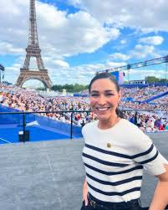Giaan retired in 2006 after swimming in the 2000 and the 2004 Olympics. Now, she’s a channel 9 television presenter and commentator and has regularly appeared on Nine’s wide world of sports, the today show, and the networks popular health series what’s good for you and the top rating travel program getaway. Giaan also commentated for the Olympics, swimming Paris 2024.

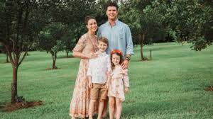On December 3rd 2011 Giaan married a man named Sam Levett and they have been married for 12 years. They now have 2 children, Zander their eldest born in 2014 and Alexa born in 2017.

She also has a dog called Roy.

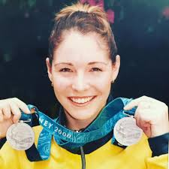

To this day, Giaan Rooney is a 41year-old mother and television presenter and commentator, living with a happy family of 4 on a macadamia farm. She achieved 4 Olympic medals; 1 gold, 3 silver.