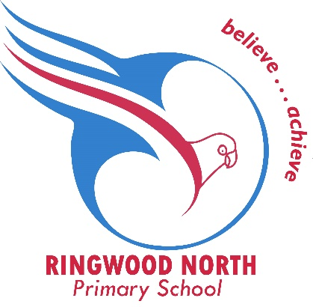
Ringwood North Primary School
PO Box 2312
Ringwood North
VIC 3134

To Our Valued Local Business,

The Parents and Friends Association of Ringwood North Primary School is a dedicated volunteer group that organises fun activities for our students while raising much-needed funds to improve school facilities.
We’re excited to announce that we’ll be hosting a Bogan Bingo fundraising event on Saturday, 11th October 2025 — a fun-filled evening for our school community. Alongside the main event, we’ll be running a Silent Auction, Raffles, and a Bottle Lottery.
To help make the night a success, we are seeking donations of items or vouchers from our generous local community that can be auctioned, raffled, or used as prizes. No donation is too big or too small — every contribution helps!
In appreciation of your support:
- Your business will be recognised on a Sponsorship Wall displayed at the event.
- All donors will also be acknowledged in our school newsletter, which is distributed to the entire RNPS community.
If you or your business are able to contribute — or if you have any questions — please contact:
Donna Johnston 📞 0421 316 231 📧 pfa.rnps@gmail.com

Thank you for considering supporting our school and helping us make this event a great success for the students of Ringwood North Primary.
Warm regards,
RNPS Parents and Friends Association

