
LEVEL NEWSLETTER
2026  Term One  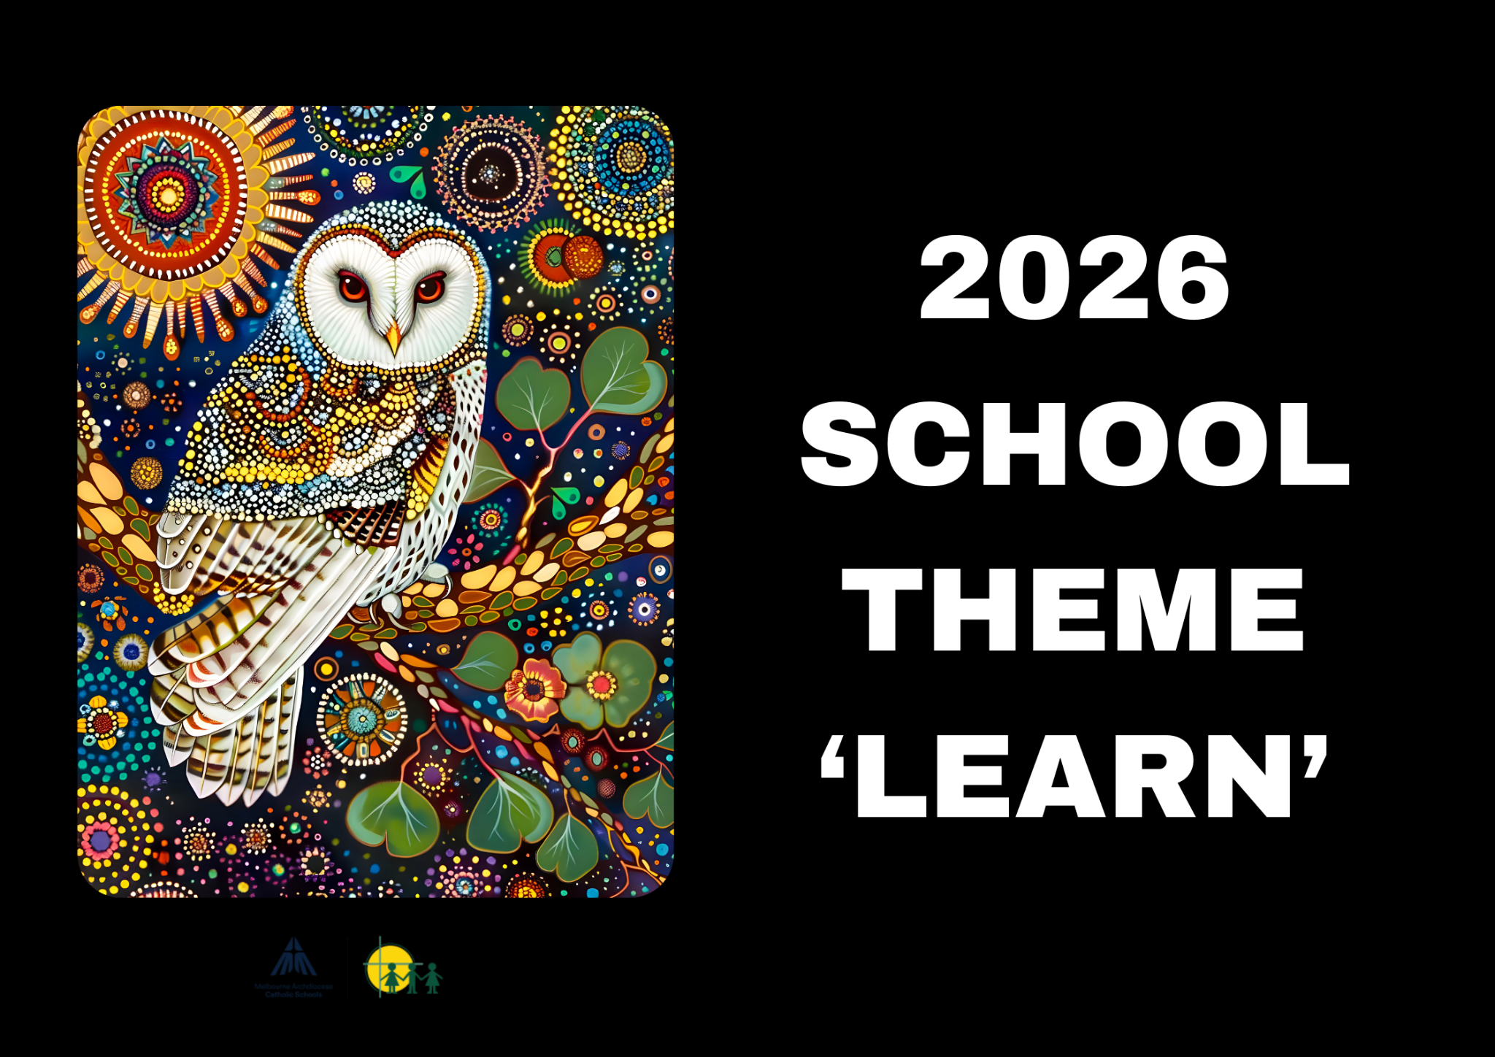 |  |   BIRTHDAYS  January  4th - Will Banbury  13th - Julian Atamian  February  7th - Sophie Zamora  9th - Arthur Xu  23rd - Thomas Vu  March  6th - Kayasha Ekanayake  11th - Zac Brekalo  24th - Eleanor Barnetby  29th - Isaac Kim  30th - Billy Lane  April  24th - Theo Chow
Staff Contact |  | Please remember to only email staff between the hours of 8am & 4pm (Mon-Fri)  Di Dimovski - ddimovski@hfmw.catholic.edu.au  Katrina Davis - kdavis@hfmw.catholic.edu.au  Michelle Luong - mluong@hfmw.catholic.edu.au
Specialist Classes | MONDAY | STEM
Specialist Classes | TUESDAY
Specialist Classes | WEDNESDAY | 4D - Art, Performing Arts, PE, Auslan  4L - Auslan, Art, Performing Arts, PE
Specialist Classes | THURSDAY | Year Level Sport
Specialist Classes | FRIDAY
RELIGION   | TOPIC: Lent - “Kick Poverty Away” and Sacrament of Reconciliation  This term, students are learning about the Christian call to help those in need and exploring the work of Catholic organisations such as the St Vincent de Paul Society and Caritas’ Project Compassion. They will explore how these organisations respond through acts of care and service and plan their own action to support the wider community. Students are also exploring the meaning of Lent as a time of prayer, sacrifice, and generosity, while reflecting on how their own choices and actions can help and support others.  Students will also be preparing to celebrate the sacrament of reconciliation for the first time. They will be deepening their understanding of Reconciliation as a sacrament of healing and forgiveness. They will explore how God’s love and mercy invite us to seek forgiveness and restore relationships with others. Through scripture, prayer, and discussions, students will reflect on making good choices, saying sorry, and showing kindness. This unit will help them recognise the importance of reconciliation in their daily lives and how it brings hope and peace to our community.
SPELLING    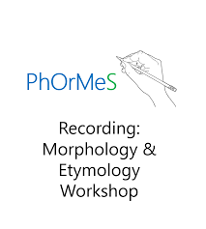 | We are continuing with the PhOrMeS spelling program, which helps students develop a deep understanding of word meanings. This knowledge enhances their ability to comprehend both spoken and written language at a high level while also supporting the use of mature vocabulary in their writing.  A key focus will be Morphology, the study of word structure and morphemes (the smallest units of meaning). Students will learn the fundamental patterns of meaning in English—such as prefixes, base words, root words, and suffixes—enabling them to predict the meanings of unfamiliar words with greater accuracy.  Weeks 2-6 - Latin Base: Spec-Spect-Spic  Weeks 7-8 - Homophones  Week 9-10 - Latin Base: Dic-Dict
LITERACY  (Reading/Writing)   | The Wild Robot  This term in Literacy, our students will be exploring the novel The Wild Robot by Peter Brown—a heartwarming story that has readers reflecting upon the link between nature and technology. Set on a remote island inhabited solely by animals, the novel follows Roz, a robot who learns to survive and connect in a wild world far from her intended purpose. Through Roz's journey of adaptation, friendship, and identity, students will delve into rich themes such as empathy, cooperation, and the connection between humanity and nature.  By the end of this unit students will demonstrate the following reading and writing skills:  - Developing reading fluency and comprehension  - Summarising main ideas  - Identifying character traits  - Analysing how the author uses structure, language, and imagery to engage the reader  - Persuasive writing skills such as:  - Form and support opinions with evidence  - Plan and structure persuasive letters  - Present their arguments effectively
MATHEMATICS  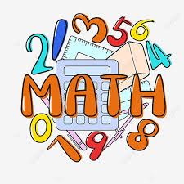 | The mathematical topics that the Year Four’s will be covering this term are:
  Topic | Unit Objective | Key Ideas
  Addition and subtraction 1 | Quantities can be combined and separated to form new quantities. | Combining, partitioning, part-part-whole, properties of addition, separation, comparison, properties of subtraction
  Fractions 1 | Fractions and decimals can be used to represent parts of whole numbers. | Quantity, number triad, partitioning, equivalence, benchmarks
  Time | Time is used to quantify, measure, or compare the duration of events or the intervals between them. | Attribute, comparison, unit of measure, equivalence, conversion
  Multiplication and division 1 | Quantities can be shared and grouped into equal groups. | Equal groups, composite units, properties of multiplication, division with a remainder, properties of division
KNOWLEDGE BASED/  INQUIRY   | Exploring Maps, World Mountains and Rivers  We begin our year with a Knowledge Rich Curriculum (KRC) unit, exploring World Maps, Mountains and Rivers. Students are learning how to read and use maps by understanding map features such as: scale, keys, compass directions, latitude, longitude and time zones. Students are also investigating major mountain ranges and river systems around the world, discovering how they are formed and why they are important for people, wildlife and the environment. Through this learning, students are developing their geographical knowledge and understanding how natural features influence how people live, travel and use resources around the world.  Key ideas students are exploring:  - How to read and interpret different types of maps  - How latitude, longitude and time zones help locate places around the world  - How mountains are formed and how they impact climate, animals and people  - The features of rivers and why they are important for life, farming and trade  - How natural environments influence human activities and communities  Human Cells and Digestion  Following this, students will complete another KRC, exploring the human digestive system and how our bodies use food for energy. Students are learning why our bodies need food, how digestion works, and how nutrients are delivered to cells to help our bodies grow, move and stay healthy. Throughout the unit, students will investigate how cells are the building blocks of the body and how they work together to form tissues, organs and organ systems. They will also learn how the body removes waste and why making healthy food choices is important for overall wellbeing.  Key ideas students are exploring:  - Why our bodies feel hungry and how food provides energy  - How the digestive system breaks down food and absorbs nutrients  - How cells are the building blocks of living things  - How cells form tissues, organs and organ systems that work together  - How the body removes waste materials  - Why nutrition and healthy food choices are important for our bodies
BEHAVIOUR CURRICULUM   | Routines  Lining up and sitting down after break times  Calm entrance/exit routine

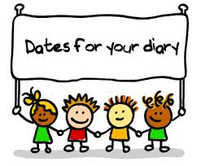 | Term One Important Dates (refer to our Google Calendar as well)  FEBRUARY  Wed 4 Prep Rest Day  Fri 6 Parent Welcome Event  Sun 8 Prep/New Family Welcome Mass (10am)  Mon 9 Children’s Mental Health Week (Wear an outfit that makes you feel confident and comfortable)  Tues 10 Safer Internet Day  P&F Meeting (6:30pm)  Meet the Teacher (Prep-Year 6)  Wed 11 Prep Rest Day  Meet the Teacher (Prep-Year 6)  Thur 12 District Swimming  Fri 13 Whole School Mass (9:15am)  FIRE Carrier Induction (10am)  Tues 17 Shrove Tuesday  Wed 18 Ash Wednesday (12pm Mass)  Prep Rest Day  Fri 20 Interschool Sport (1)  Mini Vinnies Soccer Event  Play Group commences (9:30am)  World Day of Social Justice  Wed 25 SAC Meeting (5:30pm)  Wed 25 Prep Rest Day  Fri 27 Interschool Sport (2)  MARCH  Wed 4 Prep Rest Day  Division Swimming  P&F Meeting (6:30pm)  Thur 5 Twilight Sports Day  Fri 6 School Closure Day (Vision for Engagement)  Sun 8 International Women’s Day (Give To Gain)  Mon 9 Labour Day Public Holiday (School Closed)  Wed 11 NAPLAN commences  Year 4 Reconciliation/Eucharist Info Night  Fri 13 Year 3-6 Athletic Trials  Sun 15 Catholic Education Week (Christ Beside Me-Walking in the Footsteps of St Patrick)  Tues 17 St Patrick’s Day  Wed 18 Open Day (all day) Everyone Welcome  Fri 20 Community Colour Run (Major Fundraiser)  Mass of St Patrick (St Patrick’s Cathedral)  Sat 21 Harmony Day  World Down Syndrome Day  Tues 24 Sacrament of Reconciliation (5pm)  Fri 27 Halogen Young Leaders Day  Summer Sport Gala Day (TBC)  Tues 31 EMR Swimming  APRIL  Thur 2 End of Term 1 (1pm finish)  Holy Thursday  Fri 3 Good Friday  Sun 5 Easter Sunday

