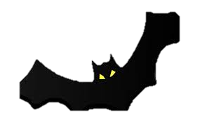The haunted house

The old orphanage was abounded but every noan and then you could hear creaking from the second floor. Teenagers used to hang out there but since the incident two weeks ago no one went there since.

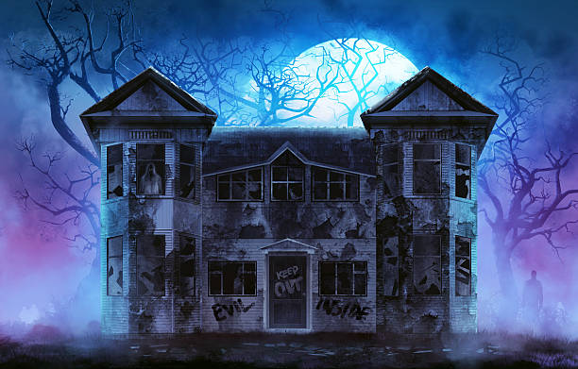A little boy went missing after his ball bounced into the house , he chased after it and never came back out . The flowers in the front yard that used to be filled with colour now lay lifeless. A essence of children laughing and playing surrounds the air, some people say its haunted by the goughsts of the dead children. The building as alone as a empty room, if you listtend closely you could hear cats snarling and dogs barking. Peeling off paint and chipped bricks is all that you see as well with big old stained windows that if you look closely you can see faint movement.