The Drought

I wake up and look at the clock,

It’s dark, I’m up before sparrow fart.

I go outside and look at the sky,

If there no rain the crops will die.

NT, WA, NSW it’s dry as a bone

I go inside,

Moan,

Maaoon,

Maaaooon.

Parked in its’ shed faithfully waiting

The silence and standstill is making it hating

The nights of nothing

Sowing gone

It has to wait until dawn

To ‘go and feed out’,

To go and meet the cows and sheep

Give them hay by the heap.

Opening my eyes after a night on the road

Where did the last five hundred miles go?

Heading north to Broken Hill

Someone please get me a coffee pill.

I look in the mirror,

The hays still there.

Channel 40 stays quiet it’s raising my hair.

Tied at her post,

Waking at the crack of dawn.

Tough as a lion scared as a fawn

You’ll never find one as stubborn as her.

She loves to chase sheep and birds

From only one

To a massive herd.

Protecting her lamb like a dragon it’s gold.

A carful mother she is very bold

To keep her baby healthy and happy,

She’s lucky not having to change nappies

I dread the day that they’ll be drafted off,

Her lambs still light as a moth.

Angus Bourchier.

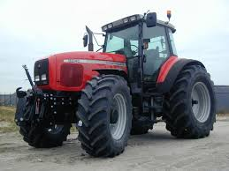

**Who;** I wrote the poem as the farmer.

**What;** It is about the drought affecting so many farmers.

**When;** This year in winter.

**Where;** In NSW, South Australia and WA.

**How;** I put myself in the farmer shoes and the ideas flowed.

**Why?** I thought I would enlighten people about the hardships farmers go through in droughts.