SORA ebooks and audiobooks instructions

- To access ebooks and audiobooks, click on the blue box with the aeroplane.
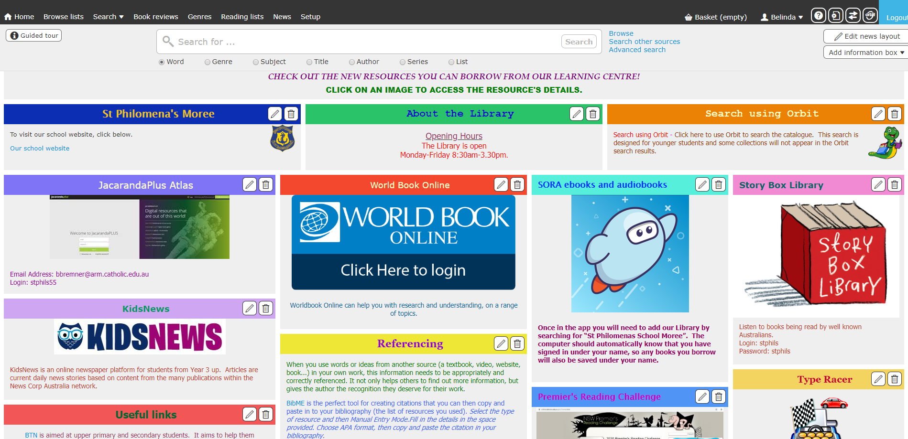

The following pages are for the initial setup. They may or may not appear depending on whether your child was in class when I went through the instructions.

- Click on ‘Find my school’.
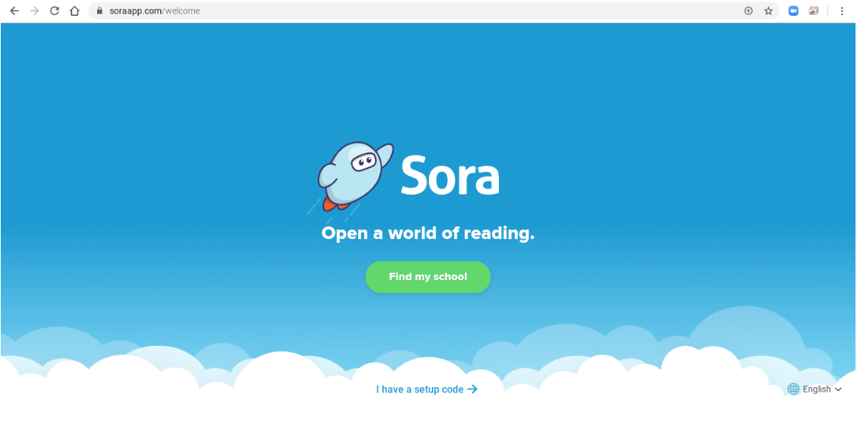

- Click on ‘My school isn’t listed’.
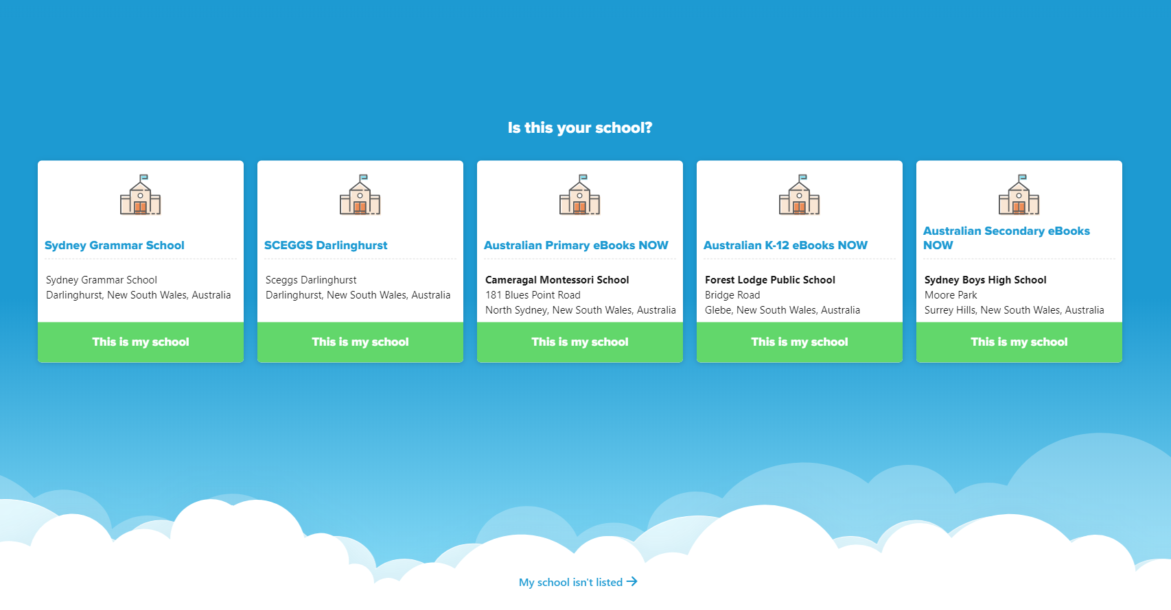

- Type in St Philomena’s. A Matching School will appear. Click on ‘This is my school’.
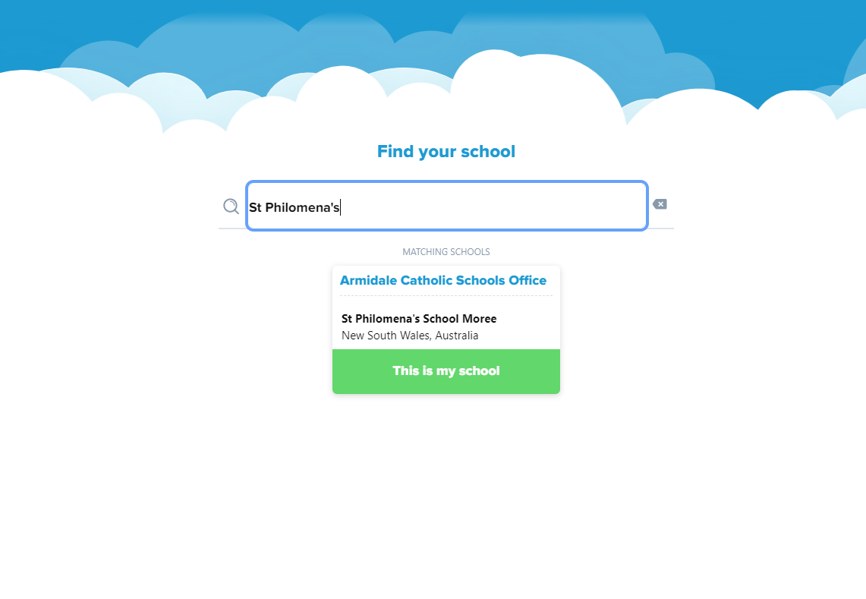

- Click on the green box.
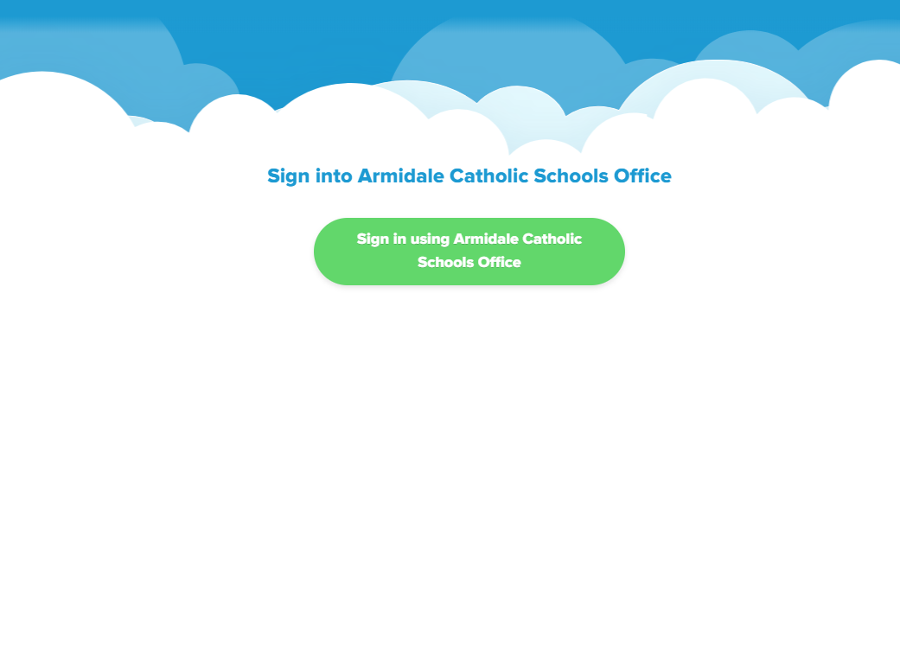

- You will then be taken to the homepage where you can browse books by Popular Subjects or by using the Search bar.
If the book has headphones with it, it means it is an audiobook. If there is no image with the book it means it is an ebook.

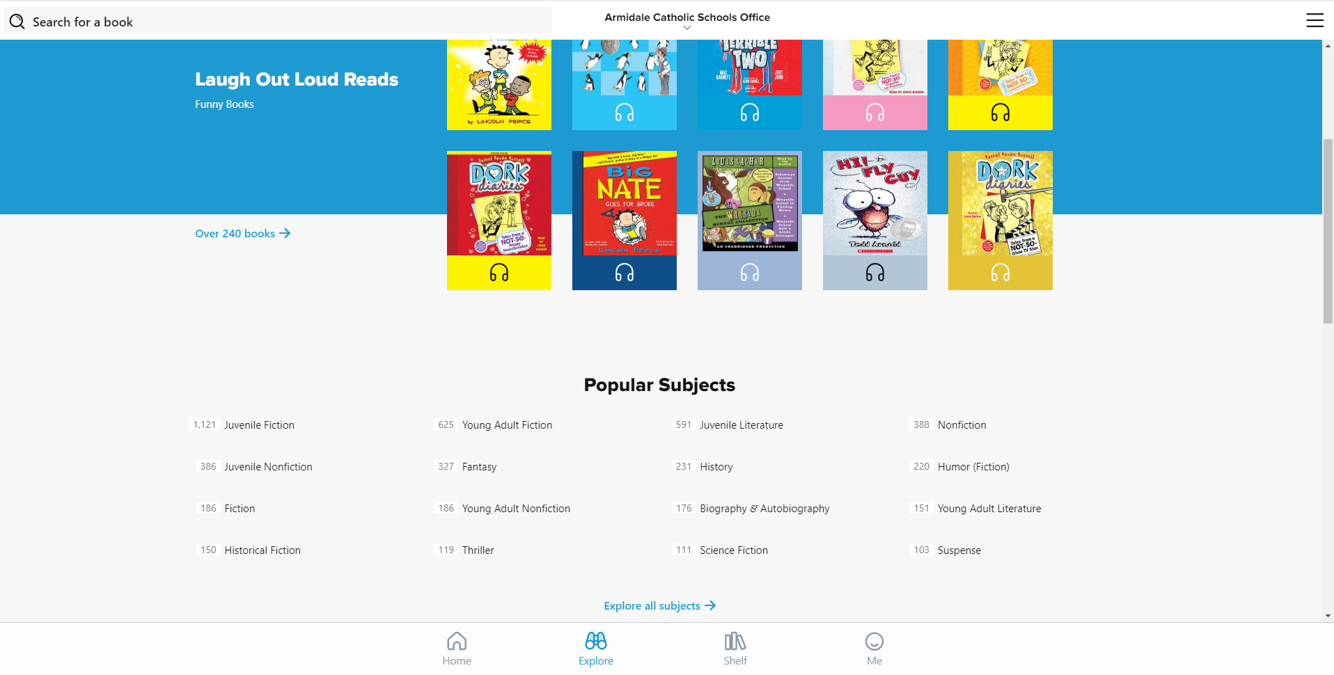

- Once you decide on a book, press borrow. If it says ‘Place hold’ this means all copies of that book are out and you can place a hold on it for when it is returned.

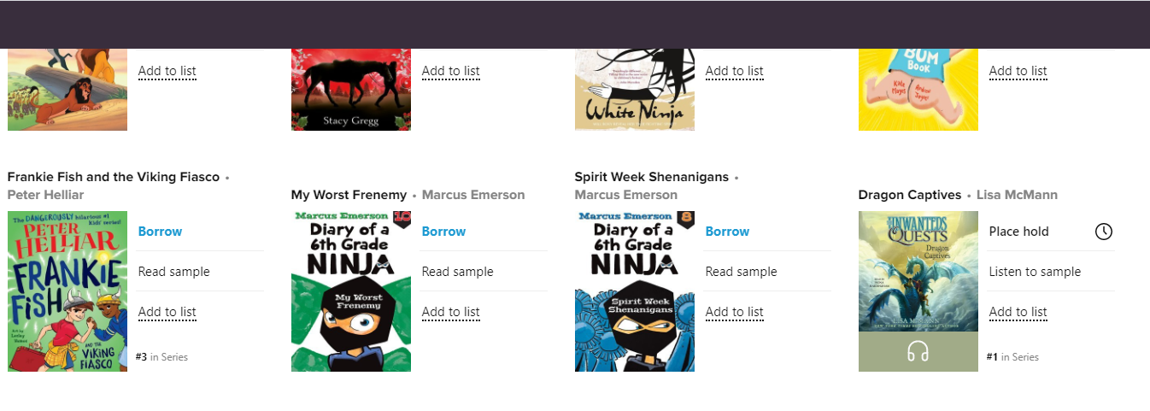

- To turn the pages click on the right hand page. To Bookmark the page click on the ribbon which will either be in the middle of the page or on the top right corner.
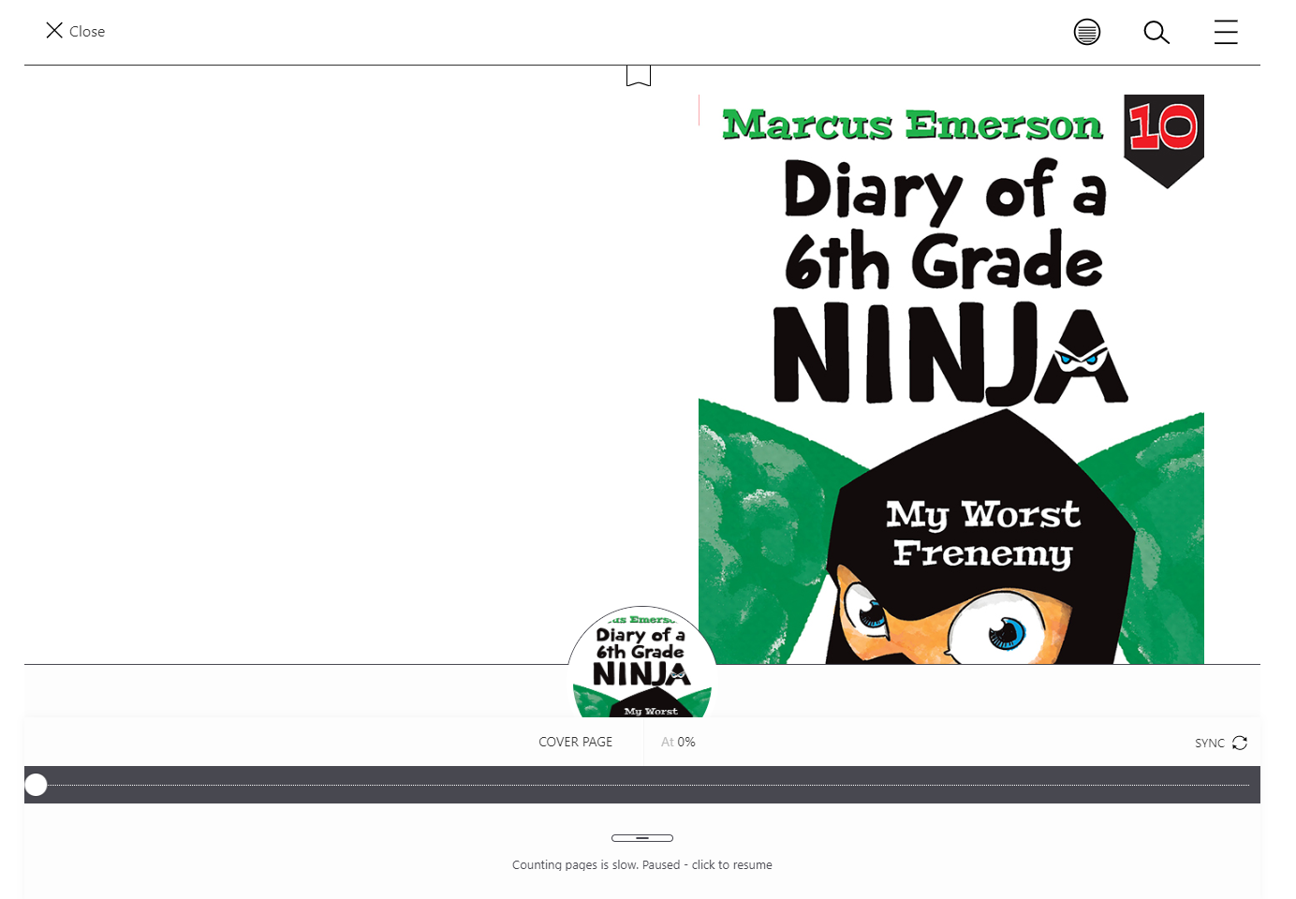

- Once the page is Bookmarked the ribbon will be filled in. If you are listening to an audiobook, you can Bookmark where you are up to in the same way. At the bottom of the page in the middle there will be a Play/ Pause button. You will need to press that too.
To get you back to the homerpage, click on the 3 lines.
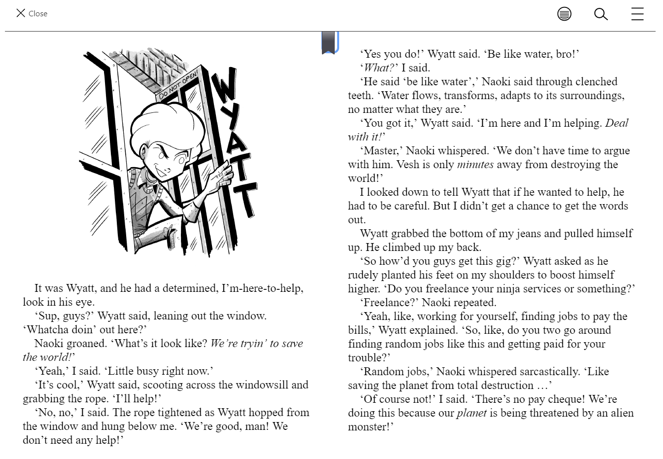

- From the homepage you can then sign out.

Home – takes you to your page showing what books you have out.
Explore – takes you to various categories of books as well as the Search bar.
Shelf – shows what books you have out.
Me – gives you details of your reading habits.

- When you want to return to the book, press Home or Shelf and click on the book. You can then Open, Renew, Return.

AUDIOBOOK E-BOOK
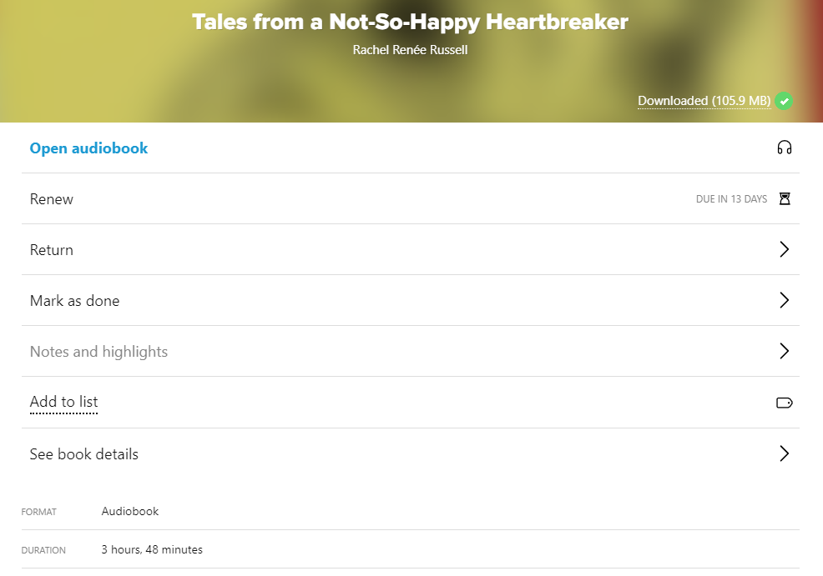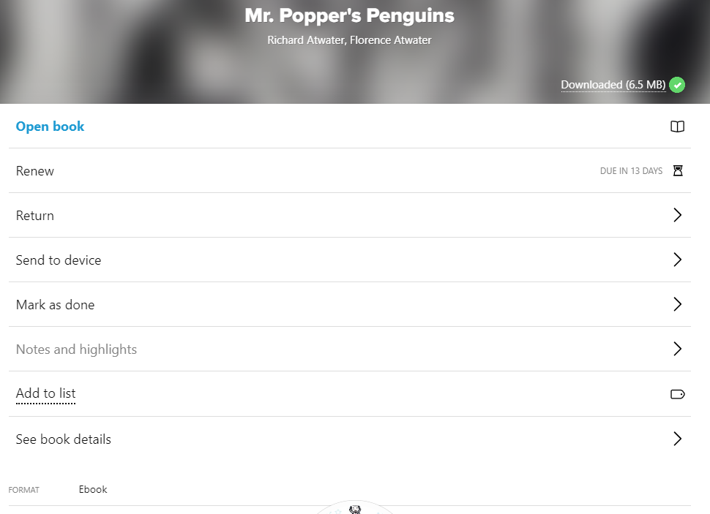

**Please don’t hesitate to email Belinda Bremner (bbremner@arm.catholic.edu.au) should you need further clarification**

