***POLLUTED***

*One beautiful morning, under the scorching hot sun, off the coasts of Sunway bay, Bob sat in a sleek, black hulled boat that rocked gently on the waves. Bob was a black-haired boy who had spent most of his life sailing the vast waters of the world. His dad had died many years ago when Bob was only ten. Bob owned a dog named Jeff.*

*Bob stared out to the ocean and watched the dark blue humpback whales leap gracefully out of the water. He slowly stroked Jeff’s coat as he stared deep into space, wondering if he had chosen the correct time to sail. Bob stood up and walked to the sail as the wind picked up, hoisting the sail in hard, Bob strode to the back of the boat and heaved the tiller over to the right. As the boat caught the wind, it tilted dangerously to the left before shooting across the water like an arrow. Suddenly, that’s when disaster struck! A huge storm swept across the sky blanketing the earth in grey. The wind howled and the rain lashed at Bob as he set a mini camp in his boat for the night. After he set up the tent, Jeff zoomed into the tent with Bob following behind. Bob went under decks to find some food. He came back holding a bag filled with food and then he dished some meat to Jeff. They went to bed and slept with the winds howling around them. The next morning the sun cast its bright rays of sunlight across the world as Bob walked slowly out of their tent. The storm had past but they had been swept to a new country, and oily birds disappearing below the waves of the murky black water. The land seemed bare apart from the factories that towered over the ocean. An oil tank burst and slowly sank down below the surface. Trucks loaded with trees drove slowly across the lands, releasing black smoke high into the sky.*

*Bob strode over to a taxi driver and persuaded him to take him to the government. The taxi driver agreed and Bob hopped in. The drive took several hours. When they arrived, Bob knock on the door and was escorted to a large room. There was one huge table, and at the end at the table sat the government. The leader whose name was Jeb spoke up and asked, “What have you come for?”*

*Bob said in a small voice, “I came to ask if you can clean this land?” Jeb thought about how dramatically the land had changed since they first arrived. He finally came to a decision that they should have a massive clean up and persuade, more people to walk or ride a bike to work or school.*

*5 years later the clean up had begun! Everybody helped and worked very hard. People recycled rubbish and produced products like bags made of recyclable materials and cars that ran on electricity. It took a few years but in the end the world had been transformed into a lush green and colourful country.*

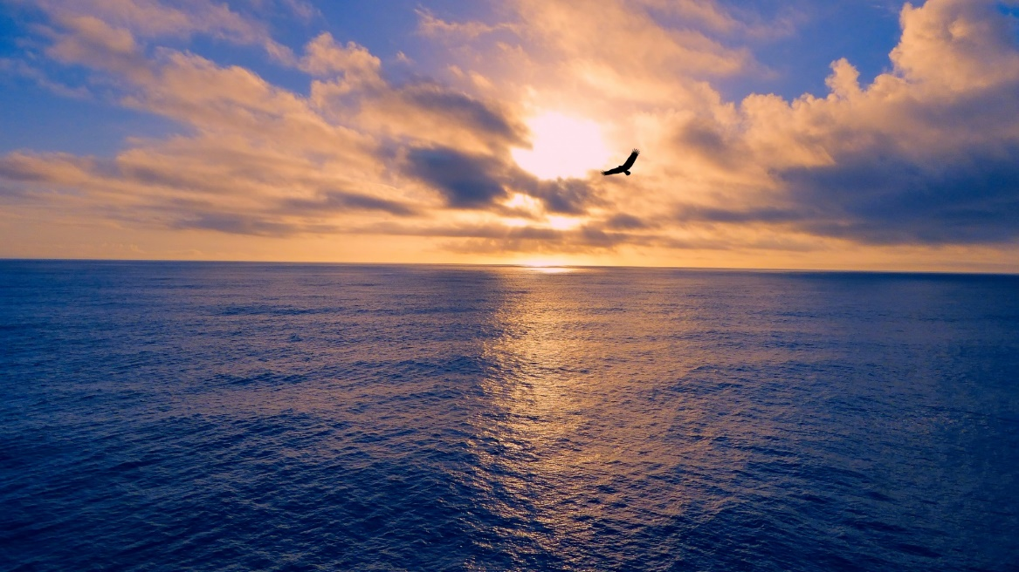

*After all the cleaning the people gathered up and cheered, hoisting Bob up on their shoulders. The celebration lasted through out the night, with lots of music and dancing. Everybody hoped for the future that the land and ocean and all the reefs would survive.*