Teaching and Learning 4S
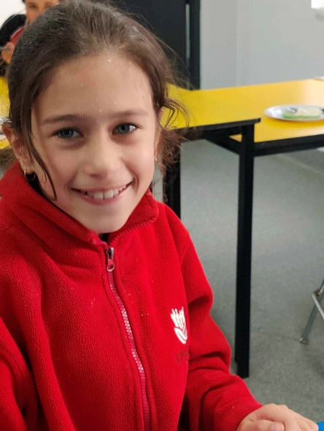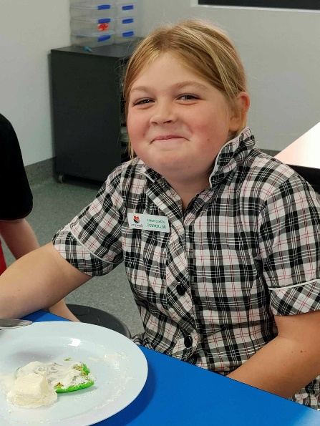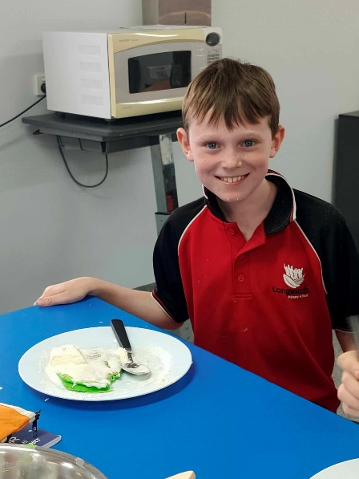
We had a fantastic Term 2, with lots of exciting experiences and opportunities. Camp, Farm, Food Science and Phoenix!
One of the highlights was Food Science with Chefs Al and Isabella. Students particularly enjoyed making green pancakes and crispy apple parcels. Students have written down and kept all of their recipes, so they can have a go at making them at home.
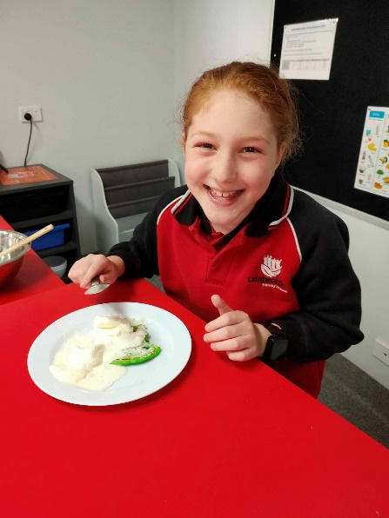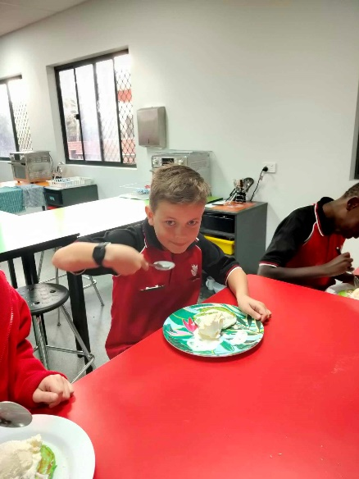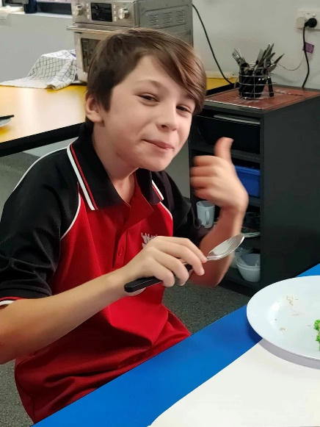
Of great excitement in our Term was visits from the South East Melbourne Phoenix Soar Program. Students were encouraged to become coaches of their own team in life, and look at who makes good teammates, and identifying character strengths in themselves and others. We then learnt some new basketball skills and enjoyed putting our skills to the test against the Phoenix players.
