CAREER NEWS Friday 10 October
 Dates to Diarise in Term 4
- Year 12 VTAC late applications – 30 September – 31 October
- VTAC SEAS and Scholarship applications – throughout September and early October

 Reminder: VTAC 2026 Upcoming Key Dates
ATARs Released | Thursday 11 December 2025
Change of Preference (CoP) closes | Saturday 13 December 2025
December Round Offers | Tuesday 23 December 2025
January Round One Offers | Tuesday 13 January 2026
January Round Two Offers | Tuesday 27 January 2026
February Offer Rounds | Tuesday 3 February 2026 onwards
For a full list of cancelled, amended, and new courses, visit VTAC Course Updates.

The VTAC website is www.vtac.edu.au

 Information Evening at The Hotel School Melbourne
An exclusive chance for your students to explore hospitality, tourism and events degrees, meet industry leaders, hear from students and alumni, and discover application pathways and support services to kick-start their global careers.
Year 12 students are invited to attend this event and network with industry whilst enjoying refreshments.
Date: Thursday 20 November 2025
Time: 5.00pm – 6.30pm
Venue: The Hotel School Melbourne
Register to attend at Information Evening at The Hotel School Melbourne
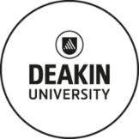 News from Deakin University
- Bachelor of Exercise and Sport Science/Bachelor of Engineering (Honours)
This unique double degree offers the opportunity to combine expertise in exercise and sports performance with essential engineering principles. If you are passionate about sport and exercise and ready to push your boundaries, this course will empower you to innovate at the intersection of sport, biomechanics, technology and design.
Students gain hands-on experience in designing and developing products and solutions for challenges in rehabilitation, biomedical technologies and sports engineering. With a major in mechanical engineering, students will contribute to the creation of products from sports equipment to athletic wear – integrating engineering expertise to optimise design and functionality. Industry experience embedded in each degree ensures you graduate equipped with practical skills in both disciplines, preparing them for exciting career opportunities.
Year 12 prerequisite subjects:
- Units 3 and 4: a study score of at least 30 in English EAL (English as an Additional Language) or at least 25 in English other than EAL
- Units 3 and 4: a study score of at least 20 in one of Maths: Mathematical Methods or Maths: Specialist Mathematics or Maths: General Mathematics

Students are encouraged to browse Bachelor of Exercise and Sport Science/Bachelor of Engineering (Honours) to find out more.

- DeakinTALENT
Explore your career possibilities with us. We support Deakin students and graduates to reach their career goals.

DeakinTALENT is dedicated to guiding students and graduates through every step of their career journey. From enrolment to graduation and beyond, DeakinTALENT offers personalised support and resources to help them explore their career options, land that next job and build a satisfying career.
Find out more at DeakinTALENT | Explore your career possibilities with us.

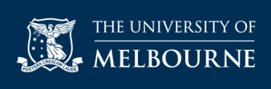 News from University of Melbourne
- Two New Majors in the Bachelor of Design
From 2026, the Bachelor of Design will include two new majors: Interior Design and Game Design.
These additions come in response to strong interest from prospective students, and the faculty is delighted to expand the opportunities available within the Bachelor of Design. All students who meet the entry requirements for this course will be eligible to pursue these exciting new majors. Students keen on finding out more about all fourteen majors on offer should browse Majors offered in the Bachelor of Design.

- Changes to the Structure of the Bachelor of Commerce
From the start of 2026, the Bachelor of Commerce will allow students more flexibility to tailor their studies.

Students will be able to select at least four of their first-year core subjects from a curated list of foundational subjects which introduce every commerce discipline, with Microeconomics remaining as the shared core subject.

Students considering this degree are encouraged to browse Structure of the Bachelor of Commerce and discover more about the 10 specialisations that will be available to students looking to add further focus within their major.

- Uni Ready Enabling Program
Want to study Science or Commerce at the University of Melbourne, but don’t yet meet the entry requirements? The Uni Ready Enabling Program could be your next step.
Over six months of full-time study, students complete four subjects that prepare them for entry into either the Bachelor of Science or the Bachelor of Commerce. Two of these subjects are specifically designed to build their mathematics skills and satisfy the VCE Mathematical Methods entry requirement.
To be eligible for entry to this course, students must have completed the following subjects and achieved these minimum scores:
- Units 1 & 2 (Year 11) in VCE Mathematical Methods
- Units 3 & 4 (Year 12): A study score of at least 25 in VCE English/English Language/ Literature or at least 30 in English as an Additional Language (EAL).
Find out more at Uni Ready Enabling Program.

- How to satisfy Subject Prerequisites
Students must satisfy prerequisites to be eligible for selection into a course at UniMelb. These prerequisites are outlined on each course page on www.study.unimelb.edu.au and in VTAC. Ideally, they do so through their VCE subjects.

However, UniMelb understands that sometimes students do not fulfill these prerequisites.
Students may be able to satisfy subject prerequisites by participating in one of the following tests or programs listed at How to satisfy Subject Prerequisites.

 News from Monash University
- Monash Innovation Guarantee (MIG)
Monash students have the opportunity to enrol in the Monash Innovation Guarantee (MIG). This is a guaranteed industry collaboration with one of 50 leading partners, with no application or interviews required. MIG elevates participant’s employability, helps them form important industry connections and ensures their voice is heard. No matter what career students are considering, MIG gives them the innovation and leadership they need to adapt and thrive in a rapidly changing world. MIG is an opportunity to make connections and develop real industry experience before they graduate.
MIG usually takes place over 3-weeks as an intensive, in-person summer unit held in January. Students work in a small team to deliver a purpose-driven solution to a real-world challenge set by an industry partner organisation, ranging from commercial or social enterprises, a government or UN agency, or even a start-up company.

- Maths & Science Prerequisites
The best way to meet the prerequisites requirements for Monash undergraduate courses is by undertaking them via your VCE or equivalent Year 12 studies.
Should students who do not have the prerequisite studies at the time offers are released will not be eligible to be considered for that course. However, Monash does accept a range of alternate options if students do not have the required VCE units or do not meet the study score.
Some of these are outlined at Maths & Science Prerequisites - Study at Monash. These options are not a definitive list but do provide students with relevant and known alternatives that may help them with planning their course progression.
It is important to note students must complete at least one of the listed alternative options before they can access the destination degree. So, for example, if a student is interested in Commerce and they have not studied Units 3 & 4 Mathematics Methods, they could enter Monash's Business, Arts or Science degree, undertake MTH1010 and then apply to transfer to Commerce.
Note: Register for the What does my first year in Science look like? - Discover Monash webinar taking place on Wednesday 15 October from 6.00pm – 7.00pm.

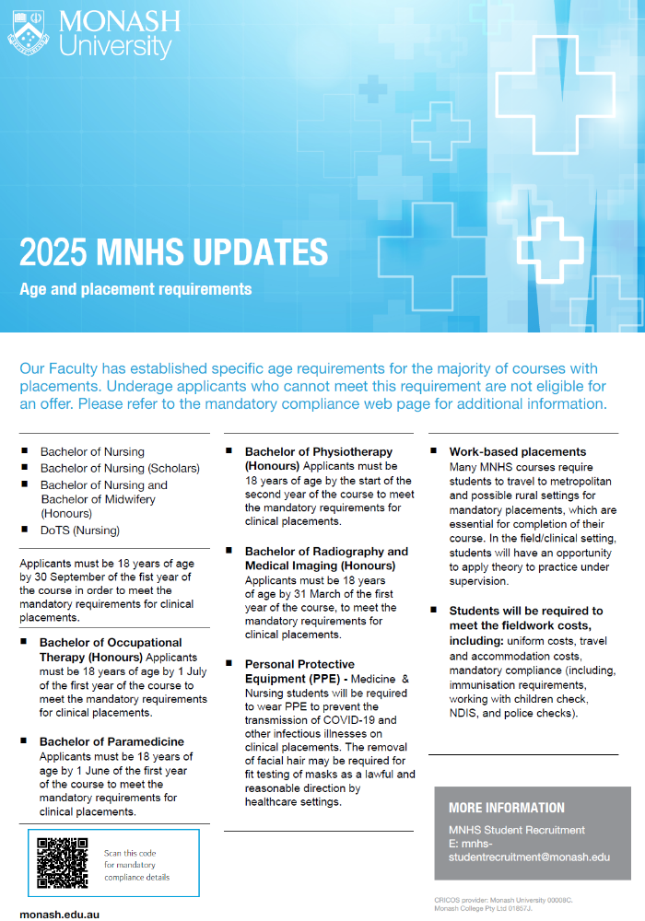
 Youth Work and/or Social Work Degrees in 2025 in Victoria
According to the Good Universities Guide - Youth Worker, Youth workers develop and facilitate programs to work with and support young people, either individually or in groups, in order to address social, behavioural, welfare, developmental and protection needs. They work closely with teachers, social and welfare workers, local authorities, health professionals, refuge workers, parents and, in some instances, the police

Social workers help people to deal with personal and social problems, either directly or by planning or carrying out programmes that benefit groups or communities. They are interested in challenging the structural barriers that contribute to inequality, discrimination, exploitation, and oppression within communities. Social workers can specialise in a range of different practice areas such as children and family, youth, violence, and sexual assault, medical and health, child protection, income support, disability, education, aged care, correctional services, family law, youth justice, community legal, psychiatric and general mental health, refugees and migrants, and Indigenous communities. - Good Universities Guide - Social Worker.
For the most part, and English/EAL is the only VCE prerequisite for the following Youth Work or Social Work degrees at the following institutions in Victoria:
INSTITUTION | MAJOR STUDIES | ATAR 2025
Australian Catholic University  Youth Work | Youth Work. | 60.65 (Mel)
Deakin University  Social Work | Social work. | 65.10 (GWF)  L/N (W)
Federation University  Social Work | Advocacy and social action, Community engagement and development, Counselling, Group work, Social policy and research for working with metropolitan regional and rural communities. | L/N (Gi)
La Trobe University  Social Work | Social work. | L/N (AW)  59.25 (Be)  56.55 (Mel)  L/N (Mi)  L/N (Shep)
RMIT University  Youth Work and Youth Studies  Social Work  Social Work/Psychology | Community services, Indigenous studies, Justice, Policy, Politics, Social sciences, Social work, Sociology, Youth studies, Youth work. | 62.10 (City)
 | Community services, Human rights, Indigenous studies, Policy, Politics, Psychological studies, Social justice, Social sciences, Social work, Sociology. | 61.10 (City)
 | Community services, Human rights, Indigenous studies, Policy, Politics, Psychological studies, Psychology, Social justice, Social sciences, Social work, Sociology. | 66.90 (City)
Victoria University Youth Work  Youth Work and Criminal Justice  Youth Work/Sport Management  Social Work | Youth work. | N/P (Foot)
 | Criminal justice, Youth work. | L/N (Foot)
 | Youth work. | N/P (Foot)
 | Social work. | N/P (Foot)
For a list of other related courses, with double-degree options, visit VTAC.

 The Australian College of the Arts (Collarts) in 2025
- Collarts is an independent college offering a range of specialised courses from animation to fashion, from music to interior design.
- Collarts offers a hands-on, collaborative approach to learning, and the college strives to support those who want to succeed in the creative and entertainment industries, both nationally and internationally.
- Throughout their education, students are given opportunities to gain work experience at music festivals, entertainment venues, recording facilities, radio stations, and with brands and organisations at the forefront of contemporary culture.
- Importantly, as part of each degree, students also undertake a comprehensive work placement.
- Students are encouraged to browse the links below to learn more -

Animation & VFX
Audio Engineering
Comedy
Digital & Social Media
Entertainment Journalism
Entertainment Management
Fashion Marketing
Fashion & Sustainability
Game Design
Graphic & Digital Design
Interior Design
Music Performance
Music Production
Screen & Media
Stage Management
Writing and Directing

