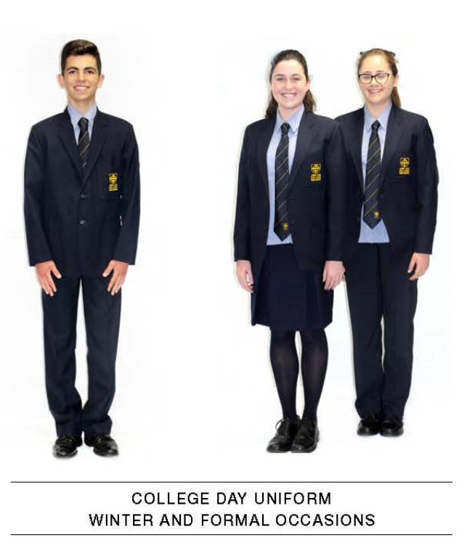
BOYS | GIRLS
College boy’s shirt x 3  College tie  College trousers x 2  Black leather lace-up shoes  College navy socks x 3 College Jumper (optional)  Plain black belt with plain buckle  College Blazer | College girl’s shirt x 3  College tie  College skirt or girl’s pants x 2  College navy tights x 3 (essential with skirt for formal occasions) College navy socks x 3 College Jumper (Optional)  Black leather lace-up shoes  College Blazer
*Quantities are an indication only based on usual requirements

