# A logo with a white bird holding a branch Description automatically generated Year 10 Work Experience

# Information and Tips for Obtaining a Work Placement

Finding a work placement doesn’t need to be stressful. You should first consider what your career goals are, how you might use work placements to reach those career goals, who you know (or who do your friends and family know) that already work in that area and may be able to help you find a work placement (this is great networking).

# What are your career goals or areas of interest?

You’ll always do better at a work placement if it interests you or helps you to achieve your career goals. It will also help find a work placement if you are clear on what interests you, this will come across to an employer and help improve your success rates.

# What contacts do you have in this area? (Family/Friends etc.)

“Cold Calling” (calling employers who don’t know you) does work, but often if you already have contacts in your network, this can be a quicker, easier and more effective way to find a work placement. Do you know anyone who has work or a work placement where you would like to work?

# Contact them to see if they can help you

Ask the people you know what is the best way to approach their contact employer and make contact. Sometimes they might introduce you to the person or let them know you will be contacting them.

# Compile a list of Potential Employers and contact details

If that hasn’t worked, it’s time to start calling some employers yourself. Make a list of who to approach and select a contact method (Phone is usually the best!)

1. To find businesses in your areas of work interest, search online for businesses or industries in the area you want to work. You could search on Facebook, Google etc. You might search for some of the following :
   1. Retail shops Wellard
   2. Cafes in Kwinana
   3. Welding businesses Rockingham
2. The yellow pages can also be used entering the business type or name and the post code where you live. This will bring up a list of businesses close to home, and as the list goes further down the page the further away the business are. See below…

<https://www.yellowpages.com.au/wa/PERTH/categories.html>

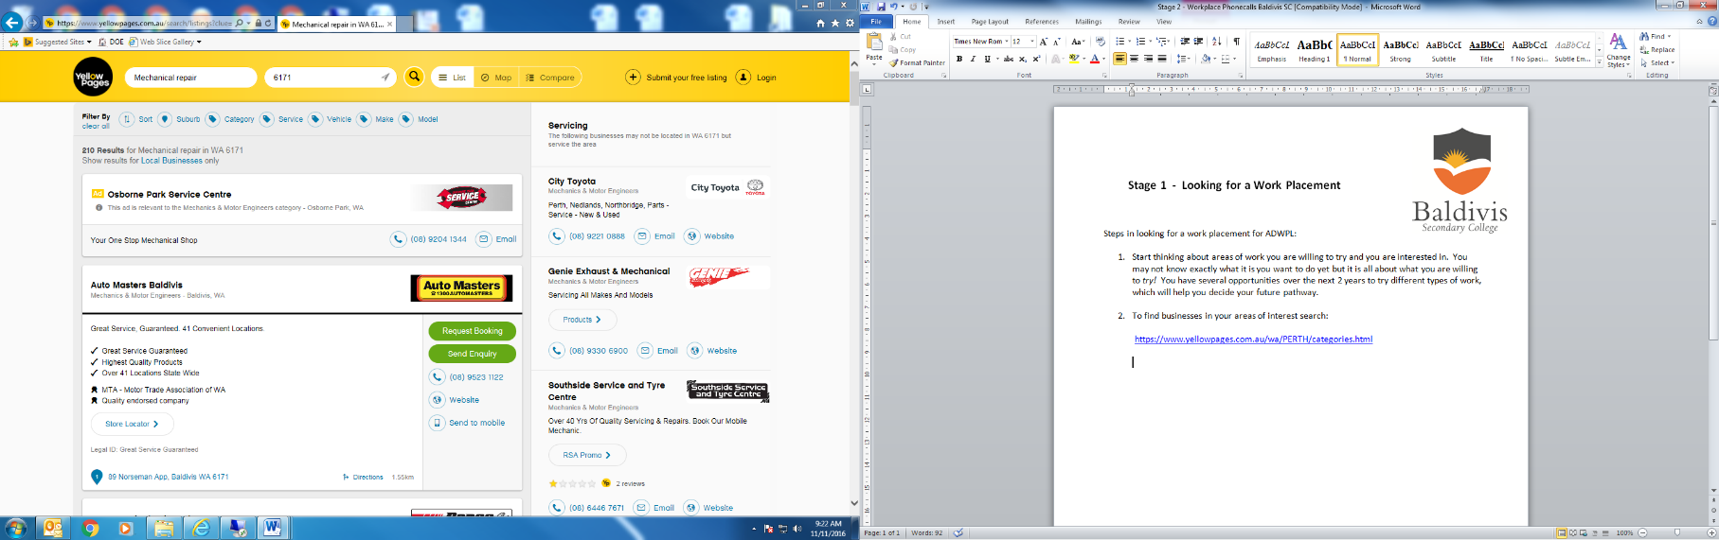

If you already know a business name then you can search for the contact details directly in Google or them directly. Other ways of finding businesses might be on local Facebook Groups or other online search methods. You could also try driving around your local area and taking note of some potential host employers.

1. List 10 business contact details on the **Stage 2 Workplace Phone Calls sheet** and then you

are ready to start calling employers… follow the instructions to make your phone calls.

Alternatively, you may choose to contact the employer via email or letter, and can use the **Requesting A Work Experience Placement Via Email Or Letter SAMPLE** Information sheet as a guide to help you.

1. Once you have received a ‘yes’ from an employer, you are ready to complete **Stage 3**, which requires you to complete the **Microsoft Workplace Learning Placement Details form**. The College will then make contact with your host employer and make arrangements from there.

*It can take many calls before you finally gain a placement, so just remember to stay positive and do not give up….you will eventually gain a spot, even if it’s not your first preference to start with, it is just a starting point! J*

# Select a Method of Approach – phone calls/emails/ letters/online applications

## Workplace Phone Calls

**Tip:** BE PREPARED

* Know the dates for work placement
* Have a pen and paper ready to take notes
* Write down everything you are told

|  |
| --- |
| **Telephone the business/organisation:** |

**Greeting**

Greet the person answering the telephone and ask to speak to someone regarding finding a work placement for next year.

*Suggested telephone greeting:*

Your name: Good morning, my name is ……………………….

Where you are from: I am a student from The King’s College and I am looking to find a one week work placement to trial working in a business like yours. May I please speak to someone regarding this?

The receptionist may need to know all details to enable your call to be transferred to the right person.

**Speaking to the right person**

Once transferred, repeat all that you said to the receptionist. Be ready to explain the following to the employer:

Student: Work experience will be for one week (fill in date and year). All insurance is covered by the College.

The employer *may* ask for you to meet for a quick interview before a decision is made. Arrange a time that suits both you and the employer.

**If the employer offers you a place immediately:**

Student replies: Thank you very much. Could I please have your name and a number/email address so that the school can send you all the necessary paperwork regarding the program and insurance.

***Complete the Workplace Details form…***

**If the employer is unable to offer you a place:**

Student replies: Ok, thank you anyway for your time.

*Sometimes, an employer may ask that you tell the school to contact them directly. If that is the case, just let them know you will do this and let me know.*

If you have any questions or doubts, feel free to come and see me at any time.

Once you gain a placement, complete the Stage 1 Form **Workplace Learning Placement Details** and the **Student Health Form,** so that I can send the employer all the necessary paperwork from the school. Return both to me as soon as possible. Good luck!

## WRITTEN COMMUNICATION TO AN EMPLOYER WHEN SEEKING A WORK PLACEMENT

This is a sample LETTER. You need to customise it to suit your needs. You can also customise it to an email format. You could do a quick call to a business, ask them for the contact person of the manager and then email it directly to the manager.

Full Name of Contact _______________________________

Title of Contact _______________________________

Name of Company _______________________________

Dear ________________________

I am writing to request for work experience at your company. I am a current student at The King’s College in Wellard and we have one week in September (16-20) to be able to gain some work experience.

Your company would potentially benefit by:

* Developing in young people a realistic understanding of employer expectations and needs.
* Giving employees a valued training role in assisting a young person to acquire workplace skills.
* Opportunity to develop an Industry Standard Work Ethic in youth as future employees.
* The prospect of recruiting new employees who are pre-skilled and immediately productive.
* Recognition of the business as a possible career choice for students.

I would benefit from work experience with your company by

* Having an introduction to a possible career pathway.
* Improving my employability and work readiness.
* Increasing my self-esteem and confidence.
* Acquiring skills identified in specific industries.
* Providing opportunity towards further study both through TAFE entry and WACE.
* Assisting in my further education and training allowing attainment of Units of Competence.

I can be reached by phone on ___________________________.

I can supply you with further information on the Program, as well as a copy of my CV.

Please don’t hesitate to call if you have any questions. I am available for an interview at your convenience by phone or in-person.

Thank you for your time and consideration. I look forward to hearing from you soon.

# Potential Host employer Tracking Form

**This is for you to write down your list of POTENTIAL Host employers. (A list of host employers to contact and see if they can offer you a work placement)**

**Tip:** BE PREPARED

* Know the dates for work placement: xxxx September 202X
* Have a pen and paper ready to take notes
* Write down the key points you are told
* List the businesses you plan to call on the tracking chart below and

keep track of the outcome of each call

|  |  |  |  |  |  |  |
| --- | --- | --- | --- | --- | --- | --- |
| **EMPLOYER** | **Contact Name** | **Email Address** | **PHONE** | **Yes** | **No** | **Other** |
|  |  |  |  |  |  |  |
|  |  |  |  |  |  |  |
|  |  |  |  |  |  |  |
|  |  |  |  |  |  |  |
|  |  |  |  |  |  |  |
|  |  |  |  |  |  |  |
|  |  |  |  |  |  |  |
|  |  |  |  |  |  |  |
|  |  |  |  |  |  |  |
|  |  |  |  |  |  |  |