Level 5 Homework Matrix
Homework tasks should ideally be completed with adult supervision. The Homework Matrix for each level will be available in the Connect newsletter once a fortnight. Tasks will be completed in student homework books and handed in to the teacher, to be signed, two weeks later on a Friday morning (even weeks). Teachers will sign homework books.

L5/6 – Reading + 8 tasks/fortnight
Reading (compulsory)  Read for: minutes every day.  Record the title of your book and the pages read in your diary. Ask an adult to sign your diary.  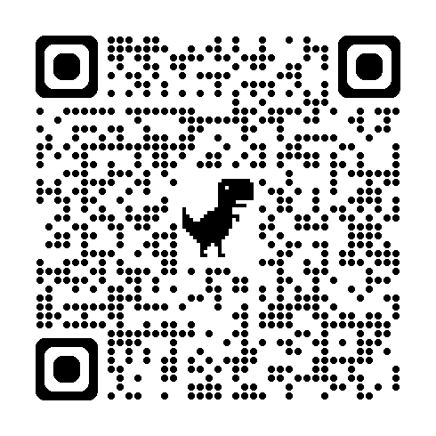 | Writing (grammar)  Use each of your spelling words in a sentence or a short paragraph to show that you understand what the word means. | Physical Education Challenge  Complete 3 sessions (20–30 minutes each):  - Jogging  - Cycling | Gratitude  Pick 3 people you are grateful for  this month. Make sure you explain  why you picked each person.0
Spelling:  Courage  Furious  Flourish  Fabulous  Country  Rough  Young  Contagious | Maths  Please order these numbers from smallest to largest.  8.21 5.10 5.80 4.94 5.52 8.89 7.70 4.55 6.73 4.01 | Art Challenge  4. Blind Contour Challenge  Task:  Choose an object.  Draw it without looking at your paper and without lifting your pencil.  Focus: observation, risk-taking, line quality  Materials: pencil | Mindfulness  Lay in a quiet room of the house or  somewhere comfortable outside  e.g. on the grass for a few minutes.  Take a moment to just stop and  listen to all the sounds around you.
Handwriting  Choose a passage from your book and re-write it in your best handwriting being mindful of punctuation spelling and spacing. | Maths Skills/Fluency  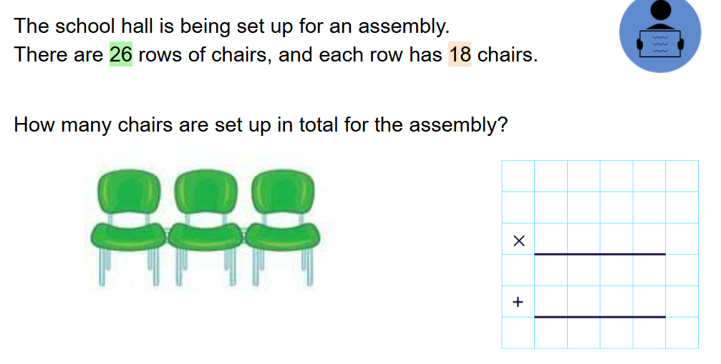 | Science Challenge  Visit - https://www.timeanddate.com/astronomy/night/australia/melbourne  Record 3 interesting facts about the movement of the Sun, Moon or planets | Emotional Literacy  Create a feelings collage using  magazines, coloured paper or art  supplies. Find pictures  representing different emotions to  create a collage that visually  portrays your feelings
Maths  Complete these multiplication problems using the vertical algorithm.  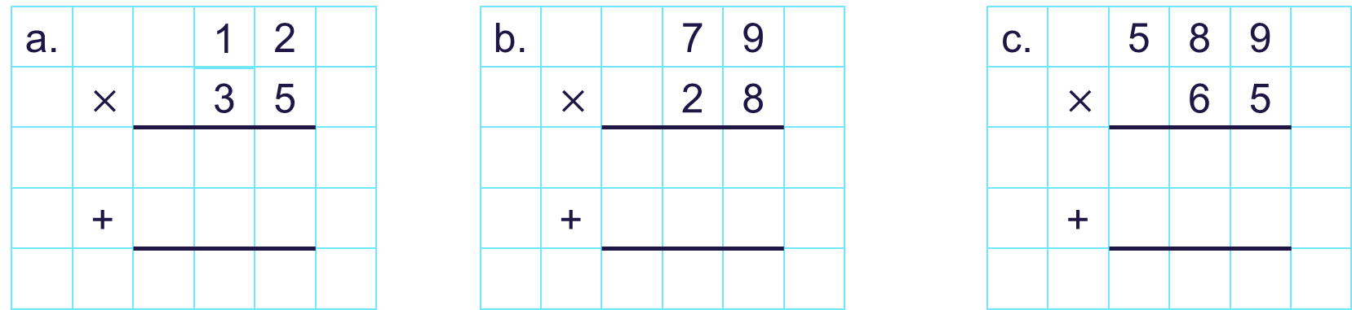 | Online Platforms  - Read a book on Wushka  - Complete tasks on Mathletics  - Play a game on Maths frame  - Listen to a story on Storybox | Mandarin Challenge  Chinese New Year Mini Artwork & Calligraphy  1️⃣ Create a small Chinese New Year artwork.  Include symbols that show luck and celebration.  2️⃣ Copy neatly:  新年快乐  恭喜发财  马年大吉  3️⃣ Write 2 sentences in English:  Why is red lucky?  or | Empathy  Think about 3 ways in which you  can brighten someone’s day this  week with random.

