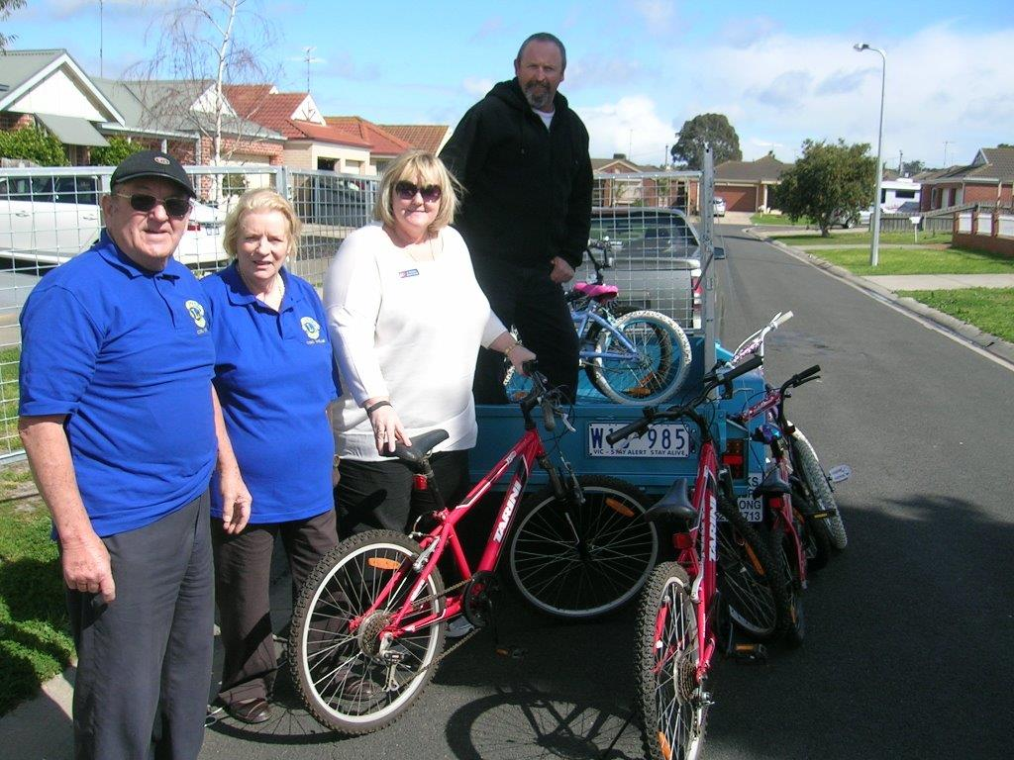
Corio Norlane Lions Club Bike Project
Do you have a bicycle at home that is no longer used and you don’t know what to do with it?
We will:
- Collect
- Clean
- Repair
- Donate to needy children
- Contact us on coriolions@gmail.com or 0402409895
We Serve

