Rockley & District
Community Newsletter
November 2025
Proudly sponsored by the Rockley & District Community Association Inc.

Dates for Your Diary
November 2025
DATE | EVENT, TIME and VENUE  WHERE KNOWN | CONTACT
Tues & Thurs | Pilates Mat Classes  10:30am School of Arts Hall | Erin  0448 408 794
Sat 8  Sun 9 | Rockley Gardens and Art Festival 10am-4pm  Tickets $15.00 for both days School of Arts Hall
Tues  11 | Remembrance Day
Dates for Your Diary
December 2025
DATE | EVENT, TIME and VENUE  WHERE KNOWN | CONTACT
Tues & Thurs | Pilates Mat Classes  10:30am School of Arts Hall | Erin  0448 408 794
Mon  8 | Rockley Public School Presentation Day  9:30am School of Arts Hall | RPS  6337 9336
Sun  14 | Rockley Artisans Market  9:00am to 1:00pm Stevens Park
Thurs 18 | Last Day School Term 4  Please Confirm With Your Own Schools
Sun  21 | St. Peter’s Anglican Church Christmas Service  10:30am St. Peter’s Morning Tea to Follow
Sun 21 -  Sun 17 | Rockley Mill & Stables Museum Open by Appointment only until Sun 17th Jan 2026
Community Newsletter
Each issue of the Newsletter can be read on the Rockley Facebook page or can be emailed to those wishing to receive it electronically. An A4 copy is available to read in the Community Noticeboard in Stevens Park, Rockley.
If you would like to have the Newsletters emailed to you each month, (there is no January Newsletter) please contact Jasmin at justjasmin@bigond.com
Rockley Mill & Stables Museum

The Rockley Mill & Stables Museum, situated in the 1862 former Rockley Steam Flour Mill, opens most Sundays between 11:30am and 3:30pm.

Available to open at other times by prior appointment, please either contact Pauline on 0432 052 265 or Jasmin by email at justjasmin@bigpond.com.

We are always very pleased to welcome new Mill Minders. Please contact Pauline or Jasmin for further details.

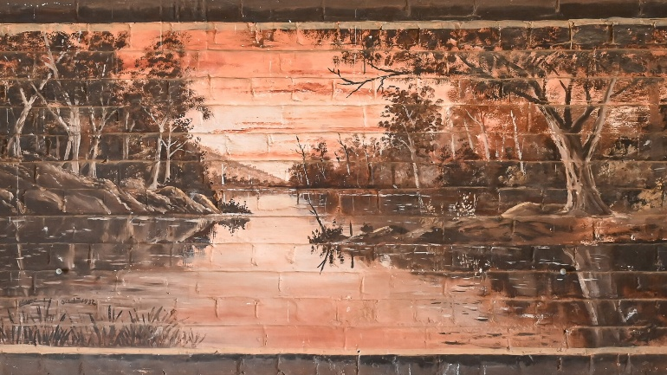
The peaceful setting depicted here is painted in oils directly onto the east wall of the RM&SM. The artist, Edmund Ernest Edgar (c.1872–1965), completed the mural in October 1932 in readiness for the first meeting of the Rockley Branch of Toc H, a Christian social organisation and movement.

Visit the RM&SM to learn more about Toc H

Rockley Studio & Fine Art Gallery

Rockley Studio & Fine Art Gallery is open by appointment.
Please contact Tim on 0413 037 436 for further information

Perthville News


Would you like to receive the Perthville News each month?
Please send your email contact to perthvillenews@gmail.com to be included on the mailing list.

Ben Chifley Catchment Group News


The Ben Chifley Catchment Steering Committee Inc. was established in the mid-1990s, by several land care groups.
Our aim is “Caring for our Waterways.”
The group undertakes activities that improve the quality of water in the Catchment area. Projects include soil conservation measures and tree plantings.
If you have any projects on your property such as gully fencing, soil erosion remediation or tree planting please contact Louise, the BCCSC Secretary, on 0407 214 508.
Projects need to be inspected before approval.

Church Services in Rockley

St Peter’s Anglican Church, Hill Street, have their Holy Communion Service at 9:30am on the first Sunday of each month except January, and in December, when a Christmas Service is held on the Sunday before Christmas Day.
Services are presently presided by Rev Anastasia Webster-Hawes. Morning tea follows. For current copies of the weekly Bathurst Anglican Bulletin, please visit www.bathurstanglican.org.au. The office landline for All Saints Anglican Cathedral, Church Street, Bathurst is 6331 4711. The office opens Tuesday and Wednesday from 9:00am to 1:00pm or contact them via email at cathedral@bathurstanglican.org.au.
St. Patrick’s Rockley Catholic Church, Phantom Street, celebrates Mass at 9:30am on the second Saturday of each month, with the rostered priest from the Cathedral Parish of St. Michael and St. John. For current weekly Cathedral Parish bulletins, please visit https://bathurst.catholic.org.au/bathurst. Open Monday to Friday, 8:30am to 4:30pm, contact the Catholic Presbytery office, George Street, Bathurst on 6331 3066, or email The Dean, Father Paul Devitt at dean.cathedral@cdob.org.au.
In Rockley, a small band of locals like to offer a quiet and reflective Ecumenical (all denominations) Worship service, encouraged by the Cathedral Parish, at St Patrick’s Catholic Church each Sunday 9:30am every weekend (except the second weekend of the month). All residents and visitors to Rockley are most welcomed to attend throughout the year.

Rockley Artisans Market

The next market will be held on

Sunday 14th December
9:00am – 1:00pm
Stevens Park Rockley

Earthwatch with Galileo
Some good news in a Conversation article:
The Weight of 3 Sydney Harbour Bridges? In 2022-2023 product manufacturers were responsible for 540,000 tonnes (those 3 coathangers) of soft plastic packaging in Australia – worse… only 6% was recovered for recycling.
Well, the good news is that since the collapse of REDcycle, the Australian Competition and Consumer Commission is proposing a new voluntary scheme were supermarkets and manufacturers work together to collect and recycle soft plastics. The Commission’s proposed industry-led scheme aims to collect and recycle soft plastic packaging and bags, and the program is to run for 8 years with an initial review after 3. Woolworths, Coles and Aldi are all involved. Let’s hope…
Ciao for now…
Rockley Waste Transfer Station

Opened and manned each Wednesday and Saturday between 2:00pm and 6:00pm during summer, it opens from 1:00pm to 5:00pm throughout winter

Poets Corner

Are you a poet or storyteller?
Please send your poems or short stories to justjasmin@bigpond.com


Rockley Gardens & Art Festival

As we are coming up for Christmas, why not consider a one-of-a-kind gift for that special someone in your life?

The art exhibition in The School of Arts Hall as part of the Rockley Gardens and Art Festival will have on display unique creations by local and slightly further afield artists and makers.

You won't find another example the same anywhere!!!

Or even if you just want to decorate your home with Christmas ambience, there will be small affordable pieces to hang on your tree, some season related, and others more general.

Come along and see what might be possible to fit into your gift stocking!

Copper foiled glass decorations by Dianne Mansell


Fused glass decorations by Sue Boyer

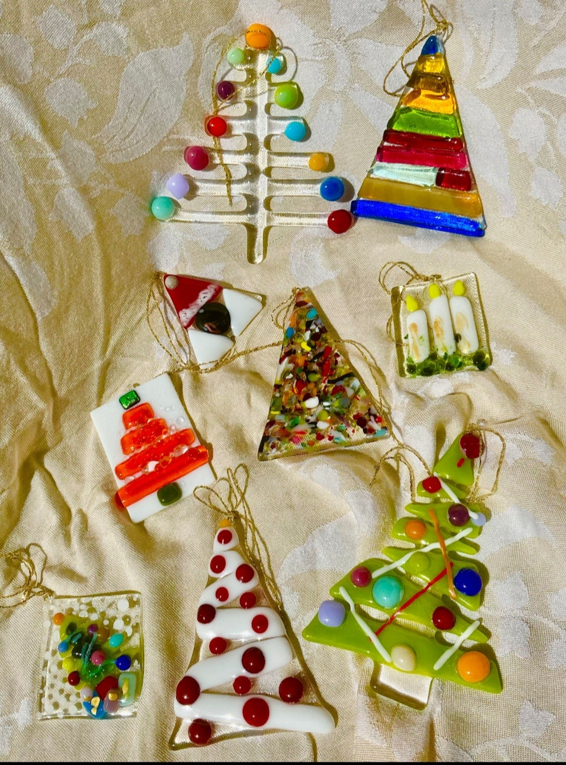

This year, the RG&AF will be held over the weekend of Saturday 8th and Sunday 9th November. For further information, please visit the RG&AF website: rockleygardensandart.weebly.com.

Cooking Column

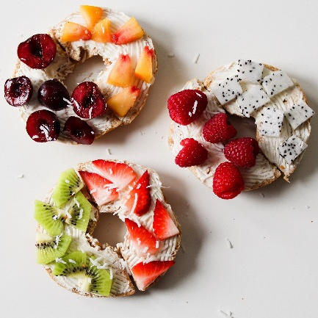
Tropical Fruit Salad Pavlova

This month I give you my tried and tested recipe for pavlova. You can top it with any fruit, but I’ve chosen tropical fruit salad to top the whipped cream.

Ingredients

6 egg whites
Pinch salt
1 ½ cups castor sugar
1 tsp vanilla extract
2 Tbsps cornflour
1 tsp white vinegar
Ingredients fruit salad
½ pineapple cut into cubes
Pulp from two passionfruit
1 banana cut into rounds
½ paw paw or papaya cut into cubes
Topping, 300 mls thickened cream whipped

Method
- Preheat oven to 100 C. Draw a 22cm circle on baking paper. Turn paper over and place on a baking tray.
- Place egg whites and salt into an electric mixer bowl. Beat until egg whites are frothy. With beater motor running slowly add sugar, one tablespoon at a time, beating well after each addition until all the sugar is added. Beat for two minutes on high until thick and glossy.
- Reduce beater speed to low. Add vanilla, cornflour and vinegar and slowly beat until well combined.
- Spoon meringue into a marked circle and smooth top and sides with a spatula.
- Bake for 1.5 hours. Turn off oven and leave the door ajar until oven is cold.
- When cold, top the pavlova with the whipped cream and fruit salad.

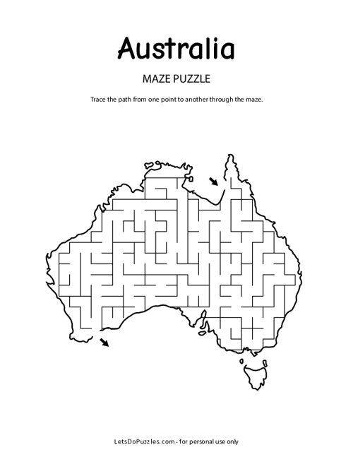
Kids Column

