Panama
Classification
Panama is in Central America. It is a narrow strip of land that connects North and South America. The official language in Panama is Spanish and is a blend of African, American Indian, North American, and Spanish influences.

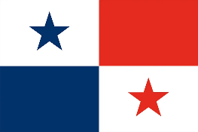
Flag
The flag of Panama is split into 4 quarters. The top right-hand corner is red, the bottom left-hand corner is blue. The other corners consist of a red or blue star. The white was meant to stand for peace and purity; The blue is for the purity and honesty of the life of the country; The red represents the authority and law in the country.

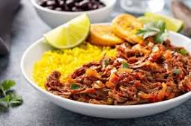
Food
The Signature dish of Panama is Sancocho de Gallina (Chicken Stew). Panamanian food reflects the nation's multi-culture background, particularly its Colombian, U.S., and Caribbean influences. Other popular foods include Arroz con Guandú (Rice with Pigeon Peas) and Hojaldre (Puff Pastry).

Landmarks
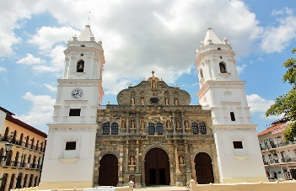
Panama top landmark is the Panama Canal. An 82km waterway. The Panama Canal serves as a shortcut that saves time and costs in transporting all kinds of goods. Other famous landmarks are The Big Screw and Old Panama.

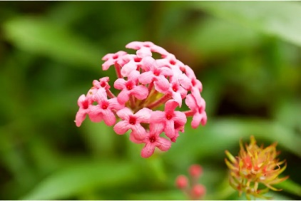
Flora and Fauna
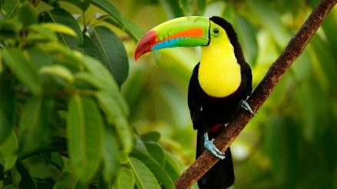
The Golden Frog is one of Panama’s national animals. More animals include. The 3 toed sloth, the capybara and the Keel-billed Toucan. Flora includes Palms, orchids, ferns, trees, vines, flowering plants, mosses, grasses. The most famous plant is the Madagascar periwinkle.

Native people and their traditions
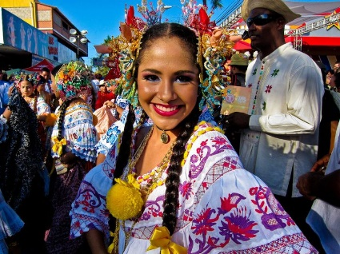
In the history of Panama, the earliest known inhabitants were the Cueva and Coclé tribes. But now there are several more indigenous tribes. As well as people from other countries. Panama is also known for its joyful, music-rich religious festivals and for boisterous holidays such as its pre-Lenten Carnival, marked by dancing, drinking, and casting away care.

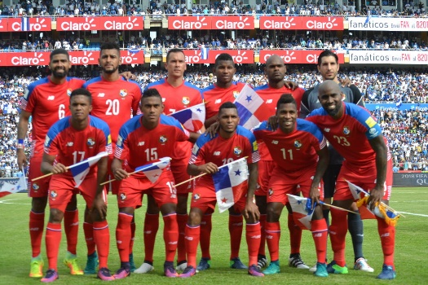
Sport
Baseball is Panama's national sport. But they have several more from Football to sports like water sports. More popular sports include Boxing, Basketball, Triathlons and rafting.

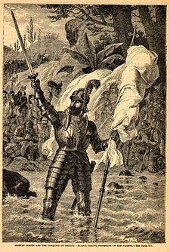
History
The area that became Panama was part of Colombia until 1903. It was discovered by Vasco Núñez de Balboa, the former governor. And for nearly 300 years Panama was a colony of the Spanish Empire. It also has 2 independence days.

Conclusion
That is about Panama. I hope you found it educational.

