School newsletter article (suggested text)

Senior secondary certificate reform
Victoria is transforming the delivery of senior secondary education with the introduction of a single senior secondary certificate that will offer greater access to quality vocational and applied learning pathways for all students. The senior secondary education reforms aim to provide access to education and training that is relevant, engaging and that delivers in-demand skills for the future world of work, ensuring that students can access education that leads to employment.
Next year students will still be able to enrol in either the Victorian Certificate of Applied Learning (VCAL) or the Victorian Certificate of Education (VCE). The following year, in 2023, VCAL students will be enrolled in the new VCE Vocational Specialisation or the new foundation pathways certificate which will be introduced to replace Foundation VCAL.
The VCE Vocational Specialisation will be recognised internationally, be valued by employers and will build on the strengths of VCAL including providing:
- flexible timetables that allow students to study at school, TAFE and work
- opportunities to experience real-life workplaces
- subjects that will build students skills and prepare them for life after school
- greater access to high quality VET learning, either in school, a neighboring school or a local TAFE
The new certificates are part of a suite of 38 reforms recommended in the Review into Vocational and Applied Learning Pathways in Senior Secondary Schooling (the Firth Review) to lift the quality and perception of vocational education and help more students access high-quality applied learning programs.

Course selection in 2022
We are supporting all students in their course selections for 2022 and are providing the following advice and information to students considering a VCAL pathway.
If students are studying VCAL in 2022 they will transfer into the VCE Vocational Specialisation with credit for completed VCAL subjects in 2023. In 2023, students will continue to study Senior VCAL subjects in the new certificate as part of the implementation process. At the end of 2023, these students will be awarded the VCE Vocational Specialisation if they meet the requirements.
Students who are studying Foundation VCAL over multiple years, including in 2022, will transfer into a new foundation pathways certificate in 2023 with credit for completed subjects. These students will study the new foundation subjects and graduate with the foundation pathways certificate.
This approach provides assurance and clarity to current Year 10 students some of whom will be among the first cohort to receive a VCE Vocational Specialisation certificate in 2023.
The following diagram sets out the senior secondary pathways for students commencing the VCE or VCAL in 2022.
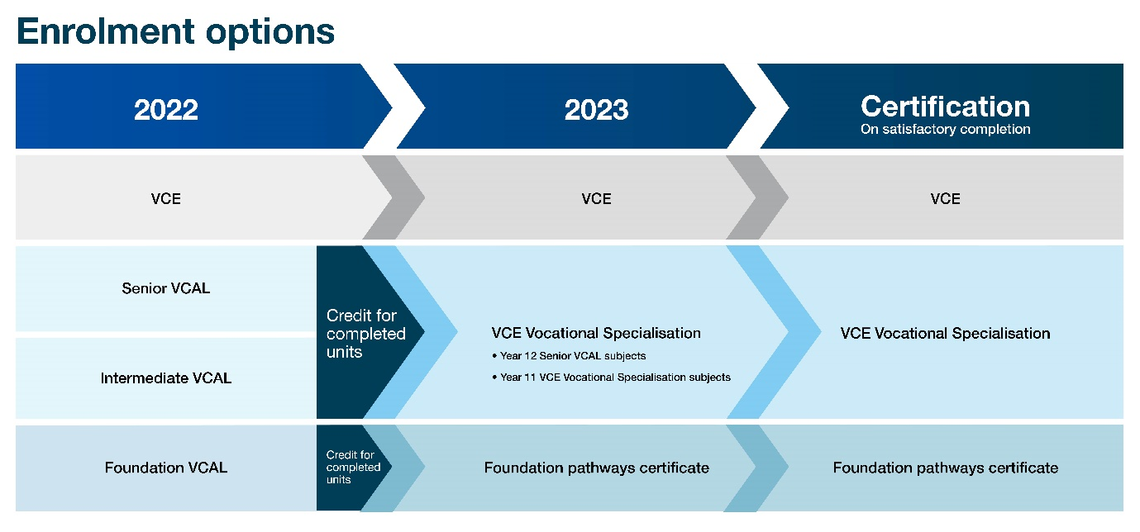
* Note: Students can also move between certificates
If you would like to talk further about these changes please contact, XXX. To learn more about Victoria’s senior secondary certificate reform, you can email the Senior Secondary Reform team.

