SCHOOL HOLIDAY PROGRAM TERM TWO 2026

These programs offer parents and their children 7-11 support with mental health and wellbeing. The one-hour sessions are run by mental health staff from the Loddon Children’s Health & Wellbeing Local. Sessions are fun, educational and interactive. Groups are small: five children with one parent per child attending.
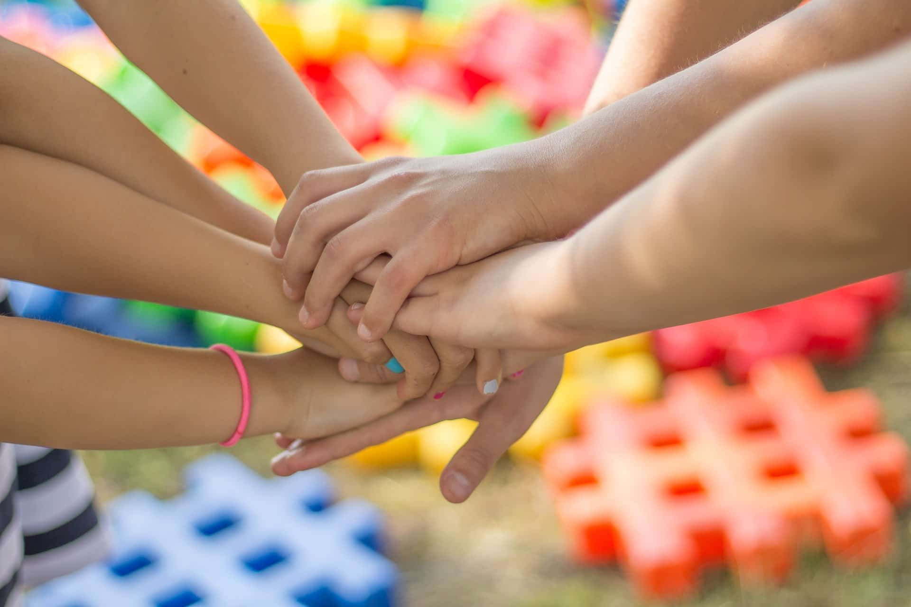
This Photo by Unknown Author is licensed under CC BY-SA
TOPICS
10.30am Worry in children or Managing feelings 4-6 year olds Please book in
1.30pm Social skills for kids or Managing Big Feelings 7-11 year olds Please book in
2.30am Parent Drop in, with questions to ask the mental health staff about parenting and or your child. Open to any age group. Kids can play in the room while we chat.
No need to book in for this session

DATES
30th June Bendigo, The Local 10.30am Worry 4-6 year olds, 1.30pm Social skills 7-11 year olds
9th July Bendigo, The Local 10.30am Managing feelings 4-6 year olds,
1.30pm 7-11 year olds

Bookings are essential:

Please call Annette or admin on 1800 433 977 or email us which sessions you want to attend, your child’s name and age, your name and contact details including telephone number and email address, icfhwlocals@bchs.com.au.

We will be in touch prior to the session to confirm details including how to access the venue.

