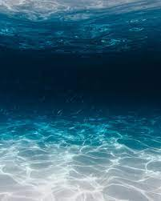**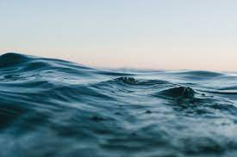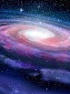The Legend of the Rift**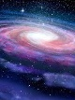

By Zackary Chia

(Sidenote: when I was planning this out, I didn’t think of the GBR so most of this is not related.)

A Dreadful story of sadness

In place that’s quite like hell

The effect of mass pollution

Now that’s quite the tale to tell.

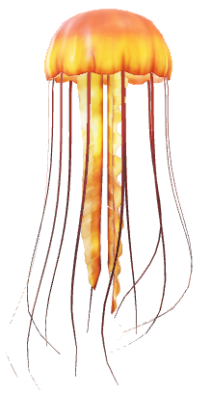The story you’re about to hear

took place not too long ago

A place that’s far, yet near

Where the land was off the coast

So come close, dear friends

The story of a man a cliff

Cause I’m about to tell you

The legend of the rift

*

A man looked down

Upon the darkness below

Knowing it’s not well



He knew that nothing

Could stop this terrible cause



Only one thing can



He felt something

Suddenly, creeping through dark

Something disrupting

Then the earth grumbled

Knocked him nearly off his feet

A small sliver of light

And “EARTHQUAKE!” they screamed

What he saw that black morning

Still is left In mind

A crevase appeared

Widening, crackling, breaking

Through the rifts of time

And then he saw it

Live animals, coral, fish

Nature at it’s best

A place of wonder

But as soon as it started

It just as quick stopped

Then it was on news

‘MYSTERY TIME RIP,’ it said

People were confused

But the old guy grinned

He knew it would come soon

And that man would change

It never happened

Again as far as we know

But it did it’s work.

 *

**History as we know it has changed.**

**The world has changed.**

**Man has changed.**

**It was confusing at first, but we soon understood it.**

**THE LEGEND OF THE RIFT**

**Thanks for reading!**