

**03/04/2023**

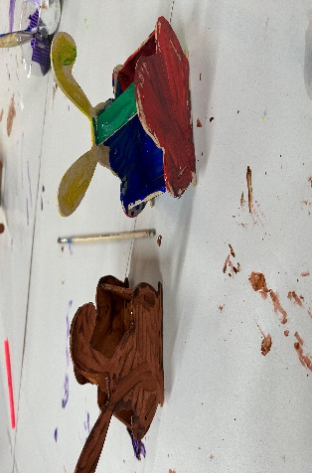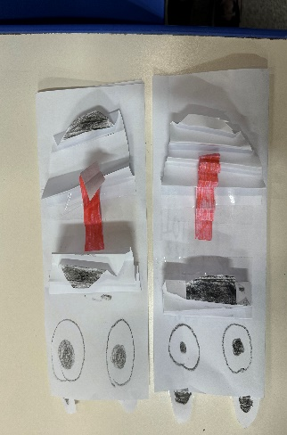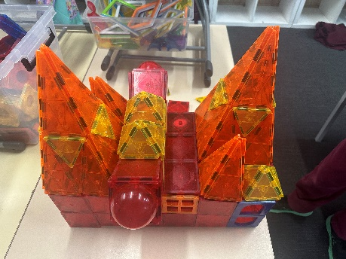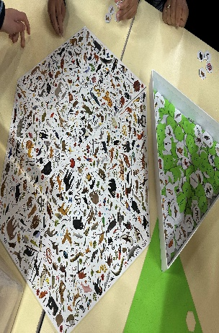](https://pp.campaustralia.com.au/)[](https://apps.apple.com/app/apple-store/id1529575453?pt=120333103&ct=edmbookings&mt=8)[](https://play.google.com/store/apps/details?id=au.com.campaustralia.parent)

Don’t forget, this Thursday 6th of April, school is ending at 2:30PM. OSHC will be open from 2:30PM.

**A message from your Coordinator**

This past fortnight children have been using their time in care to make the most of the last of Term 1. This end of term focus has been centred around creativity, innovation and lots of easter activities. Children have been using the equipment around them to go above and beyond in creating designs and sculptures, an example of this is the wooden easter bunny baskets, that students created and designed, as well as their easter bunny frames. We are very excited to welcome back the children to the Autumn Holiday Rocketeers Program, filled with increased exciting activities and adventures. Parents don’t forget to sign your children up!

**Oatlands Primary School**

Join in the fun of Outside School Hours Care activities and experiences with Your OSHC and Rocketeers.

**Make a booking**

Book now

* Rocketeers
* Movie Excursion
* Bounce Excursion

**Activities coming up**