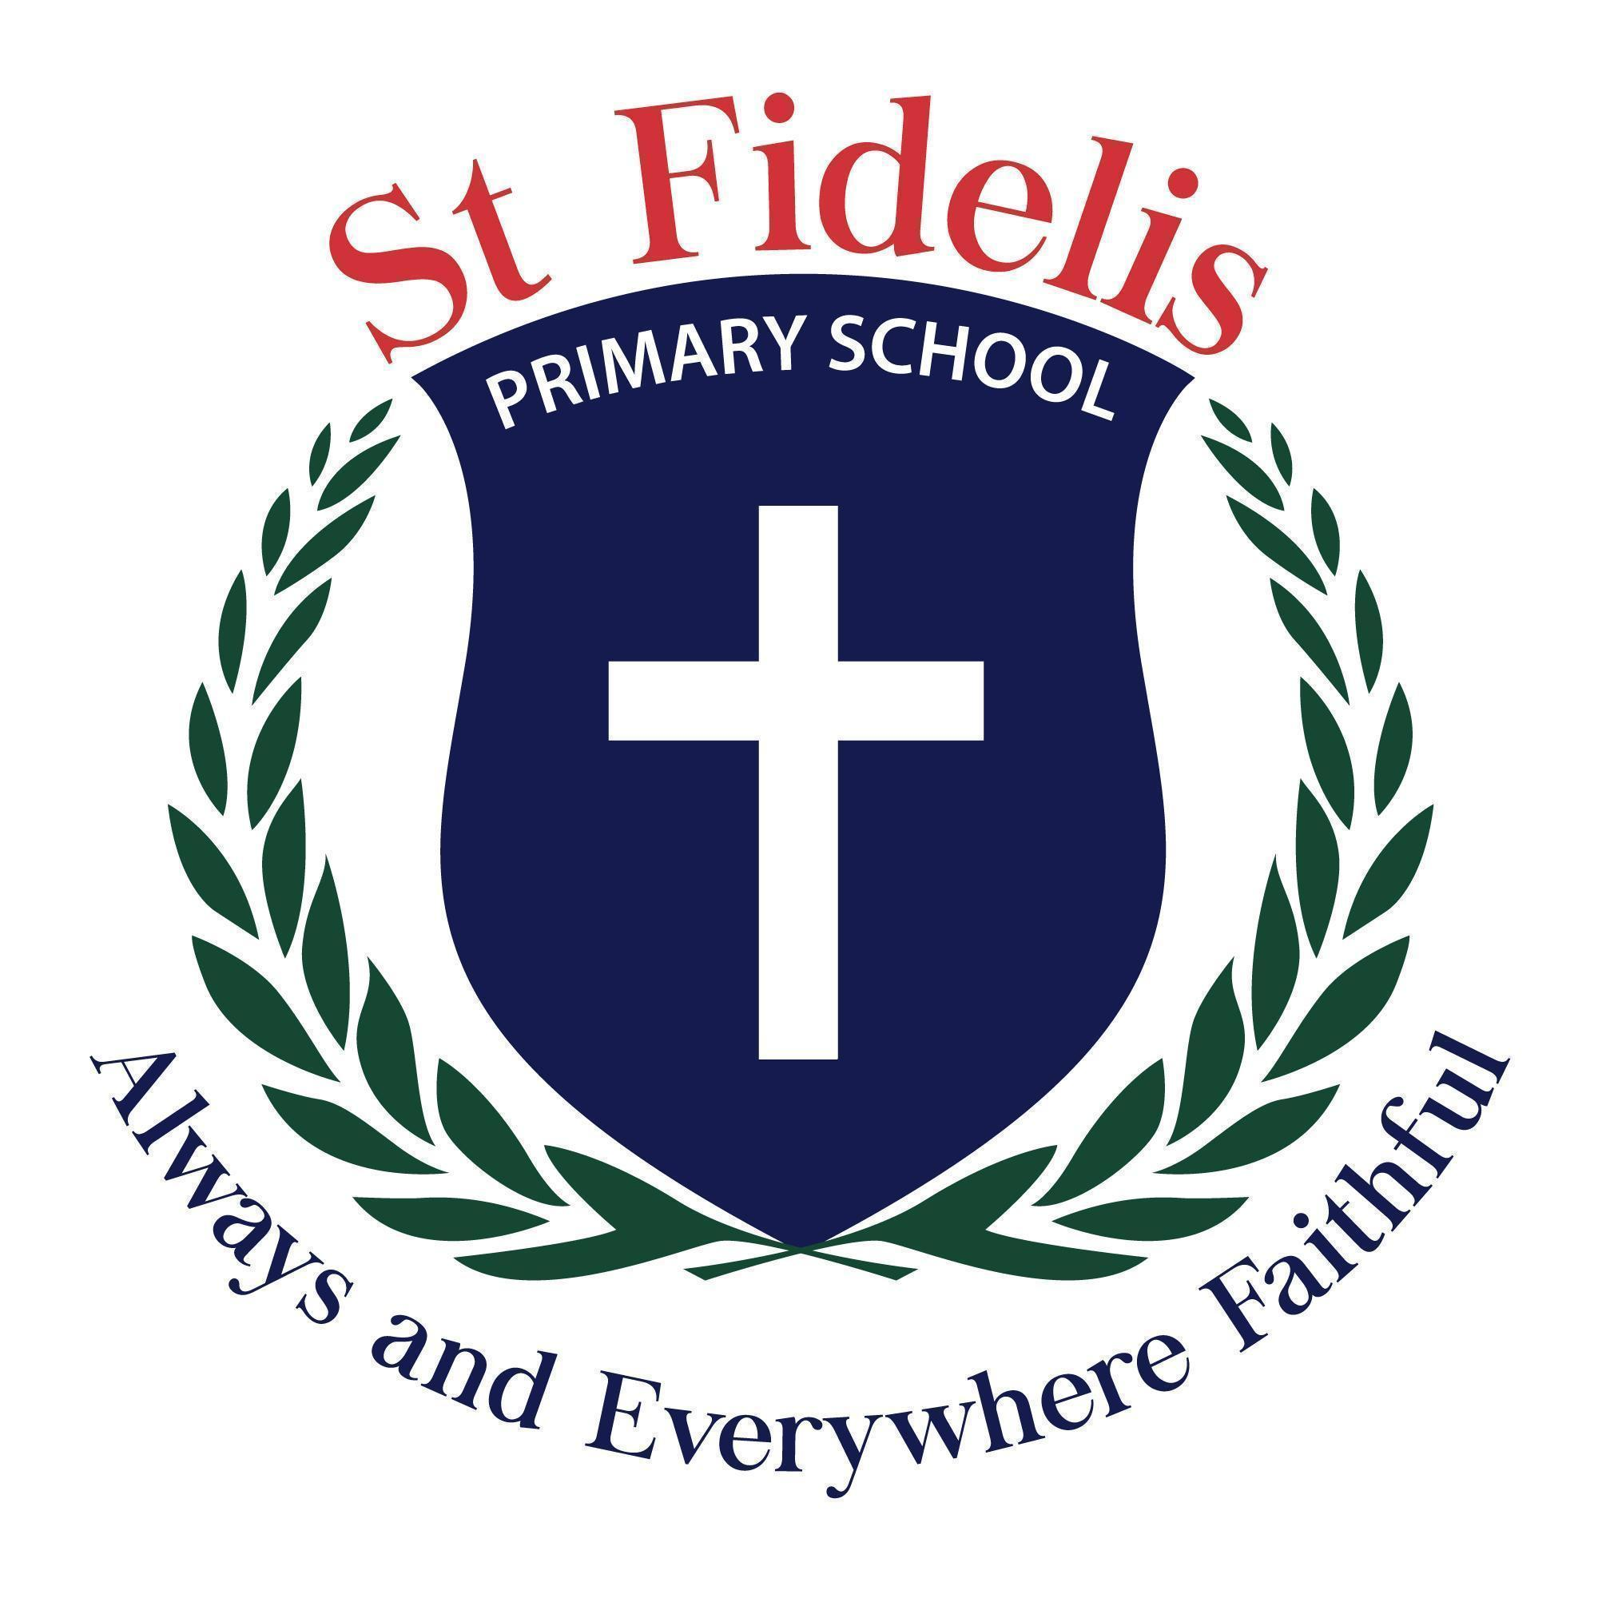

December 2025
SCHOOL FEES AND LEVIES 2026

Dear Parents and friends,

Thank you to all the families for your continued support in paying school fees. School fees ensure all children are provided the best experiences and resources to support their learning.

2026 Family School Fee | $2354.00 per family  This amount is payable in full at the beginning of the year or in three installments of $784.67 which is due at the beginning of Terms 1, 2 and 3.
Family Capital Levy  (Due at the commencement of the school year) | $105.00 per family  This levy contributes towards the maintenance of our buildings and grounds
Subject Levy per Child  (Due at the commencement of the school year) | $360.00 per student This will cover all of your children’s books and stationery requirements and also covers the purchase of materials for different subject areas such as English, Maths, Inquiry, Art, Technologies/STEM and Physical Education, Religious Education and The Resilience Project Workbook per child
Excursion Levy per Child  (Due at the commencement of the school year) | $130 per student  This will cover the cost of incursions and excursions. This will not be refundable should your child be away on the day of the excursion.  Transport costs for interschool sports are not included in the excursion levy. Students will be required to pay for these separately as the need arises.
Camp Levy  (Years 5 & 6 Only) | $440.00 per student  This will cover the Camp for Years 5 & 6 students only

Fee Information
- Accounts are generally sent home twice each term and prompt payment of the term fee is required.
- Method of payment can be made by cash,credit card, EFTPOS or EFT.
- Where non-payment of fees occurs, parents will be asked to attend an interview with the principal to discuss the issue. Any unpaid fees may be directed to our Fees Collection Agency for recovery.
- The fee structure is reviewed each year through consultation with the Principal and Business Manager.

2026 SUBJECT LEVY FEE AND SCHOOL FEE SCHEDULE

All Fees will be invoiced at the start of the year

LEVY FEES PER CHILD

Foundation-Year 4 Students | Subject Levy per Child  Excursion Levy per Child  TOTAL | $ 360.00  $ 130.00  $ 490.00
Year Five & Six Students | Subject Levy per Child  Excursion Levy per Child  Camp Levy  TOTAL | $ 360.00  $ 130.00  $ 440.00  $ 930.00

SCHOOL FEE - PER FAMILY
School Fees – Per Family | $ 2354.00
Capital Levy – Per Family | $ 105.00

PAYMENT SCHEDULE
Divide your Amount Owing by THREE (3) Instalments due by:
Instalment 1 | Friday 20th March 2026
Instalment 2 | Friday 19th June 2026
Instalment 3 | Friday 11th September 2026  ALL FEE payments to be completed

Payments are accepted by CASH, DEBIT CARD OR CREDIT CARD

If you wish to pay Direct Debit please contact the school Office.

Payments via Direct Debit would be weekly or monthly ensuring that all fees are
finalised by the end of 3rd Term ( Friday 18th September 2026)

Should you have an queries please contact the school office on 03 383 3600 or email principal@sfmoreland.catholic.edu.au

This School Fees and Levies schedule is reviewed in December of the current year.

2026 MACS (Melbourne Archdiocese Catholic Schools) School Fees Concession Program for eligible families under the eligibility criteria)

Eligibility Criteria
For families meeting any of the following:

- Any family of Aboriginal or Torres Strait Islander heritage
- Health Care Card holders (Eligible for CSEF-refer to the Camps, Sports, Excursions Fund application from for more information ) or visit.https://www.vic.gov.au/camps-sports-and-excursions-fund
- Genuine Financial Hardship
- Any family holding a DVA Gold Card
- Refugees and holding an ImmiCard
- Home-Schooled students (part time) meeting the above criteria

For eligible applicants (those that meet the above criteria) the 2026 concessional annual school fee rates are:

ONE CHILD | TWO CHILDREN | THREE CHILDREN
$810 | $1240 | $1620

These rates do not include Years 5 & 6 camps. The Years 5& 6 camp fees will be in addition to the above for the eligible families.

Families who meet one of the above criteria will be required to fill out forms in February 2026.

Kind Regards
Manuela Watson
PRINCIPAL

