# Roasted Broccoli and Lemon Pizza

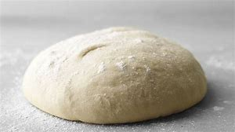(with yoghurt)

*Makes 2 medium-large pizzas*

**Ingredients**

* 2 cups self-raising flour
* 1 cup plain yoghurt
* 1 tbsp olive oil (for dough)
* ½ tbsp olive oil (for broccoli)
* Pinch of salt
* 1 head of broccoli (small)
* ½ lemon
* ¾ cup mozzarella

## **Equipment Needed**

* 2 baking trays
* Baking paper
* Mixing bowl
* Wooden spoon
* Clean tea towel
* Rolling pin
* Knife
* Zester
* Measuring spoons
* Measuring cups

## *Note: use a little plain flour for dusting if dough is too sticky when kneading or rolling out.*

## **Method**

* Line baking trays with baking paper.
* Combine the flour, yoghurt, olive oil and salt in the large mixing bowl.
* Mix well with the wooden spoon until it comes together.
* Turn the dough out onto the bench and knead with your hands for 5 mins.
* Set aside, cover with a clean tea towel, and allow the dough to rest for at least 5 minutes.
* Cut up broccoli into small florets.
* Fry florets in a fry pan with ½ tbs of olive oil.
* When dough has rested, divide the dough into 2 equal parts.
* Roll out thinly (in the shape of the tray)
* Place dough on trays.
* Top broccoli. Zest ½ lemon over broccoli and sprinkle with mozzarella.

Don’t forget to clean up! ☺