***TRINITY TIMES*** 10th Of September 2020 003

*WE WANT TO SEE YOU!!*

Send us a pic of you doing your fave lockdown activity….. Share it with everyone to give us all ideas on getting through the last few weeks with smiles on our faces! Email your pic to fscroggie@tcs.catholic.edu.au

**PET OF THE WEEK**

Owner: Melina Xenos

Name: Battie Age: 3 years old

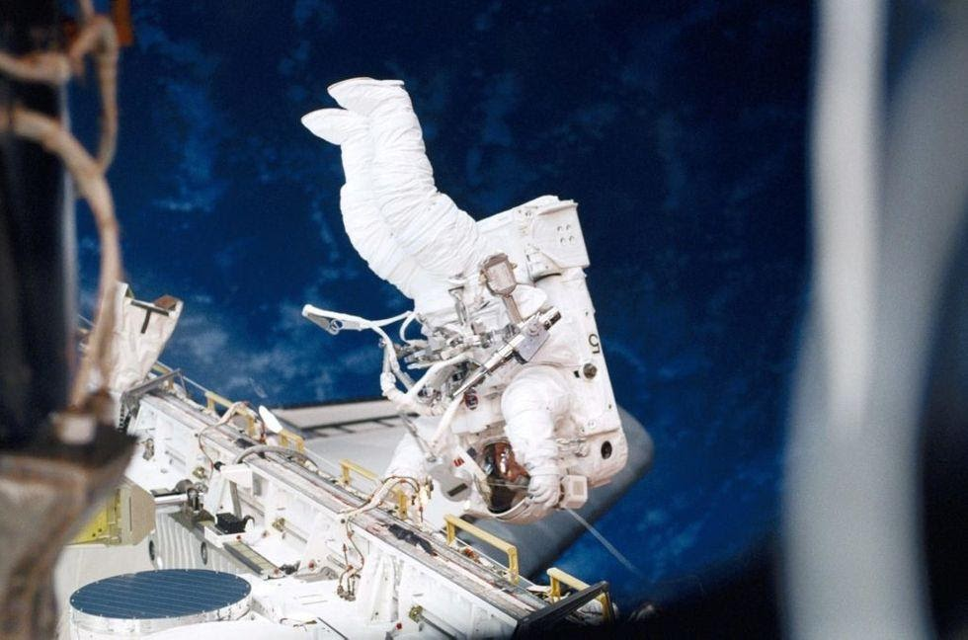

NASA is offering STEM activities ranging from building foam rockets to solving space station emoji puzzles. Parents can also download colouring sheets and books for younger children.

<https://www.nasa.gov/stem-at-home-for-students-k-4.html>

**REFLECTION BY ABOL AKOL**

This week has been very productive for me. In my class we have been doing a lot of work like reading the book Lion doing e books class meetings and many more. This term has been very productive for myself and I've learnt so much about myself

**BIRTHDAYS**

Nancy 2/3UR will be 9

Vy P/1AP will be 7

Clementine P/1SG will be 7