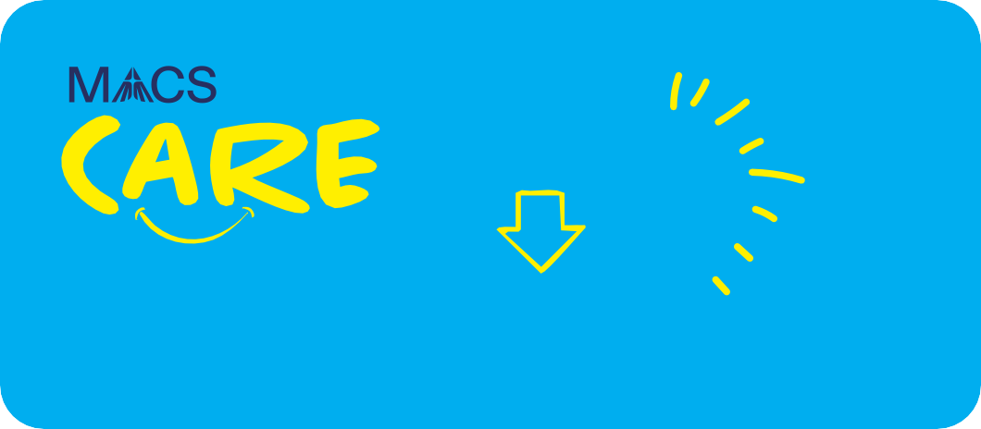
Parent/Carer Newsletter
1

Child Safe Standard 1
Working together for Child Safety

“Establish culturally safe environments in which the diverse and unique identities and experiences of Aboriginal children, young people and students are respected and value.’’
As Catholic educators, we have a moral, mission-driven and legal responsibility to uphold and actively promote the wellbeing and safety of every student entrusted in our care. Our commitment to the protection of students is enabled in nurturing, respectful and safe communities where the uniqueness and sacred dignity of every young person are celebrated, and they can flourish in their learning and development.
This newsletter series provides an overview of what the Child Safe Standards are, how they are designed to help keep children and young people safe and what school governed by Melbourne Archdiocese Catholic Schools (MACS) are doing to prioritise and achieve this.

Overview of the Child Safe Standards:
The Victorian Child Safe Standards are a set of 11 minimum requirements that all organisations working with children must meet. These standards are designed to:
- Prevent child abuse and harm.
- Make child safety a shared responsibility.
- Support the wellbeing of all children, including Aboriginal and Torres Strait Islander children and children with disabilities.
- Promote the participation and empowerment of children and young people.
These standards apply to all school staff, volunteers, contractors, and anyone working with children in schools.

Our Commitment
Our commitment to the protection of students is enables in nurturing, respectful and safe communities where the uniqueness and sacred dignity of every young person are celebrated, and they can flourish in their learning and development.

This vision is driven by the Gospel message of love, justice and abundance, beautifully reflected in the words of John:

“I have come so that they may have life and have it to the full’’
(Jn 10:10)

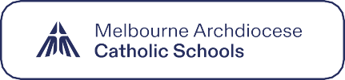

Note: The term ‘Aboriginal’ includes Aboriginal and Torres Strait Islander peoples. It is important to be respectful of how individual children, students, their families and community refer to themselves and use appropriate language when referring to individuals or communities.

Working together for Child Safety

Parent/Carer Newsetter 1 2 of 2
Spotlight on Child Safe Standard 1
Creating a Culturally Safe Environment for Aboriginal Children
Child Safe Standard 1 relates to children and young people feeling culturally safe, respected, and valued.

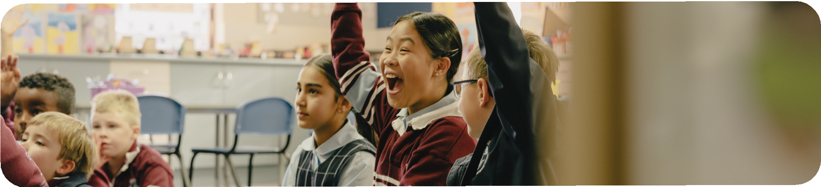
What does this look like in a school environment?
  - Celebrating culture: We include and celebrate Aboriginal culture in our classrooms/events e.g. NAIDOC Week, researching stories to share, inviting guest speakers.
  - Taking a stance: We lead by example against racism and swiftly respond if it is observed.
  - Working together: We contact and engage with Aboriginal families and communities to make sure our school is welcoming and inclusive. We ask families what they need to feel supported at our school.
  - Ongoing development: Our staff receive training and knowledge to better understand and support cultural safety.

How Parents, Carers and Guardians can get involved!

Here’s how you can support:
- Familiarise yourself with the school’s child safety policies and understand how they support student wellbeing.
- Provide feedback when you notice something that may impact a child’s safety or wellbeing.
- Support your child when they express their views and that their opinions are valued and heard.
- Join in on school activities, parent committees or forums that promote child safety and wellbeing.

Want to know more?
If you have any questions or would like to learn more about how we’re supporting child safety, please get in touch.

More information on the Child Safe Standards can be found via the Commission for Children and Young People (CCYP) website.

Check out these additional resources below to learn more!

- Wurundjeri Woi Wurrung Cultural Heritage Aboriginal Corporation
- Koori Heritage Trust
- Aboriginal Catholic Ministry Victoria
- AIATSIS: Map of Indigenous Australia
- Yoorrook Justice Commission

Working together for Child Safety

