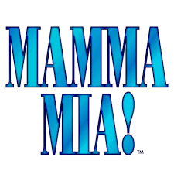
TERM 1 AUDITION TIMELINE &
LEARN FINALE DANCE
WEEK | TUESDAY  AFTERSCHOOL | WEDNESDAY  AFTERSCHOOL | THURSDAY  AFTERSCHOOL
6 | CALLBACKS # 1 &  LEARN FINALE DANCE  (Dancing Queen) | CALLBACKS #1  cont | LEARN FINALE DANCE  cont
7 | CALLBACKS # 2 &  LEARN FINALE DANCE  (Mamma Mia) | CALLBACKS #2  cont | LEARN FINALE DANCE  cont
8 | CALLBACKS # 3 &  LEARN FINALE DANCE | CALLBACKS # 3  (if necessary) | LEARN FINALE DANCE  cont

WEEK 9-CASTING ANNOUNCEMENT!!
CHOOKAS!

