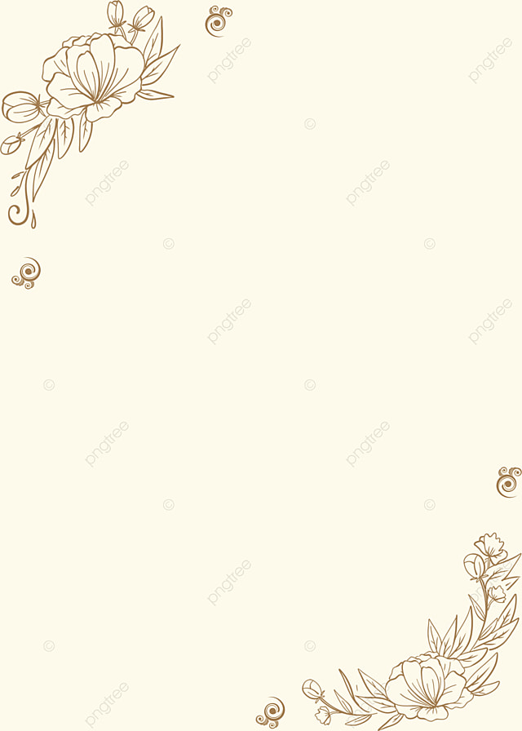
Poems
I am brave and strong
I wonder what snow looks like
I hear talking
I see books
I want to be a police officer
I am brave and strong
I pretend to be naughty
I feel fast and energised
I touch buttons
I worry about high school
I cry when I get hurt
I am brave and strong
I understand I need to protect the environment
I say nice things to people
I dream about meeting Santa
I try to be good at everything
I hope I get a new cat for my b-day
I am brave and strong

