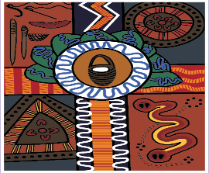
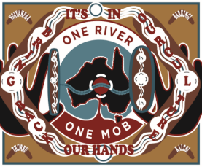
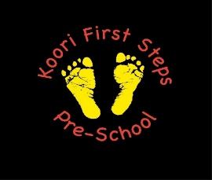

Mungabareena Aboriginal Corporation Programs
- Local Justice (LJ)
- Youth Justice (YJ)
- Male Perpetrator Counsellor Outreach Worker
- Bushfire Recovery Counsellors Male & Female
- Koori Maternity Support (KMS)
- Midwife
- Admin Support/Housing
- Family Violence (FV)
- Family Violence Homelessness Program
- Planned Activity Group (PAG)
- Home and Community Care (HACC)
- Social and Emotional Wellbeing
- Alcohol & other drugs
- Aboriginal Family Led Decision Maker (AFLDM)
- Aboriginal Cultural Support Planner (CSP)
- Aboriginal Health Promotion and Chronic Care (AHPACC)
- Chronic Disease Outreach (ITC)
- Connecting Cultures Coordinator
- Koori Families as First Educators (KFFE)
- Koori First Steps Preschool (KFSP)
- Playgroup
- Men`s & Women`s Groups
Feel free to come in and talk to the staff at
8 High St and/or 21 Hovell St Wodonga or call 02 6024 7599

