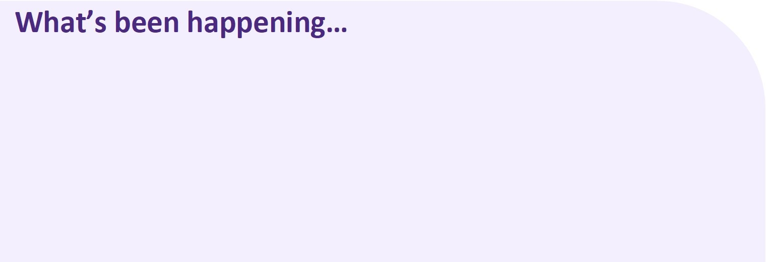
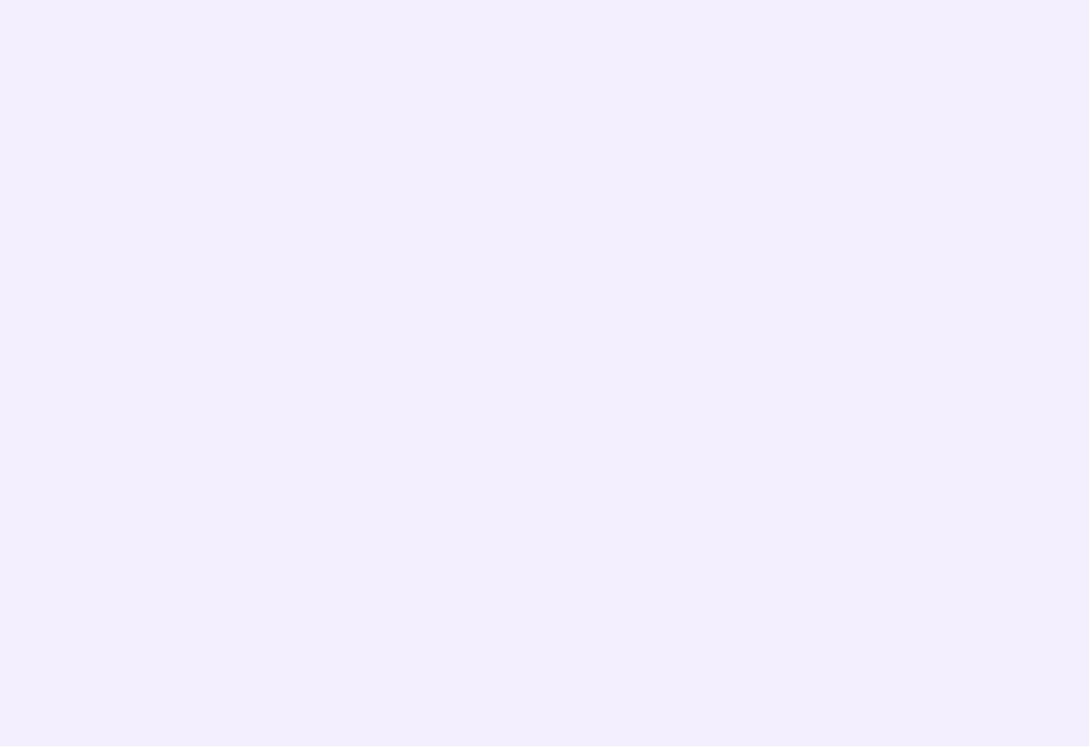

What’s been happening…
Our highlights from the last two weeks have been our Friday Funday
Dragon Festival Theme Day, we had so much fun attempting to make
our very own fortune cookies and raising the dragon boats we made.
We completed our week of Science Academy activities; we loved the
paper helicopters and the Oobleck.
This past week we also celebrated Reconciliation week this past week,
we did this by having discussions each day about reconciliation and
what that looks like, and completed activities such as our bridging
pledges, a Aboriginal flag with our handprints and we completed a
Sorry Day Research Task which was so informative. We really tried to
focus this week not on teaching the children about Reconciliation but
getting the children to focus on understanding the theme of the year
and focusing on how we can be better for the future.

REMINDERS:

Non notified absences will
incur a $20 fee. Please be
sure to notify the service
via phone or via the parent
portal app.
BUNYIP

OSHCLUB

Policy Corner

Feedback & Complaints

At OSHClub, your feedback is paramount, and we take both positive and negative very seriously. Knowing that we are fulfilling yours and your family's needs is very important, and we want to ensure that we are doing anything in our power to do so.

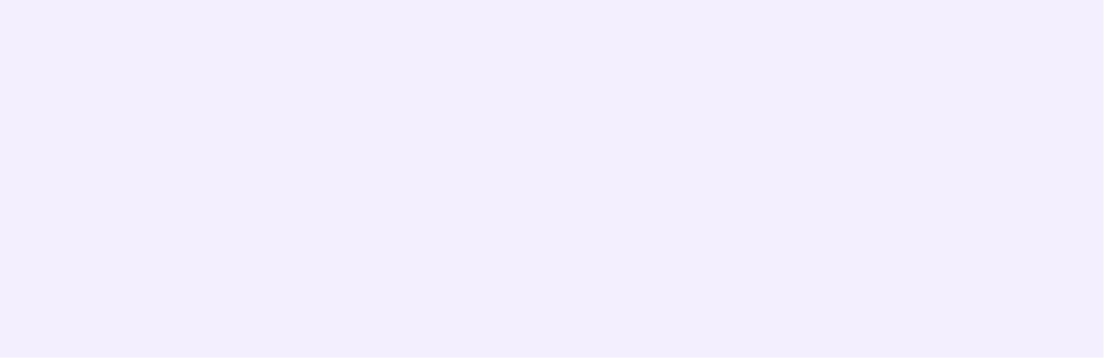
All feedback and complaints can be provided to staff, or the coordinator in service. We always do what we can to rectify any concerns you may have - and we of course love positive feedback as well.
If you would like to speak to someone else to provide them with feedback, please see the coordinator for these details, or find the contact information in service or on our key information sheets.
If you have any further questions regarding this policy, or if you would like to recommend a way to make providing feedback easier - please let us know!

Child Safe Standard
Child Safe Standard 1


Here at OSHClub, we follow the Child Safe Standards which is a list of 11 standards that we need to Implement to keep children safe. Child Safety Standard 1 Is: Organization establish a culturally safe environment in which the diverse and unique Identities and experiences of Aboriginal children and young people are respected and valued. We embed this standard by having a child led acknowledgement of country, weekly Indigenous activities, yarning circles, cultural books and discussions and having an Indigenous season’s display. If you have any further suggestions on how we can embed this standard, please let us know.

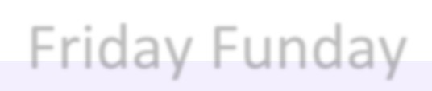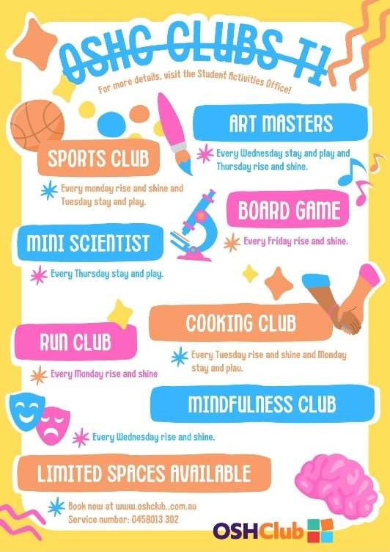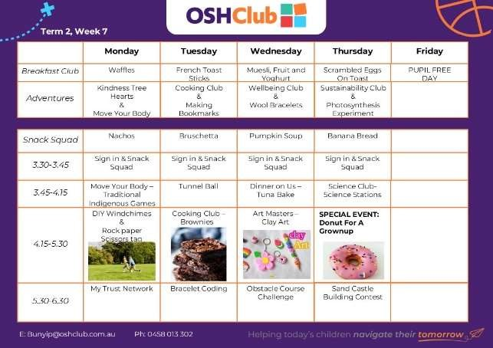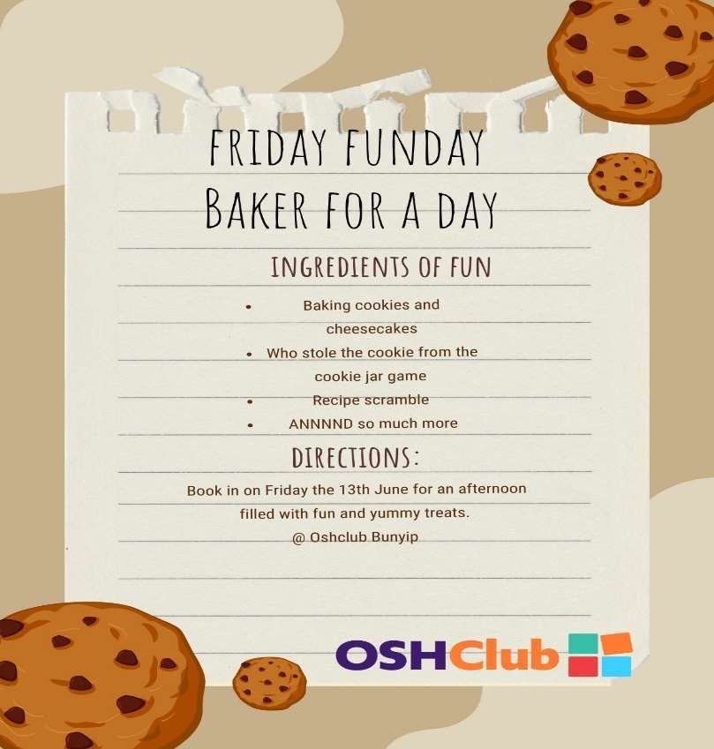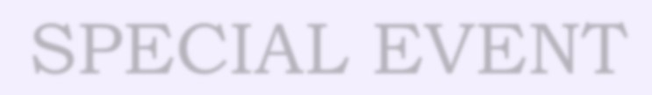

Friday Funday

SPECIAL EVENT

