Level 5 Homework Matrix
Homework tasks should ideally be completed with adult supervision. The Homework Matrix for each level will be available in the Connect newsletter once a fortnight. Tasks will be completed in student homework books and handed in to the teacher, to be signed, two weeks later on a Friday morning (even weeks). Teachers will sign homework books.

L5/6 – Reading + 8 tasks/fortnight
Reading (compulsory)  Read for: minutes every day.  Record the title of your book and the pages read in your diary. Ask an adult to sign your diary.   | Writing (grammar)  We are learning to use coordinating conjunctions to create compound sentences with correct punctuation. E.g ‘The team played hard, yet they still lost the game’.  Task: Create separate examples of a compound sentence for every coordinating conjunction with correct punctuation.  For  And  Nor  But  Or  Yet  So  Challenge: Underline the two independent clauses, circle the subjects and highlight the coordinating conjunction. | Physical Education Challenge  Go for a run at home. Alternate between jogging for 30 seconds and walking for 30 seconds for 5 minutes. Try to maintain a steady pace and rhythm throughout your run. | Gratitude  Pick 3 people you are grateful for  this month. Make sure you explain  why you picked each person.
Spelling:  We are learning about the root word dic-dict meaning to say or proclaim. Break the following words into their morphemes by colour coding the prefixes in yellow, root words in green and suffixes in red. Count how many morphemes are in each word. Want an extra challenge? Use each word in a sentence.  predict  diction  dictate  edict  contradict  indicate  predicated  vindicate  adjudicate  verdict | Maths  Draw an array to match each question.  a) 4 groups of 7  b) 6 groups of 5  c) 8 rows of 3  Write the multiplication equation that matches each array. | Art Challenge  Observe and draw a leaf carefully. Focus on detail, texture, shading and accurate proportions. | Mindfulness  Lay in a quiet room of the house or  somewhere comfortable outside  e.g. on the grass for a few minutes.  Take a moment to just stop and  listen to all the sounds around you.
Writing  Challenge: Writing Sprint. Set a timer for 15-minutes. Using your best handwriting write a response to the following picture prompt. It can inspire any genre of writing e.g narrative, recount, poetry.   | Maths Skills/Fluency:  Write 1 tenth (0.1) less for the following numbers:  3.34  2.98  3.405  0.78  13.768  1.0  Write 1 tenth (0.1) more for the following numbers:  4.768  16.8  9.999  2.5  5.67 | Light!  Light travels in straight lines. Draw the beams from the lights.  - 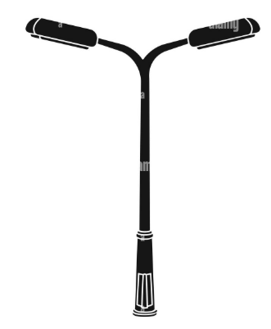 B.  | Emotional Literacy  Create a feelings collage using  magazines, coloured paper or art  supplies. Find pictures  representing different emotions to  create a collage that visually  portrays your feelings.
Maths  Remember that:  - perimeter = length + width + length + width  - area = length x width  We can use our knowledge of factor pairs to help us find all the possible length and width measurements.  Think about all the possible rectangles that have an area of 24m²:  - What is the largest possible perimeter for a rectangle with an area of 24 m²?  - What is the smallest possible perimeter for a rectangle with an area of 24 m²?  - What do you notice about the relationship between the length of the sides and the size of the perimeter? | Online Platforms  - Read a book on Wushka  - Complete tasks on Mathletics  - Play a game on Maths frame  - Listen to a story on Storybox | Mandarin Challenge  Write 2 sentence using the following words:  E.g. wo hui tiaowu 我会跳舞 I could dance.  Changge 唱歌，tingyinyue 听音乐，kanshu 看书，huahua 画画 | Empathy  Think about 3 ways in which you  can brighten someone’s day this  week or ways in which you can  cheer someone up if you notice  they’re sad.

