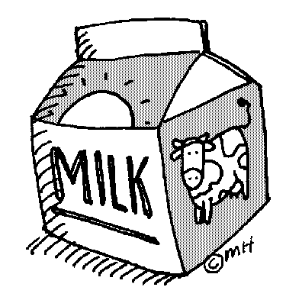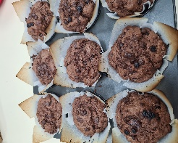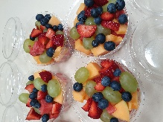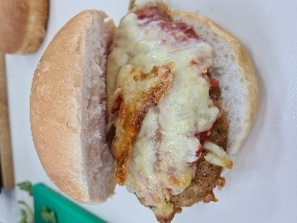I**nstagram ksccanteen *All Bread from Kelly’s May Contain Nuts***

**DRINKS LIST.**

Oak Thick Shake $4.00

Oak Milk 600 ml $4.50

Nippy’s Milk Drink $3.00

Up n Go $3.00

Bottled Water $2.00

Prima $1.00

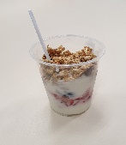

**LUNCH MENU.**

**Hot Food**

Sausage Roll CM $4.00

4n20 Sausage Roll $4.00

***Hot Dog $4.00***

Steamed Dim Sims $1 each

***Warm Cheese Bacon Roll $3.50***

***Chicken Parma Roll $5.50***

Nachos $5.50

***Cheeseburger or with Bacon $5.00***

***Vege Burger $5.50***

***Sweet Chilli Chicken Wrap $5.50***

***Lasagne CM $6.50 GF Lasagne also available $6.50***

***Chicken Schnitzel lettuce and Mayo Roll $5.50***

***Pizza $5.50 each***

1. ***BBQ Chicken***
2. ***Ham and Pineapple***
3. ***Pepperoni***
4. ***Ham, Cheese and Tomato***
5. ***Pumpkin and Feta (Veg)***
6. ***Cheese and Tomato (Veg)***

***Salad Roll*/ Wrap $6.50**

Standard salad consists of lettuce, tomato, cucumber, carrot, beetroot and cheese with ***mayo***, butter, salt and pepper

Ham and Salad 7.00 Chicken and Salad $7.00

***Chicken Cesar Salad Bowl $6.50***

***Sandwiches $5.50 or Rolls $6.00***

(Toasted extra 50c)

Ham and Cheese Egg and Lettuce

Cheese and Tomato Chicken

***Cheese, Carrot and Mayo*** Ham

Ham, Cheese and Tomato Cheese

Cheese and Vegemite Vegemite

Egg and Lettuce

**Toasted 30 cents extra. Extra salad fillings 30 cents each.**

**Please state if mayonnaise not required.**

**No butter unless requested.**

**(Choice of white or multi grain roll, please state).**

**Sandwiches (white bread only).**

**Wraps**

Cold Meat & Salad Wrap $6.00

(Ham, Chicken or Tuna) includes mayo

Salad Wrap $5.00 includes mayo

**Sweet Chilli Chicken** Tenders Wrap with Salad $5.00

**Sweet Chilli Chicken** Tenders with lettuce & mayo $4.00

**SALADS**

Tub of Salad $6.50

Tub of Meat & Salad $7.50

(Fresh Chicken Meat, Ham or Tuna).

**RECESS.**

***Cheese & Bacon Rolls $3.50***

***Coffee Scrolls $3.50***

Egg & Bacon Muffin $4.00

***Hot Dog $4.00***

Dim Sims $1

***Ham and Cheese Croissants $4***

**HOT SOUP**

(Term 2 & 3 only)

Various types

$5 small or

$6 Large.

With or without

***Dinner Roll*** 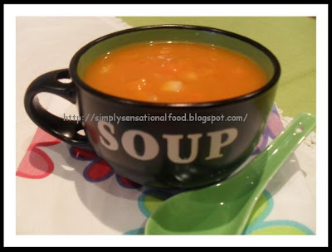

**FRESH**

Fresh Fruit Salad $4.50

Fresh Baked Items $2.50

Fresh Fruit $1.00

Tub of watermelon $3.50

**KORUMBURRA SECONDARY COLLEGE CANTEEN MENU & PRICE LIST. 2023**

***NEW***

I now have Quorn vegetarian schnitzels so can make parmas/ chilli wraps on request

**Gluten Free**

**Options**

**ICE-CREAMS**

Calippo $1.50

***Paddle Pop $2.50***

**Drumsticks $2.50**

***Bulla Frozen Yoghurt$2.50***

98% Fat Free & Gluten Free Frozen Yoghurt $2.50

***Mayo, chilli and tomato sauces as well as chips may contain nuts***

**Instagram ksccanteen**

**Vegetarian**

Chilli wrap $5.50 Parma Roll $5.50

Nachos $5.50

***Vege Burger: Lettuce, Cheese Mayo $5.50***

***Cheese Tomato Pizza $5.50***

***Pumpkin and Feta Pizza $5.50***

Spinach and Feta Rolls CM $3.50

**Allergen Information**

**Items in bold and this colour contain NUTS**

***Items bold and this colour MAY contain traces of NUTS***

EFTPOS Available.

30c surcharge

ORDER UR LUNCH

**SPECIALS**

Advertised in canteen daily and on Instagram

Follow at **ksccanteen**

