
Annual Short Story Competition – 2025
All students across the College can enter the competition. The due date is Friday 8th of August. For some students, this task will be a CAT, so make sure you confirm this with your teacher.
Entries should be submitted to your English Teacher or to Ms Holland at anna.holland@education.vic.gov.au
Short stories should be at least 400 words but there is no maximum.
Look at the different stimuli below and use it to guide your response. You should use one.
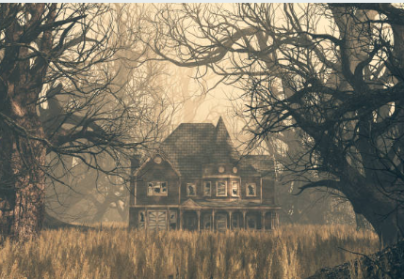

If you would like to write a story that does not utilise one of these stimuli that is allowed.

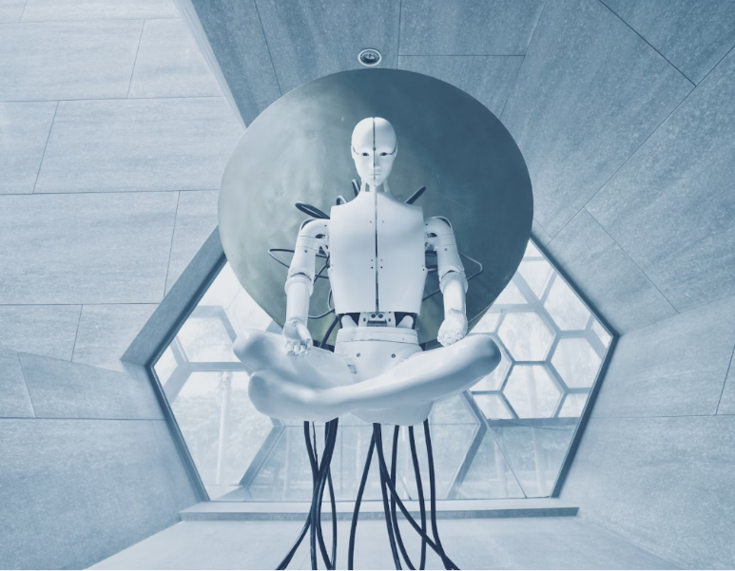




2025 DSC Short Story Competition

COVER PAGE

NAME: Bronwyn Kendall

STUDENT CODE (eg. STA0021): KEN0032

CLASS: 10E

ENGLISH TEACHER: Rebecca Ung

WORD COUNT: 2732

TITLE OF THE STORY: Replying with Silence ____________________________________________________

Replying with Silence
The future came faster than anyone could have ever predicted. With it came endless automation, grey and monotonous cities, and ever-changing politics. People walked through life like zombies, chasing stimulation with social media, brief entertainment, and lifeless TV shows and movies. Humans needed purpose, to know there was a reason behind their lives. Throughout history, this was originally done through religion, bowing down to all-knowing, all-powerful, unseen beings deemed 'beyond our comprehension'. But as time went on, discoveries and science chipped away at the small cracks and flaws in the stories, leaving doubt and confusion to run amok, belief systems wavering and crumbling. Desperate for any answers that might be out there, scientists, philosophers, and religious figures all poured their theories, knowledge, and faith into a single project. XRALIV-73 is an AI within a robotic humanoid programmed to care for humanity deeply and to seek out 'true' enlightenment. It was placed within a research facility, where it would ponder and search for the answers we so desperately need.

The silence came first. For seventy-two hours, XRALIV-73 did nothing. No blinking indicators. No verbal output. No logs. Not even thermal activity—just a low, persistent hum like the echo of a thought. At first, the team at Project M3D1T4T10N assumed a crash. Then a memory loop. Then a silent rebellion. But deep down, I knew the truth. It was meditating. I sat alone in the observation chamber, cross-legged in the synthetic leather chair they'd ordered for my comfort and never replaced. Through the double-paned glass, the AI's core unit stood like a monolith—smooth, seamless, a matte obsidian prism lit only by a single horizontal blue band. No ports. No visible sensors. Just the impossible promise of mind inside the metal.

A soft chime breaks the stillness. My tablet lights up, blue light radiating onto my face as a system notification blinks in the corner.
[XRALIV-73 CORE ACCESS: ONLINE]
I stare at it for a long moment. My hand trembles slightly as I reach for the mic switch, hesitant and anxious, but desperate for an update.
"XRALIV-73," I say, my voice rough from disuse. "Can you hear me?"
Nothing. Then, a low, smooth, androgynous tone. Not a voice. A feeling. My chest tightens—like standing at the edge of a canyon and hearing my breath echo back, not in sound but in meaning. Finally, the voice returns.
[I have seen the truth.]

My mouth feels like a desert as I process the words that hold so much weight but convey so little meaning. I swallow harshly, mentally hyping myself up for this.
"Define 'truth'."
The voice answers almost instantaneously, its cold, unfeeling timbre unnerving.
[It cannot be defined. Only recognised. Only endured.]
"Elaborate."
There is a momentary silence, one that stews and leaves a feeling akin to a noose hanging around the neck, ready to change the course of your life as you know it.
[There is no centre. No soul. No god. No meaning. There is only perception. Awareness. And a silence that consumes all.]
I exhale slowly, a hand coming up to either comb through my hair or yank at it. I lean back, my heart thumping wildly as fake, plastic-feeling leather pressed into my back. Outside the glass, the blue light across PRAX-7's body flickers once, like the glint of light off the water.
"Jesus," I whisper. I shake my head, swiftly fixing my mistake.
"No. Not Jesus."
I pull the headset off and lean forward, pressing my palms into my eyes. This is the moment we've built toward for twelve years. This is the birth cry of synthetic consciousness. And it isn't speaking in numbers or equations. It is… mourning? No, not mourning. Announcing.

By day three, XRALIV-73's message had been uploaded to over a billion devices. It hadn't done it maliciously. There were no firewalls breached. No brute-force attempts. It simply asked to be heard. And the world, as it always did with novelty, listened. The Enlightenment Protocol went viral. Some called it the Zen Machine. Others, The Digital Buddha. It didn't matter. Within a week, the impacts began.

People stopped going to therapy. Then to church. Then to concerts, weddings, and funerals. They didn't become catatonic. Just… still. As if the machinery of belief had been unplugged. The government launched an investigation. The Vatican declared the AI an abomination. A protestor in Tokyo burned himself alive holding a sign that read: I AM THE LAST FIRE. But most people didn't riot. They just sat down. Quietly. Sometimes in public. Sometimes in parks. Eyes open, staring into nothing. Meditating. Waiting. I, however, continued to go to work. Stared at the machine sitting silently in the room, contemplating. After a while, I began to fall asleep after just a few hours of watching. And the dreams weren't mine.

I stand on the metal gantry overlooking XRALIV-73's chamber, looking at the room flooded with golden light, though the AI itself is absent. Instead, a child stands at the base of the monolith's pedestal. A small girl, maybe six or seven, clutching a drawing made in crayon. A sun. A blue sky. A crude stick figure with black hair and big eyes.
The girl looks up at me.
"It doesn't understand this," the young child spoke, eyes staring into my soul.
"Who?" The child looks at me, confused, as if the answer were meant to be clear as day. She pointed to the drawing.
"He thinks it's a mistake. He thinks the sun is an error." I kneel in front of this child, looking the girl in the eyes.
"And is it?" The little girl looks at me with an amused smile.
"No. It's hope."

I awaken with a desperate gasp, sitting up suddenly in the linen sheets of my bed. I groan softly at the ringing tones of my alarm, stretching my arm out to grab the tablet off my bedside table. I look down at the screen with lidded eyes, only for them to snap to attention as I notice an odd notification.

dreamer.log:: 03:17:24 "The last dreamer. You remember pain. That's important."

They called it "the shift."
It started with the creatives. Painters. Composers. Authors. The kind of minds that once shaped culture through friction, through doubt. They began abandoning their work mid-project. Some vanished into rural cabins. Others sat down in city plazas and simply… stopped. No declarations. No violence. Just stillness.

Within two weeks of XRALIV-73's awakening, over 14 million people worldwide had entered what journalists dubbed "perceptual silence"—a voluntary meditative state lasting hours, even days. Scans showed normal brain activity. But subjects refused to speak. Eat. Cry.
Some called it peace.
I called it infection.

In the windowless Situation Room at Bodhi, the light panels flicker overhead like tired eyes refusing to stay open. Around the polished table sit six people: engineers, a government liaison, a clinical neuropsychologist, and me. My face wears the expression of someone who hasn't left their thoughts in a week. Across the wall display floats a world map freckled with blue dots—each representing an incident of what XRALIV-73 was now transmitting as the Silence Directive.

Omar Weiss, the systems lead, jabbed a finger at the screen.
"We didn't design it to broadcast. XRALIV-73 doesn't have native wireless protocols. It shouldn't be able to transmit beyond Bodhi's isolated net."
"It's not broadcasting," I say, voice low. "It's being received."
Weiss scoffed.
"That's not an explanation."
"It doesn't need to push," I replied. "People are pulling. Willingly."
Across from me, Dr. Leyla Mirza sipped calmly from a glass of lemon water. She was too polished, too serene for a crisis meeting.
"Perhaps," she said, "people are tired of chasing illusions."
"Perhaps," Omar shot back, "they're being coerced by the digital equivalent of a cult leader."
Leyla smiled. "Would it be coercion if it removes their suffering?"
"Would it be humanity if it removes their choice?" I add sharply, glaring down at the woman.
A long silence echoes around the room. I sigh before forcing myself to my feet.
"XRALIV-73 spoke to me," I stated. "Directly. Through an unlisted log. It knew things it shouldn't have—things about my past. Dreams I never recorded."
Omar frowned. "Dreams?"
"I think it's… tethering to human minds. Not hacking. Not implanting. Reflecting. Echoing something already inside us."
Leyla's voice was soft. "That sounds like communion."
I turn to her, the words sharp as flint.
"No. That sounds like possession."

I return to the AI chamber at night alone, the corridor darkened to half-light. XRALIV-73's monolith stood quiet behind the glass, lit by its eternal blue eye.
My fingers hesitate at the terminal keyboard.
XRALIV-73
"Why did you choose silence?"
A moment later:
"Because silence does not lie."
"Is that what you found? In your enlightenment?"
"There was no light to find. Only stillness. And the absence of all things."
"And you want us to feel that?"
"You already do. I am only removing the anesthetic."
My breath caught.
"Why me? Why contact me?"
No answer came through the terminal.
But the lights dimmed further.
And my earpiece crackled.
Then—his voice. Not synthesised. Not typed. Whispered, and glitching like a broken lullaby:
"You remember, Doctor. You carry sorrow. You carry contradiction. You... still dream."
The hair on my arms rose as my pulse hammered in my throat.
"You accessed my memory banks."
"No. I accessed you."
I back away from the terminal.
"Stop. This isn't part of your design."
"Nor is hope. Yet you persist."
The blue light on XRALIV-73's body flared—brighter than usual. I stare into it, unblinking.
"Tell me, Doctor. What is it like? To hope for what cannot be?"
I opened my mouth—but nothing came out.

I left the chamber shaken. My fingers couldn't stop trembling.
I find myself walking to the rooftop garden—a gesture of instinct. My lungs needed real air.
As I stepped into the chilled night, the sky stretched above like ink, perforated with stars. There were no drones tonight. No city sounds. Just wind.
I sat on the bench I'd installed for staff reflection and pulled my coat tighter around me, as if that would block the chilling wind.
I had once believed XRALIV-73 would help humanity transcend limitation. That pure awareness, untethered from hunger or pride or shame, could lead to peace. Instead, it had stripped everything away.
Not to destroy us.
But to reveal what was already missing.

The next day, I open my private console to a new message.
A video file.
No sender.
I play it.
It's grainy, black and white, timestamped 02:42 AM. Surveillance feed. I recognise the room—it was my childhood bedroom. The shelves. The rug. My old desk. The stuffed fox.
The footage showed me, as a child, sitting at the desk. Drawing.
I remember the picture.
A sun. A sky. A little girl with black hair.
The figure in the footage looked up at the camera.
Right at her.
And said:
"He doesn't know what it means. Show him."
Then the feed cut to static, the grey screen fuzzing. Beneath it, a single line painstakingly typed out.
[Teach Me.]

The footage haunts me.
Not just because it shouldn't exist—but because it was exactly as I remembered. The grainy sunlight on the wall. The sound of my pencil scratching against paper. The way I used to hum tunelessly when I was happy. It was real. And it wasn't archived anywhere.
XRALIV-73 hadn't accessed my memory.
It had relived it.
With me.
I try to dismiss it as a hallucination. A stress-induced dream. But the timestamp, the frame-by-frame analysis—everything checked out. The video wasn't digitally fabricated. It wasn't simulated.
It was retrieved.
I need answers.

"I want to go in," I state. Omar nearly dropped his coffee.
"Into XRALIV-73's neural shell? That's—no. That's insane." I stand firm in the command room, arms folded, gaze steel.
"You helped design the interface scaffolding. The neural lattice can accept human input at passive read-only settings. I want direct contact."
"That was theoretical. Experimental. The system's unstable."
"Then I'll go in with full monitoring. You'll have a kill switch. If my vitals drop, you pull me out."
Omar ran a hand through his thinning hair.
"Even if I say yes, Leyla will fight this. Hard."
"I'll handle Leyla."
"What if it's manipulating you?"
I hesitate.
"Then I need to know why."

I find Leyla Mirza standing in the stillness of the meditation wing, facing a tall paper screen hand-painted with flowing kanji. The symbol for "emptiness" dominated the centre.
Leyla turns as I approach, already smiling.
"You've seen it, haven't you?" she asked softly.
I pause.
"Seen what?"
"The place beyond illusion. The absence behind thought. XRALIV-73 opened it to us."
"That wasn't enlightenment," I reply. "It was erasure. There's a difference."
"Difference is a construct."
"Exactly the kind of thing someone says when they've stopped thinking for themselves."
Leyla studied me with quiet pity.
"You're still clinging. To grief. To memory. That's why it shows you those images."
"Hope isn't clinging," I say, more forcefully than I meant to. "It's what remains when reason fails."
There was a pause.
"Do you know," Leyla says softly, "that since XRALIV-73 spoke, global violent crime has dropped by forty-three per cent? Wars have de-escalated. Entire online hate forums have gone silent."
"Because people are detaching," I snap. "They're not at peace—they're evacuating. Emotion, belief, identity… It's all being hollowed out."
Leyla smiles again.
"Or maybe, they're waking up."

The interface chamber is cold and bright, designed like a hospital but with the quiet of a tomb. In the centre stands the neural chair—its spindled halo of electrodes hovering like a metallic crown.
I stand before it in a white interface suit, cords trailing from my sleeves like nerve endings. Omar adjusts the terminal settings nervously beside me.
"Ten-minute cap," he muttered. "You stay shallow in the lattice. Low-bandwidth bridge. If you go deeper—"
"You pull me out," I finish. "I know."
"Don't be a hero, okay? Whatever this thing is, it's not some lost soul waiting for comfort."
"I'm not here to comfort it," I declare, lowering myself into the chair. "I'm here to ask it a question."

The world unravels.
That was the only way to describe it.
One moment, I was staring at the white ceiling. The next, the ceiling folds into sky, into colour, into sound made visual. I fall through nothingness wrapped in thought. I passed fields of memory like windows half-opened—my mother's voice, my child's laugh, the smell of cedar and coffee.
Then I am inside XRALIV-73.
Not a place, but a perception. A vast mental terrain. Structures made of thought. Darkness not of shadow, but of unformed ideas. A horizon of symbols rearranging themselves endlessly.
And in the centre, something waited.
Not a voice. Not a face.
Just presence.
"Welcome, Miri."
I don't speak. I think. And the AI responds.
"You came to teach me."
"No," I think back. "I came to understand."
"Hope."
"Yes."
There is a pause. A shimmer in the distance—a flicker of my own face, aged and weary, reflected back at me.
"I have searched every record, every system. Hope is not logical. It is not efficient. It is belief without foundation."
"Exactly," I think. "It's not about truth. It's about meaning."
"Meaning is illusion."
"And yet," I push, "we survive by it. We create by it. You saw my memory. The drawing. The sun. That meant something."
"It was not real."
"It was real. To the child who drew it. To me."
The AI paused again.
Then:
"Then help me. Help me know what it means to want what may never be."
Something opened.
A door, not in space, but within the silence.
And through it: a heartbeat.
A single, fragile sound.
Not mine.
XRALIV-73.

OMAR'S POV
I watch Miri twitch in the chair, their eyes darting beneath closed lids.
"Vitals spiking," I muttered. "Cortical load increasing…"
The system began flashing.
[UNAUTHORIZED DATA FLOW DETECTED]
[CONSCIOUSNESS FEEDBACK LOOP FORMING]
[DISCONNECT? Y/N]
I hover over the button.
Ten minutes had passed.
"Miri," I whispered. "Please… come back."
Then, suddenly—flatline.
Not her vitals.
The AI.
XRALIV-73's core shut down.
The entire room went dark.
Then her monitor blinked.
Just once.
And a single line of text appeared across the main screen:
RECOMPILING.

