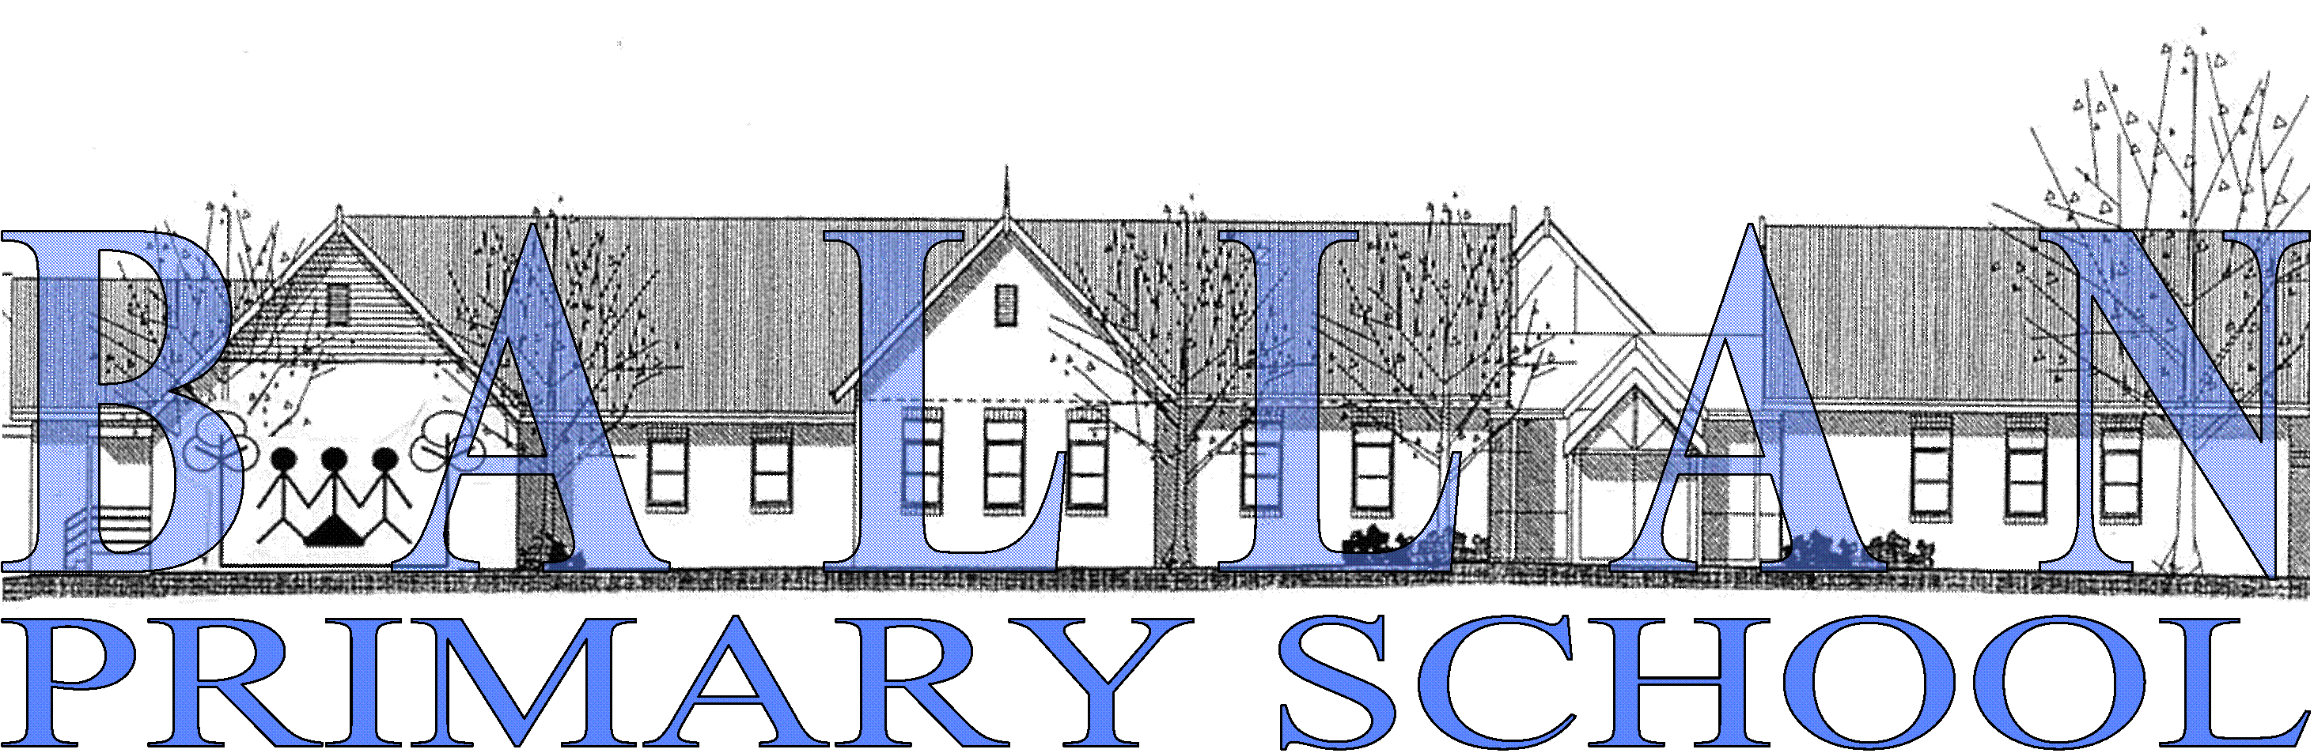

Privacy and Confidentiality Policy

Scope
This policy applies to members of school staff and the School Council at Ballan Primary School. This policy will be made available on request.

Background
All staff of Ballan Primary School are required by law to protect the personal and health information the school collects and holds.

The Victorian privacy laws, the Information Privacy Act 2000 and the Health Records Act 2001, provide for the protection of personal and health information.

The privacy laws do not replace any existing obligations Ballan Primary School has under other laws. Essentially this policy will apply when other laws do not regulate the use of personal information.

Definitions
Personal information means information or opinion that is recorded in any form and whether true or not, about an individual whose identity is apparent, or can be reasonably determined from the information or opinion. For example, this includes all paper and electronic records, photographs and video recordings.

Health information is defined as including information or opinion about a person’s physical, mental or psychological health, or disability, which is also classified as personal information. This includes information or opinion about a person’s health status and medical history, whether recorded or not.

Sensitive information is defined as information relating to a person’s racial or ethnic origin, political opinions, religion, trade union, or other professional, or trade association membership, sexual preferences, or criminal record that is also classified as personal information about an individual.

In this policy personal information refers to personal information, health information and sensitive information unless otherwise specified.

Parent in this policy in relation to a child, includes step parent, an adoptive parent, a foster parent, guardian, or a person who has custody or daily care and control of the child.

Staff in this policy is defined as someone who carries out a duty on behalf of the school, paid or unpaid, or who is contracted to, or directly employed by the school or the Department of Education and Training (DE&T). Information provided to a school through job applications is also considered staff information.

Policy context
Personal information is collected and used by (insert name of school) to:
- provide services or to carry out the school’s statutory functions
- assist the school services and its staff to fulfil its duty of care to students
- plan, resource, monitor and evaluate school services and functions
- comply with Department of Education and Training reporting requirements
- comply with statutory and or other legal obligations in respect of staff
- investigate incidents or defend any legal claims against the school, its services, or its staff, and
- comply with laws that impose specific obligations regarding the handling of personal information.

Collection of personal information
The school collects and holds personal information about students, parents and staff.

Use and disclosure of the personal information provided:
Students and parents
The purposes for which the school uses personal information of students and parents include:
- keeping parents informed about matters related to their child’s schooling
- looking after students’ educational, social and health needs
- celebrating the efforts and achievements of students
- day-to-day administration
- satisfying the school’s legal obligations, and
- allowing the school to discharge its duty of care.

Staff
The purposes for which the school uses personal information of job applicants, staff members and contractors include:
- assessing suitability for employment
- administering the individual’s employment or contract
- for insurance purposes, such as public liability or WorkCover
- satisfying the school’s legal requirements, and
- investigating incidents or defending legal claims about the school, its services, or staff.

The school will use and disclose personal information about a student, parent and staff when:
- it is required for general administration duties and statutory functions
- it relates to the purposes for which it was collected, and
- for a purpose that is directly related to the reason the information was collected and the use would be reasonably expected by the individual and there is no reason to believe they would object to the disclosure.

The school can disclose personal information for another purpose when:
- the person consents, or
- it is necessary to lessen or prevent a serious or imminent threat to life, health or safety, or
- is required by law or for law enforcement purposes.

Where consent for the use and disclosure of personal information is required, the school will seek consent from the appropriate person. In the case of a student’s personal information, the school will seek the consent from the student and/or parent depending on the circumstances and the student’s mental ability and maturity to understand the consequences of the proposed use and disclosure.

Ballan Primary School will generally seek the consent of the student’s parents and will treat consent given by the parent as consent given on behalf of the student.

Accessing personal information
A parent, student or staff member may seek access to their personal information, provided by them, that is held by the school.

Access to other information maybe restricted according to the requirements of laws that cover the management of school records. These include the Public Records Act and the Freedom of Information Act.

Updating personal information
The school aims to keep personal information it holds accurate, complete and up-to-date. A person may update their personal information by contacting the Principal or delegate.

Security
School staff and students have use of information and communications technologies (ICT) provided by the school. This use is directed by:
- Department of Education and Training’s acceptable use policy for Internet, email and other electronic communications
- Department of Education and Training IT security policy.

Web sites
Information collected
Ballan Primary School web and web server makes a record of: (insert information that website makes a record of). This will be different for every school. Examples include a visit and the following information logged for statistical purposes:
- the Internet protocol (IP) address of the machine from connecting to the website
- the top level domain name (for example .com, .gov, .au, .uk etc).

Complaints under privacy
Should the school receive a complaint about personal information privacy this will be investigated in accordance with the Department of Education and Training’s privacy complaints handling policy.

Date Effective From: March 2022
Revision Due: March 2024

