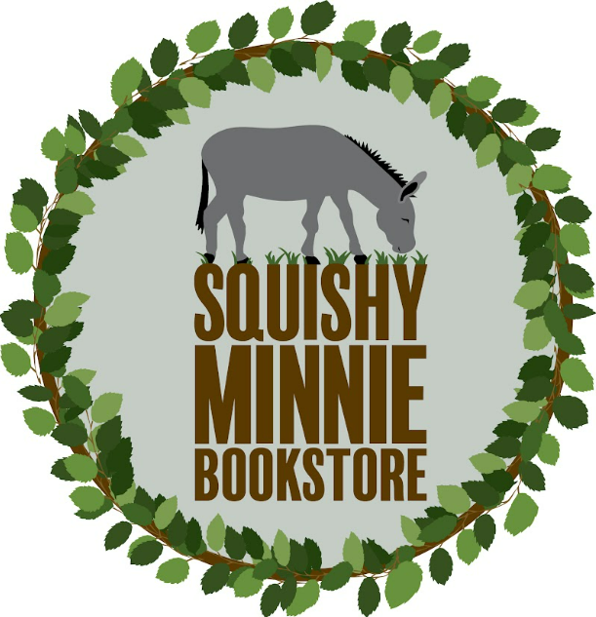 **Book Fair** 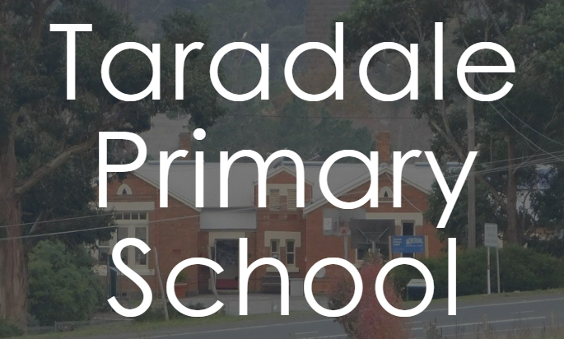

|  |  |  |  |
| --- | --- | --- | --- |
| **Child’s Name** | | | |
| **Parent/Carer’s Name** | | | |
| **Parent/Carer’s Contact Phone Number** | | | |
|  | | | |
| **Book Title** | **Price** | **Number of Copies** | **Total** |
|  |  |  |  |
|  |  |  |  |
|  |  |  |  |
|  |  |  |  |
|  |  |  |  |
|  |  |  |  |
|  |  |  |  |
|  |  |  |  |
| Totals |  |  |  |

Please pay by bank transfer if possible

(it’s easier for school office staff)

**Bank: Bendigo Bank Limited  
BSB: 633 000  
Acct: 211 496 328  
Name: Lyra & Iorek Pty Ltd  
Write your school's initials and your child's surname in the description.**

**Do you need a tax receipt? (prices include GST) Y / N**