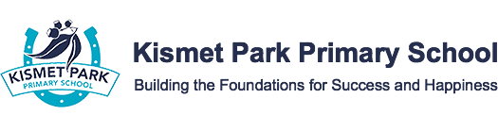 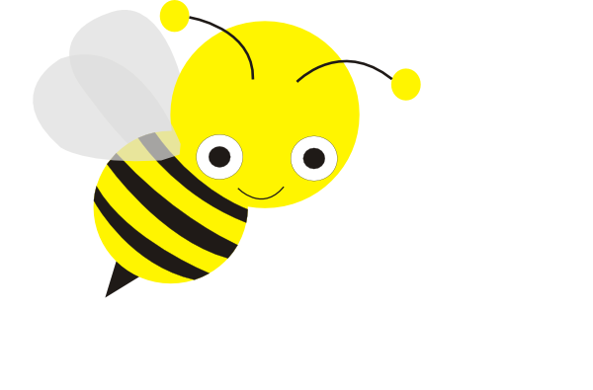

**SUNSMART policy**

**Purpose**

The purpose of this policy is to encourage behaviours at Kismet Park Primary School to minimise the risk of skin and eye damage and skin cancer.

This policy provides guidelines to:

* support staff and students to use a combination of sun protection measures when UV index levels are 3 or above (generally mid-August – end of April)
* ensure that there are outdoor environments that provide adequate shade for students and staff
* ensure students are encouraged and supported to develop independent sun protection skills to help them to be responsible for their own protection
* support our school’s strategies to meet its duty of care and occupational health and safety obligations to minimise harmful UV exposure and associated harm for students and staff.

**scope**

This policy applies to all school activities, including camps and excursions. It is applicable to all students and staff.

**policy**

Excessive exposure to the sun’s ultraviolet (UV) radiation can cause health problems including sunburn, damage to skin and eyes, and an increased risk of skin cancer.

UV radiation:

* cannot be seen or felt
* can be reflected off surfaces such as buildings, asphalt, concrete, water, sand and snow
* can pass through light clouds
* varies in intensity across the year (highest in Victoria from mid-August – end of April)
* peaks during school hours.

Sun safety is a shared responsibility and staff, parents and students are encouraged to implement a combination of sun protection measures whenever UV levels reach 3 and above (typically from mid-August to the end of April in Victoria). Information about the daily local sun protection times is available via at [sunsmart.com.au](http://www.sunsmart.com.au) or bom.gov.au.

Kismet Park Primary Schoolhasthe following measures in place to help reduce the risk of excessive UV sun exposure for staff and students.

**Shade**

Kismet Park Primary Schoolwill provide sufficient options for shelter and trees to provide shade on school grounds, particularly in places such as:

* where students congregate for lunch
* outdoor lesson areas
* playground areas

When building works or grounds maintenance is conducted at Kismet Park Primary School that may impact on the level of shading available to staff and students, a review of the shaded areas available will be conducted and further shading installed as appropriate.

**Sun protective uniform/clothing**

Kismet Park Primary School recommends that from mid-August to end of April, and whenever UV levels reach 3 and above, students come to school wearing sun-protective clothing such as:

* loose, cool, closely woven fabric
* shirts with a collar and/or high necklines
* tops with elbow length or long sleeves
* longer style shorts and skirts

From August 15th to 30th of April, all students **must** wear a sun protective hat that shades the face, neck and ears for all outdoor activities. Hats may also be worn for all outdoor activities outside of the August to April time period, by parent or student choice.

Staff and students are encouraged to wear hat styles that protect the face, neck and ears when outdoors, for example broad-brimmed, legionnaire or bucket.

Students are required to wear a school hat or another similar style hat that protects the face, neck and ears when outdoors, for example broad-brimmed, legionnaire or bucket. Students who are not wearing appropriate protective clothing or a hat may be asked to play in the shade or in a suitable area protected from the sun.

**Sunscreen**

Kismet Park Primary School encourages all staff and students to apply SPF30 (or higher) broad-spectrum, water-resistant sunscreen daily whenever UV levels reach 3 and above. Sunscreen should be applied at least 20 minutes before going outdoors, and reapplied every two hours according to [manufacturer’s instructions](https://www.tga.gov.au/book/4-labelling-and-advertising).

Kismet Park Primary School has strategies in place to remind students to apply sunscreen before going outdoors for example i.e. reminder notices and posters near exits.

At Kismet Park Primary Schoolstudents are welcome to attend the sickbay to access sunscreen. Staff and students who may suffer from allergic reactions from certain types of sunscreen are encouraged to contact Davina Rowell in sick bay to implement a management plan to reduce the risk of an allergic reaction at school.

Staff and families should role model SunSmart behaviour and are encouraged to apply SPF 30 (or higher) broad-spectrum, water-resistant sunscreen when outside.

**Sunglasses**

Where practical Kismet Park Primary School encourages students and staff engaged in outdoor activities to wear close-fitting, wrap-around sunglasses that meet the Australian Standard 1067 (Sunglasses: Category 2, 3 or 4) and cover as much of the eye area as possible.

**Curriculum**

Students at our school are encouraged to make healthy choices and are supported to understand the benefits and risks of sun exposure. Kismet Park Primary School will address sun and UV safety education as part of our Health program.

Staff are encouraged to access resources, tools, and professional learning to enhance their knowledge and capacity to promote sun smart behaviour across the school community.

## communication

This policy will be communicated to our school community in the following ways:

* Available publicly on our school’s website
* Included in staff handbook/manual
* Discussed at parent information nights/sessions
* Reminders in our school newsletter
* Hard copy available from school administration upon request

**related policies and resourses**

* The Department’s Policy and Advisory Library:

[Sun and UV Protection Policy](https://www2.education.vic.gov.au/pal/sun-protection/policy)

[Duty of care](https://www2.education.vic.gov.au/pal/duty-of-care/policy)

* [SunSmart](http://www.sunsmart.com.au/)

**POLICY REVIEW AND APPROVAL**

|  |  |
| --- | --- |
| Policy last reviewed | September 2022 |
| Approved by | School Council |
| Next scheduled review date | 2025 |