Sora instructions
Here are step by step instructions on how to borrow Sora ebooks and audiobooks on a smartphone or your laptop.
The important thing to remember is that the school is member of a huge Library called ACEN Member Collection.

On a Laptop:
Go to the Sora Website
Click on  Find my school | 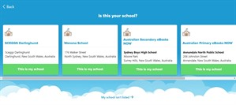
Click on the link at the bottom - My school isn't listed, then type in  ACEN  Click This is my school | 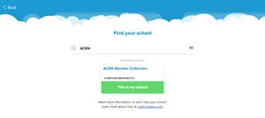
Pull down the menu to Select your school | 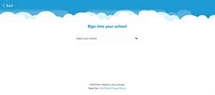
Select ACEN Member Collection | 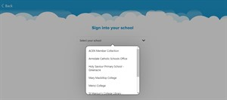
Click on ACEN Member Collection | 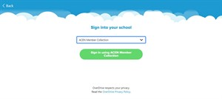
Log in as you usually would at school, using the same username and password. | 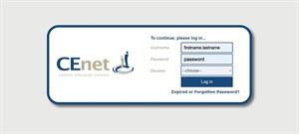
Remember to select Armidale as your Diocese, then Log in | 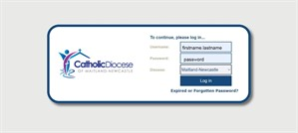
That will take you to Sora! | 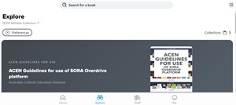
It's important to set your Preferences, so click on Preferences | 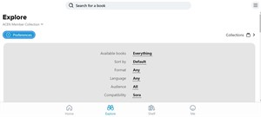
For example, if you'd like Audiobooks in English that you can borrow straight away, that aren't too young for you, set these preferences.  Click Apply | 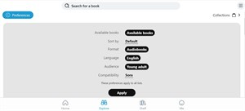
Then look for a book | 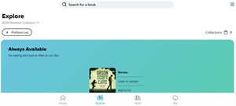
When you've found one you like, click on Borrow | 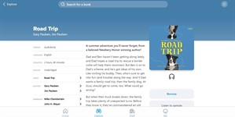
Then the audiobook is on your laptop ready to listen to. | 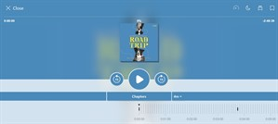

On a Smartphone:
Smartphones are great for listening to audiobooks - you can listen anywhere!
Find the Sora app on your App store  Click Install | 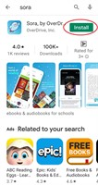
Click Open | 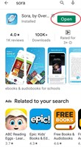
Click on Find my school | 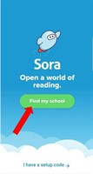
The app will ask "Is this your school? Ignore the schools, and click on My school isn't listed at the bottom | 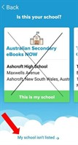
The app will ask you to Find your school. Remember we belong the the ACEN Member Collection! | 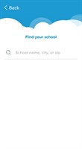
Type in Acen, and when ACEN Member Collection appears, click on This is my school | 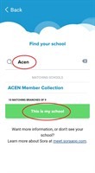
Then the app will ask you to Sign into your school. On the drop down list, click on the first choice ACEN Member Collection | 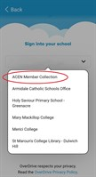
Click Sign in using ACEN Member Collection | 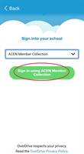
Log in with your school username and password | 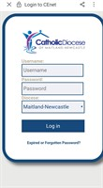
And you're set!  It's important to set your Preferences | 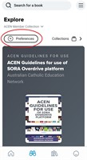
This will narrow down the resources displayed to you | 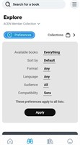
You can choose whether to view all books or only those that can be borrowed right away, whether to see ebooks or audiobooks.  Choolse the Preferences that you want, and then click Apply | 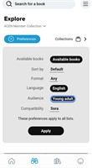
Now you're ready to find a book! | 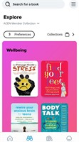
Find a book you like, and click Borrow | 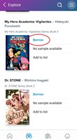
The book will appear on your shelf | 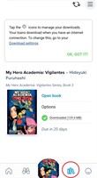
And you can read it. | 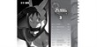

The very last step is to enjoy!

