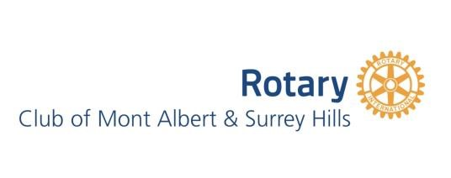

CHRISTMAS FRUIT MINCE PIES

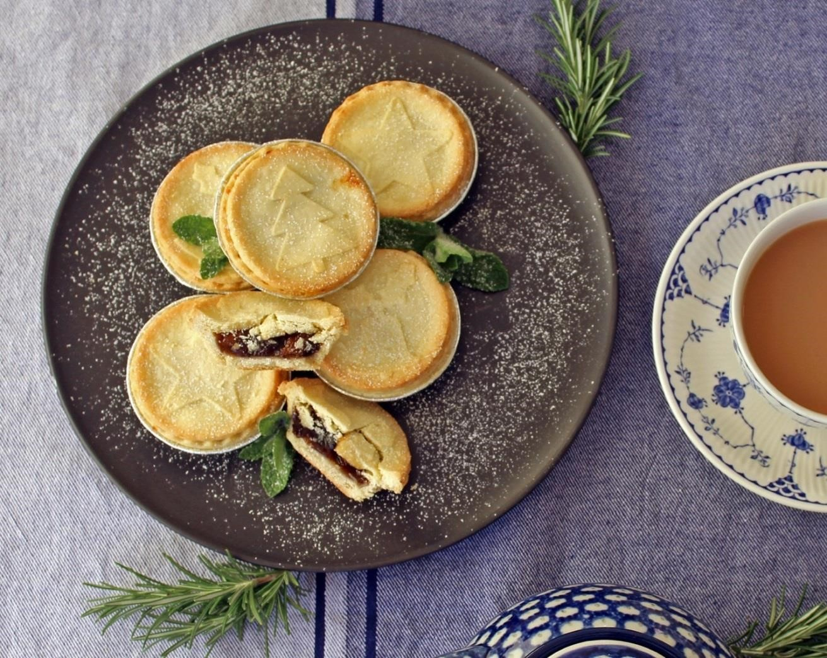

$12 per pack of 6!

$1.50 per pack donated to your school or club
The support of Bread Street Bakery, Hamilton Street, Mont Albert is greatly appreciated
Email orders by 15 December 2023 to: david_winter1954@hotmail.com

Please make payment by Direct Deposit into MASH account, noting your organisation:
Account Name: Rotary Club of MASH
BSB: 633 000
A/c No: 123530552

