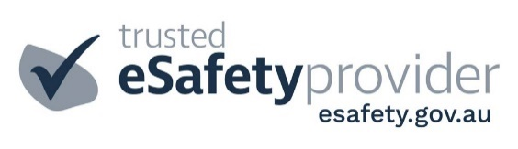

Cyber Safety Parent Information Session at Uraidla PS
November 2, 2021 6:30-7:30pm

We would like to invite all parents and carers to a Cyber Safety information session which will be held in the school Hall (OSHC room) on 2 November at 6:30pm. The session will be run by Cybersafe Families, an Adelaide Hills provider endorsed by the eSafety Commissioner, to share the latest research and best practice approaches to online safety education for families. The evening session will provide parents and carers with strategies to help make home environments cyber safe. All Cybersafe Families presentations are delivered by professionals in the field, who have an understanding that all children are at different stages in their online journey. Parents are encouraged to bring their own device(s) to the presentation, and will be guided through how to check the security settings.

The parent information session will include:

You can find out more about cybersafe families on their website: https://cybersafefamilies.com.au/

We will be following COVID safety plan for the evening. Please wear a mask and maintain 1.5m between yourself and others. Please note that we will not be distributing tickets; we will write your name on a sign in sheet at the door.

Following the presentation, the Parents and Friends will be holding a free wine tasting to launch their Term 4 wine fundraiser selling Longview wines in the lead up to Christmas. There will be an opportunity to ‘try before you buy’ for free and also to purchase a glass of wine or soft drink on the night if you choose. We haven’t had many opportunities to socialise together as a school community this year so plan to stay on following the presentation if you can!

Cyber Safety Parent Information Session at Uraidla PS
November 2, 2021 6:30-7:30pm

Yes we would like to attend the Cyber safety parent Information Session.
Name(s) of those attending: _________________________________________________________
Please find enclosed $5 person.
I/ we agree to abide by COVID safe regulations on the evening.

Name ________________________ Signature_____________________ Date__________________

