

Skye Primary School
Kitchen Garden Program

Creative Salad

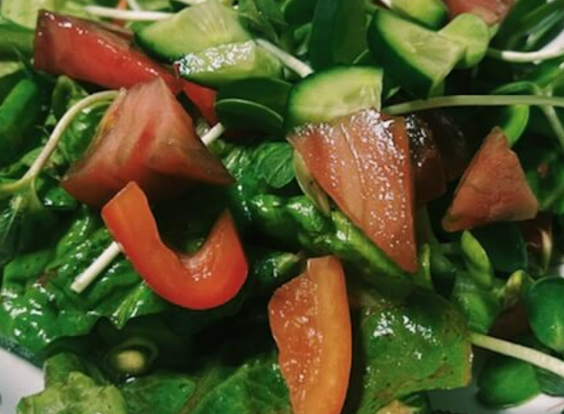

Equipment:  Colander  Knife  Measuring spoons  Serving bowl  Garlic crusher (maybe)  Spoon | Ingredients:  Dressing  2 pinches of sea salt  Pinch of black pepper  Balsamic vinegar, or red wine vinegar, or lemon (maybe a combination).  Extra virgin olive oil  Honey (if you want)  Salad  Please go down to the garden and use your imagination. You may find;  Spinach  Apples  Kale  Herbs  Tomatoes  Cucumbers  Zucchinis  Corn  Borage (purple flowers)  Indigenous edible plants  Fridge and cupboard  Feel free to look in the fridge and cupboard for anything you’d like to use. Check with Mrs Furlong that the ingredient is not needed for other classes.

What to do:

- Use your imagination to make this salad. Ask an adult if you need help.

