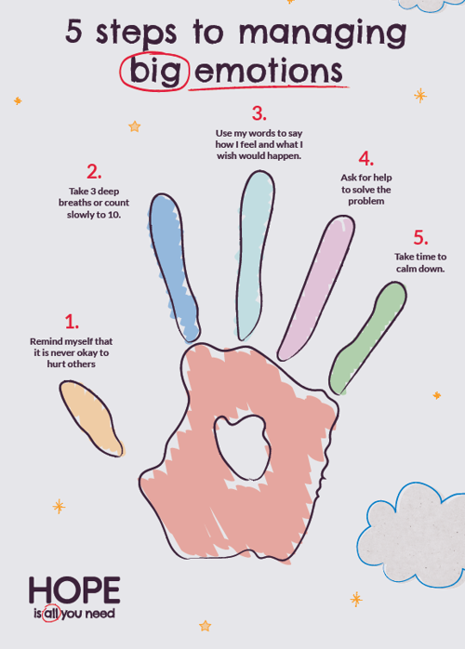
Being a teenager can come with some pretty big emotions. Anger, frustration, disappointment, anxiety and sadness can sometimes feel overwhelming, especially when young people are also managing school expectations, friendships, family life and the pressures that come with growing up. Emotional regulation isn’t about stopping these feelings or pretending everything is ok, it is about learning to recognise emotions, understand what might be behind them, and finding healthy ways to respond.
One of the most helpful things we can teach young people is that all emotions are valid, but not every reaction is helpful. Feeling angry is ok: yelling at someone or becoming aggressive is not. Feeling anxious is understandable: but avoiding things that make us uncomfortable can sometimes make the anxiety stronger. Learning to create a small space between feeling an emotion and acting on it is a very important life skill.
Simple strategies such as naming the feeling, noticing what is happening in the body, taking time before reacting and talking to someone can be helpful when emotions are running high. Adults can also help by staying calm, listening without immediately trying to solve the problem, and acknowledging what the young person is feeling can be more helpful than trying to go straight to giving advice.
Learning to manage big emotions takes practice, ad the goal isn’t to never feel upset, it is to gradually build the skills to move through difficult emotions safely and confidently.

