1/27 Bank St Box Hill

SUPPORTING OUR LOCAL COMMUNITY

Available to residents of Whitehorse residing north of Canterbury Road on low incomes to relieve financial stress. Includes international students, asylum seekers and other non- Australian residents.

* Food: supplies of packaged, frozen and refrigerated foods, bread, fresh fruit and vege- tables (when available)
* Food Vouchers for supermarket purchases
* Assist with chemist, utility and phone accounts
* Phone cards & Telstra Assistance Certificates
* Transport assistance (petrol & Myki credits)

We can advocate on your behalf with utility and phone companies to avoid disconnections and to negotiate affordable payment plans.

We provide information and referrals to a wide range of free local community services with the expertise to best assist individual needs including: legal advice, financial counselling, emergency housing, health, tenancy rights, no interest loans and counselling.

**Tel: (03) 92854801**

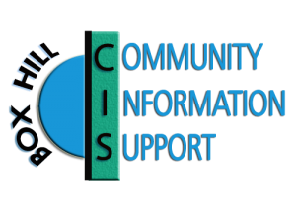

**(opening hours only)**

**Email:** [**help@boxhillcis.org.au**](mailto:help@boxhillcis.org.au)[**www.boxhillcis.org.au**](http://www.boxhillcis.org.au/) **facebook.com/boxhillcis**

**OPENING HOURS**

**Closed public holidays**

**Monday 11:00am - 3:00pm Wednesday 9:30am -12:30pm Friday 11:00am - 3:00pm**