
Form 1: Application for Permission to Travel – School Students
This form is for school students requiring regular bus travel.
This form can also be used for pre-school students together with the Form 6: Written undertakings for pre-school students.
For other types of travellers, please use the appropriate form:
- Form 2: Application for Adhoc Travel
- Form 3: Application for Permission to Travel - Post-secondary and Apprentices
- Form 4: Application for Permission to Travel - General public
Submit completed and signed form to the coordinating school
Travel requested in: |  |  |  |  |  |  | Term: |  |  |  | Year:
PARENT/CARER DETAILS
First Name: |  |  |  |  |  |  |  |  |  |  |  |  | Surname: |  |  |  |  |  |  |  |  |  |  |  | Telephone:
Email:
RESIDENTIAL ADDRESS
Street Address:
Town/Suburb: |  |  |  |  |  |  |  |  |  |  |  |  |  |  |  |  |  |  | State: |  |  |  |  |  |  |  | Postcode:
Exact distance (in km) by the shortest practicable route: |  |  |  |  |  |  |  |  |  |  |  |  |  |  |  | Home to school: |  |  |  |  | km |  |  | Home to bus stop: |  |  |  |  |  |  | km
POSTAL ADDRESS
☐ Same as above
Postal Address:
Town/Suburb: |  |  |  |  |  |  |  |  |  |  |  |  |  |  |  |  |  |  | State: |  |  |  |  |  |  |  | Postcode:
Additional emergency contact if parent/carer is unavailable:
Name: |  |  |  |  |  |  |  |  |  |  |  |  |  |  |  | Relationship: |  |  |  |  |  |  |  | Telephone:
STUDENT TRAVELLER ONE
First Name: |  |  |  |  |  |  |  |  |  |  |  |  | Surname: |  |  |  |  |  |  |  |  |  |  |  |  | Date of birth:
Travel start date: |  |  |  |  |  |  |  |  |  | School enrolled: |  |  |  |  |  |  |  |  |  |  |  |  |  |  |  |  |  |  | Year level at  time of travel:
Does the student have a medical condition or other relevant medical assessment? If yes, please provide details:
Which days do you intend to use this service? (check the applicable box/s):
MON |  | ☐ |  |  |  | TUE |  | ☐ |  |  | WED |  |  |  |  | ☐ |  |  | THU |  |  | ☐ |  |  |  | FRI |  |  |  | ☐
STUDENT TRAVELLER TWO
First Name: |  |  |  |  |  |  |  |  |  |  |  |  | Surname: |  |  |  |  |  |  |  |  |  |  |  |  | Date of birth:
Travel start date: |  |  |  |  |  |  |  |  |  | School enrolled: |  |  |  |  |  |  |  |  |  |  |  |  |  |  |  |  |  |  | Year level at  time of travel:
Does the student have a medical condition or other relevant medical assessment? If yes, please provide details:
Which days do you intend to use this service? (check the applicable box/s):
MON |  |  | ☐ |  |  |  | TUE |  |  | ☐ |  | WED |  |  |  |  | ☐ |  |  |  | THU |  | ☐ |  |  |  |  | FRI |  |  | ☐
STUDENT TRAVELLER THREE
First Name: |  |  |  |  |  |  |  |  |  |  |  |  | Surname: |  |  |  |  |  |  |  |  |  |  |  |  | Date of birth:
Travel start date: |  |  |  |  |  |  |  |  | School enrolled: |  |  |  |  |  |  |  |  |  |  |  |  |  |  |  |  |  |  |  | Year level at  time of travel:
Does the student have a medical condition or other relevant medical assessment? If yes, please provide details:
Which days do you intend to use this service? (check the applicable box/s)
MON |  |  | ☐ |  |  |  | TUE |  |  | ☐ |  | WED |  |  |  |  | ☐ |  |  |  | THU |  | ☐ |  |  |  |  | FRI |  |  | ☐

Conditions of Travel
To ensure the safety of all passengers on school buses, the following conditions apply at all times.
To ensure safe travel on school buses, students must agree to the following:
- Ensure you are standing off the road at all times when waiting for the bus and strictly no playing on the road at the bus stop
- Ensure the bus has stopped completely before trying to get on the bus
- Make sure you and your belongings are inside the bus at all times.
- Not throw anything from a bus window or have anything hanging out a window.
- Place bags and other belongings in the allocated storage areas.
- Get on and off the bus quietly and in an orderly manner.
- Stay in your seat while the bus is moving.
- Not distract drivers with screaming, shouting or unruly behaviour.
- When you get off the bus only cross the road when the bus has left and it is safe to do so.
- No dangerous or flammable goods are allowed on the bus, for example aerosol cans.
- Travel on the bus service allocated to you, to and from your approved bus stop only. Do not change to one that will take you to a sports or social event.
- Wear a seat belt at all times (where fitted) except for getting on and off the bus.
- Sit in an allocated seat if instructed.
To ensure students are considerate to one another and their bus driver, they must agree to:
- In the morning, arrive at the bus stop 10 minutes prior to departure.
- Not eat, drink, vape or smoke while on the school bus.
- Use a standard conversational tone and not use offensive language or call out to others on board or to passing traffic or people.
- Listen to the bus driver and bus captain. They are responsible for maintaining school bus safety and also have the authority to report any vandalism or misbehaviour including but not limited to bullying, teasing, or aggression.
- Leave your bike in a safe and secure place if riding to the bus stop. Department of Transport and Planning and the Department of Education are unable to accept responsibility for the safety of your bike.
- Behave appropriately and respectfully on a school bus at all times as behaving inappropriately places the safety and wellbeing of all on board at risk.
Non-compliance with any of the above conditions may result in the following:
- The driver will stop the bus.
- The student’s name and full details of the breach will be recorded.
- The student will be transported to school or to their normal drop off.
- The breach will be reported to the coordinating principal.
- The coordinating principal will take necessary action as guided below.
- In rare and exceptional circumstances where there is an immediate threat to student safety or the safe operation of the bus, and only as a last resort, drivers are authorised to eject passengers from a bus.
Following the report of a relevant incident, the coordinating principal may take the action below:
- First incident – verbal warning to student.
- Second incident – written warning to parent/carer
- Third incident – one week suspension of student from school bus travel.
- Fourth incident – the student will not be allowed to travel on the school bus for the remainder of the term, year or an appropriate period determined by the coordinating principal.
A serious incident that endangers other students, bus staff or property may result in immediate suspension for a period determined by the coordinating principal.
Responsibilities of parents/carer if student is under 18 years of age:
- Parents/carers are responsible for transporting their children to and from authorised bus stops and their safety at the bus stop while waiting for the bus.
- Supervision is not provided at roadside stops. Parents/carers are responsible for their children upon disembarking the afternoon service.
- Parents/carers waiting for bus passengers at a roadside bus stop should wait on the same side of the road as the bus to prevent accidents.
School bus travel is a privilege and not a right and consequences will follow a breach of these conditions. It is understood that bus travel is provided and accepted on these conditions.

PARENT/CARER TO COMPLETE:
I certify that:
- All the above details are true and correct.
- I will notify the principal in writing within 7 days of any change of address or school.
- I agree to pay the costs of repairs or damage to the bus, or its replacement if totally destroyed, caused by the vandalism or deliberate act of my child(ren).
- I acknowledge that bus drivers are not medically trained and are not expected to perform any medical intervention. In the event of a medical emergency, the driver will call emergency services.
- I consent to release the information in this form to Public Transport Victoria (PTV) to assist with planning for transport services.
- I will notify the principal in writing should my child(ren) no longer require transport assistance.
I accept the authority of the coordinating principal with regard to student discipline on the school bus service.
I agree to abide by the above Conditions of Travel.
I understand that if I or my child (ren) do not comply with the Conditions of Travel, it may result in my child (ren) not being permitted to travel on the school bus service.
I understand that if my child(ren) are assessed as not eligible for transport assistance, I will be required to pay a Term fare of $125 for each child or I may apply for a fare exemption. Fare exemption criteria are listed on page 4 of this application form.
If assessed as not eligible (fare payer or with an exemption), I understand that my child(ren)’s permission to travel on the school bus service is subject to the following terms and conditions:
- My child(ren) may only travel where seating is available on the service after all students with prior rights have been accommodated.
- I will make alternative arrangements if seating becomes insufficient after students with prior rights to travel are accommodated.
- My child(ren)’s continued access to the bus service will be subject to review at the end of each term.
- My child(ren) may not form a case or part of a case for the retention, extension or addition of services, or a route or timetable alteration, or the provision of a larger vehicle.
I acknowledge the decision about whether my child(ren) can travel on the school bus service is at the discretion of the coordinating principal and may be reviewed at any time in accordance with these terms and conditions.
Parent/carer name:
Parent/carer signature:
Date:

STUDENT (s) TO COMPLETE:
I accept the authority of the coordinating principal with regard to student discipline on the school bus service.
I agree to abide by the above Conditions of Travel.
 | Student one | Student two | Student three
Student name:
Student signature:
Date:

ELIGIBILITY CHECKER
Use this chart to assist in determining the student’s eligibility to travel on a school bus.
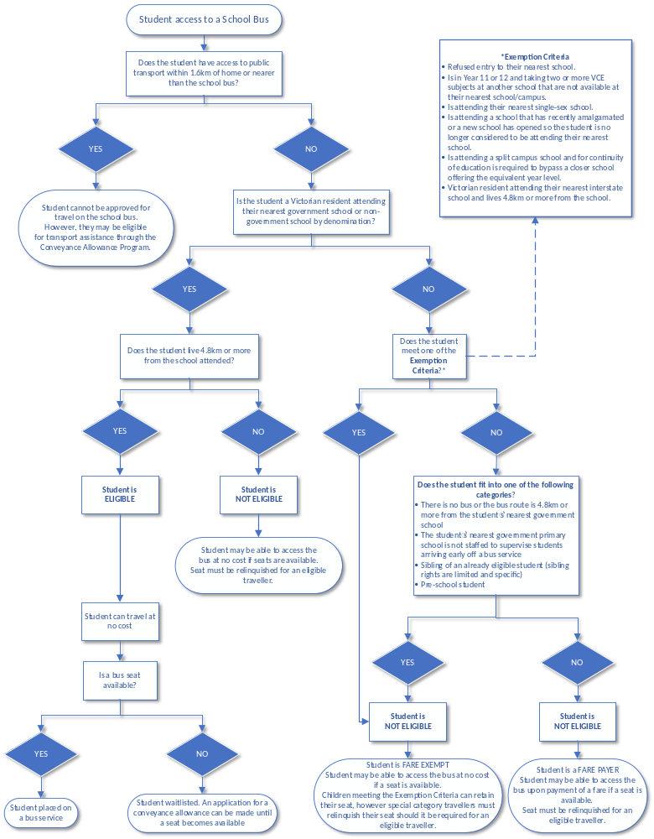

OFFICE USE ONLY
Date Form Received: |  |  | Received By (name):
Date Form Assessed: |  |  | Form signed? Return to applicant if not signed |  |  |  |  | ☐ Yes ☐ No
For pre-school students, has the Form 6: Written undertakings for pre-school passengers been signed? |  |  |  |  |  |  |  |  |  |  | ☐ Yes ☐ No
☐ Application Approved |  |  |  | ☐ Application Declined |  |  | Waitlisted? |  |  |  | ☐ Yes ☐ No
Have any of these students been granted eligibility based on an exemption? If yes, specify exemption from policy:
Student one:
Student two:
Student three:
Please indicate the student’s Eligibility Status below (Eligible, Not Eligible – Fare Payer, Not Eligible – Exempt)
Student one:
Student two:
Student three:
Total Fare amount  (if applicable): | $ |  | Has Parent/carer been invoiced? |  |  |  |  |  | ☐ Yes ☐ No | Date:
Fares collected? | ☐ Yes ☐ No |  | Has Parent been notified in writing of travel status? |  |  |  |  |  | ☐ Yes ☐ No | Date:
BUS SERVICE DETAILS
AM Bus Service (s)
Bus route allocated: |  |  |  |  |  | Bus operator:
Interchange details -if req.: |  |  |  |  |  | Bus operator:
Pick-up bus stop location: |  |  |  |  |  | Pick up time:
Drop off bus stop location: |  |  |  |  |  | Drop off time:
Seat number allocated: |  |  |  |  |  | Bus roll updated: |  | ☐ Yes ☐ No
Comments:
PM Bus Service (s)
Bus route allocated: |  |  |  |  |  | Bus operator:
Interchange details -if req.: |  |  |  |  |  | Bus operator:
Pick-up bus stop location: |  |  |  |  |  | Pick up time:
Drop off bus stop location: |  |  |  |  |  | Drop off time:
Seat number allocated: |  |  |  |  |  | Bus roll updated: |  | ☐ Yes ☐ No
Comments:

IMPORTANT:
- When advising Parents/carers that a fare payment is required, it is important to communicate the full fare amount and the fare payable due date prior to advising that travel is approved. The fare is a flat rate regardless of the frequency of travel.
- Parents/carers must be advised that travel cannot be approved until fare payment (term by term) is made.
- Please ensure that all fares collected are recorded on the fares acquittal template, available on the School Bus Program policy in the Department of Education’s Policy and Advisory Library.
School Bus Coordinator Name:
School Signature – Coordinating Principal / Delegate signature:
Date:

