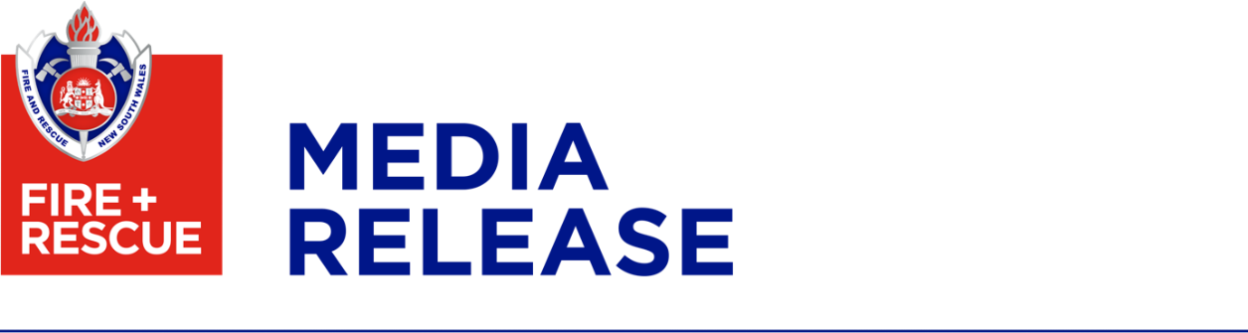

4 May 2022

Come and meet your local firefighters on Open Day

Come and meet your local firefighters and learn about home fire safety at the Fire and Rescue NSW (FRNSW) Open Day on Saturday, 14 May 2022.

Many fire stations across NSW will be throwing open their doors between 10.00am and 2.00pm to showcase FRNSW’s broad capabilities.

Children will be able to see a fire truck, demonstrations and firefighting equipment whilst the grown-ups will be able to find out more about home fire safety.

FRNSW Commissioner Paul Baxter said Open Day was an opportunity to show people that firefighters do so much more than fight fires.

“From fires, road crashes, hazardous material incidents and natural disasters to urban search and rescue, our crews are prepared for anything and ready to help anytime, anywhere,” Commissioner Baxter said.

“A large part of our role is to educate the community about home fire safety and that’s where Open Day comes in.

“This year we are focussing on the importance of having a working smoke alarm in your home.

“Each year, approximately 20 people die in NSW from fires that could have been prevented.

“Each death is a tragic loss for families, friends and the wider community.

“Additionally, for each fire fatality, there are also hundreds more people who survive a fire but suffer life-changing health consequences.”

Commissioner Baxter said there is a 10 per cent increase in the number of house fires during the cooler months, with many fires starting in bedrooms and loungerooms due to heaters and electric blankets.

“This year we want to help residents prepare their homes and in particular, encourage them to check their smoke alarms and have a Home Fire Escape Plan,” Commissioner Baxter said.

We have developed a Get Ready for Winter checklist - to find out more, visit https://www.fire.nsw.gov.au/winter.

For more information on FRNSW Open Day or to find out if your local fire station is participating, visit www.fire.nsw.gov.au/openday

[ends]

