Trinity Times 003 3rd of September 2020
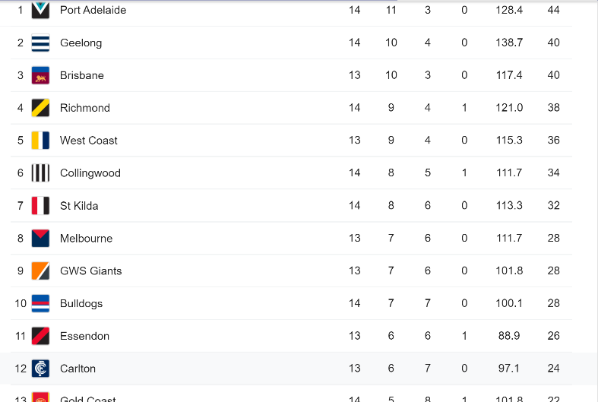
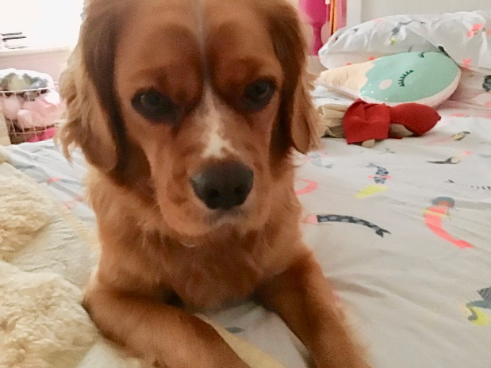
As we approach the end of home-schooling, we are beginning to look back on the term and we begin to see what we have gone through together. This term and last term have been extremely hard terms but we will be back at school next term and will hopefully not be put into lockdown again this year.
Joke of the Week
Why were the fish grades bad?
BIRTHDAYS
Georgia Shea P/1SG will be 6
Oscar Cao 4/5MG will be 10
Aiden in P/1SG will be 6
Jasmine in 5/6FA will be 12
Sierra in 4/5MG will be 10
Have a great week
WEBSITE OF THE WEEK
NASA is offering STEM activities ranging from building foam rockets to solving
space station emoji puzzles. Parents can also download colouring sheets and
books for younger children.
https://www.nasa.gov/stem-at-home-for-students-k-4.html
SPORT
Collingwood has thrashed Carlton and demolished their final chances in a 64-48 victory.
PET OF THE WEEK
Owner: Amy Jordan
Name: Alfie Jordan
Age: 3 years

