



Welcome back families, we have finally made it to term 4!!

***Week 1: enjoying the outdoors***

We started week one off with enjoying the lovely sunny days by being able to spend most of our afternoons soaking up the sun in the yard. We have enjoyed playing on the playground showing educators and our friends all the new tricks we can do on the play equipment on the playground and playing football on the oval with our friends. We have been showing off our moves when playing musical statues and musical in the mornings before we start school. As well as enjoying a nice fresh fruit salad as we come from a hot day of school

**Charlotte**- I like playing on the slide outside.

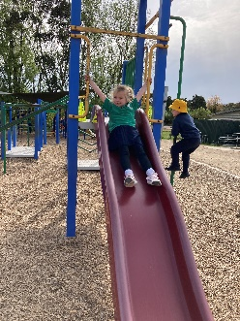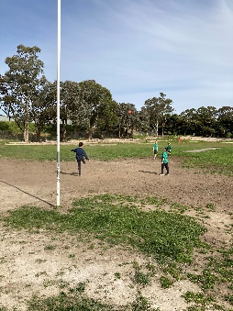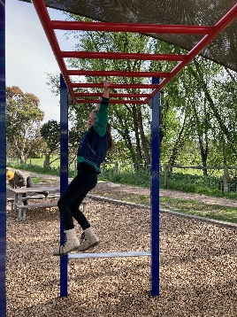

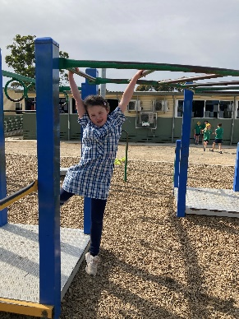

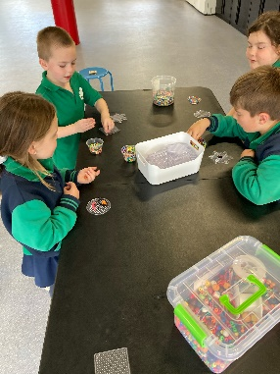

**For all family enquires**

I can be contacted on the service

phone number Tuesday – Friday 8.50am – 9.30am

2.30pm – 3.30pm

***Week 2- Getting crafty***

During this week we have got our creative minds on and made creations out of Hama beads and magiclay to make figurines. This has allowed us all to work together with one another to make different amazing art pieces. We have also played many indoor games such as scavenger hunts keeping away from the rain building on our sportsmanship and teamwork skills. As well as many colorings and group play making new friends.

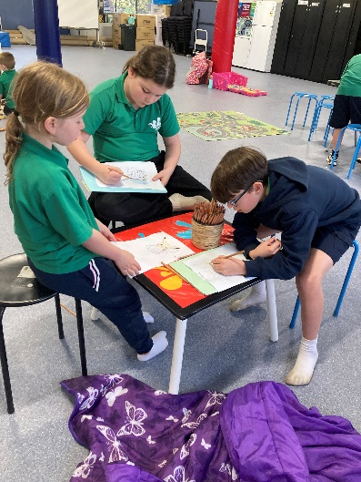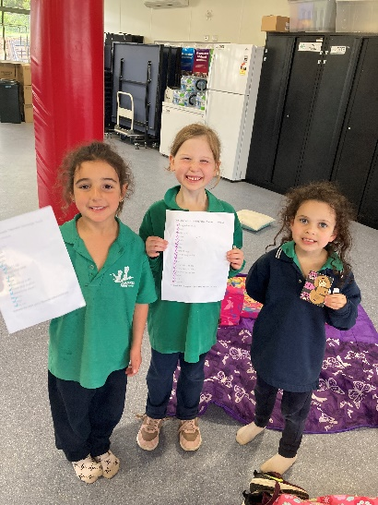



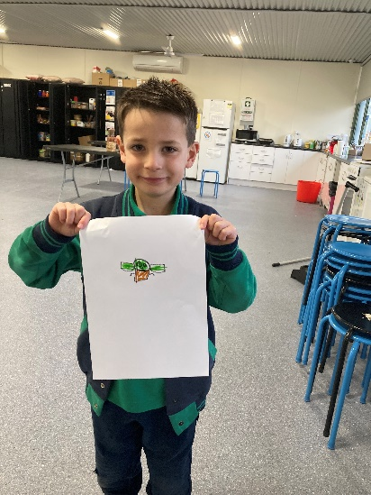

**Donna Moore**

**Cranbourne South PS**

**Coordinator TheirCare**

**0498 520 339**

**Cranbournesouth@theircare.com.au**