**CAREER NEWS** **Friday 9 October**

 **Dates to Diarise in Term 4**

* **Year 12 VTAC late applications** – October and early November
* **VTAC SEAS and Scholarship applications** –due October

** Reminder: VTAC 2021 Upcoming Key Dates **

|  |  |
| --- | --- |
| **SEAS Applications** | Friday 9 October 2020 |
| **VTAC Scholarships** | Friday 9 October 2020 |
| **VTAC Personal Statement** | Friday 4 December 2020 |
| **ATARs Released** | Wednesday 30 December 2020 |
| **Change of Preference (COP) closes** | Monday 4 January 2021 |
| **January Round International Offers** | Thursday 7 January 2021 |
| **January Round Domestic Offers** | Thursday 14 January 2021 |
| **February Offer Rounds** | Monday 1 February 2021 onwards |

**For a full list of cancelled, amended, and new courses, visit** [**VTAC Course Updates**](http://www.vtac.edu.au/courses-inst/courseupdates.html)

**The VTAC website is** [**www.vtac.edu.au**](http://www.vtac.edu.au)

[](https://www.seek.com.au/career-advice/article/australias-most-needed-jobs?fbclid=IwAR2ilw2ehYoNoqjBz_b8TMuXRQQ0W5icrSntM_RrIxUKsUZ72vs7DywfY5U)  
**Click on the diagram above for an interesting read**

** Emerging Occupations**

*The National Skills Commission (NSC) has developed a data-driven approach to identify emerging occupations within Australia.   
By identifying emerging skills and looking at how these skills change existing jobs, we are able to identify emerging or new jobs in the labour market.*

New occupations often emerge as a result of the need to adapt and learn new skills. The current COVID-19 crisis has seen situations such as manufacturers having to learn new techniques to make unfamiliar, in demand products, and restaurant owners having to quickly developed or enhanced their skills in e‑commerce, for example.  
The diagram below illustrates some emerging occupations. Students are encouraged to browse the [National Skills Commission](https://www.nationalskillscommission.gov.au/introduction) website and learn more about emerging occupations.

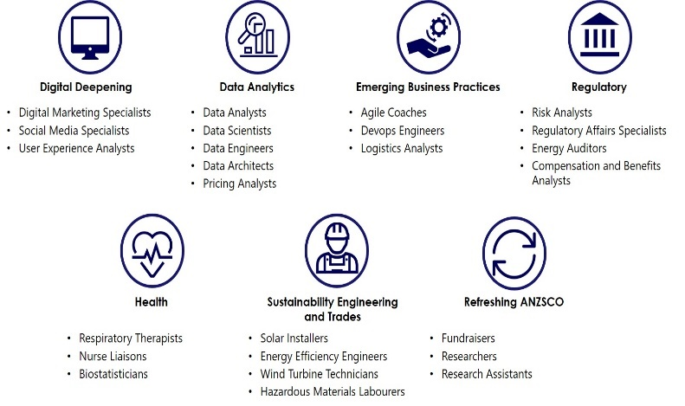

** Torrens University - no longer considering the ATAR**

*In light of the disruptions caused by COVID-19, we have decided to change our key admissions criteria for students planning to study at Torrens University Australia.*  
Torrens University is removing the ATAR (Australian Tertiary Admission Rank) as the key admissions criteria for applicants aiming to study at Torrens University. The institution will no longer consider the ATAR as it primary entry requirement.

**Find out more at** [**Torrens University New Entry Requirements**](https://www.torrens.edu.au/new-entry-requirements-2021)

cid:449235102@16032009-17DC **Studying Osteopathy at VU**

***Osteopaths diagnose, treat and provide preventative advice about disorders that affect the body's musculoskeletal system, using manual techniques to alleviate stresses and dysfunction to improve the body's function (***[***Good Universities Guide - Osteopath***](https://www.gooduniversitiesguide.com.au/careers-guide/browse/osteopath)***)***

*VU offers one of only three of these accredited programs in Australia. Core studies include anatomy, osteopathic science, physiology, and biochemistry. Students undertake fieldwork and clinical practice to prepare them for their osteopathy career.*  
Students considering a career in osteopathy need to complete the **Bachelor of Science (Osteopathy)** first; this is a 3-year course and provides an entry into an osteopathy career. Completion of the Bachelor of Science (Osteopathy) course alone does not make graduates eligible for registration as Osteopaths. Students must also complete the Master of Health Science (Osteopathy) in order to be eligible to register as an Osteopath. So, the double degree program is:

* [Bachelor of Science (Osteopathy)](https://www.vu.edu.au/courses/bachelor-of-science-osteopathy-hbso)  – 3 years
* [Master of Health Science (Osteopathy)](https://www.vu.edu.au/courses/master-of-health-science-osteopathy-hmho) – 1,5 years

**On completion of both programs, students will be eligible for:**

* registration with the **Osteopaths Registration Board of Victoria**
* registration as an Osteopath in all other Australian states
* membership with the **Australian Osteopathic Association**

For further information about registration requirements, visit the [Australian Health Practitioner Regulation Agency](http://www.ahpra.gov.au/Registration.aspx) website.

VU has a an [Osteopathy Teaching Clinic](https://www.vu.edu.au/campuses-services/our-services/health-wellbeing-clinics/osteopathy-clinic) which usually operates over 40 weeks per year, and students are required to attend clinical sessions on a rotation basis including outside of semester hours to maintain a public service and provide continuity of patient care. Clinical training, including fieldwork, is crucial in the preparation to becoming an Osteopath.

**For more information about studying osteopathy at Victoria University, visit** [**Osteopathy at VU**](https://www.vu.edu.au/courses/bachelor-of-science-osteopathy-hbso)

**Diploma of Teacher Education Preparation**

*The* ***Diploma of Teacher Education Preparation*** *may be the right study choice for students with the motivation, capability, and personal attributes to be a great teacher.*

The ***Diploma of Teacher Education Preparation (Dip TEP)*** is an accredited AQF5 level qualification aimed at students who do not initially meet the minimum ATAR for teaching. The course has been developed as part of the Victorian Government’s Excellence in Teacher Education Reforms to ensure that disadvantage and diverse educational experiences are not a barrier to capable and committed people who want to pursue a career in teaching.

Successful completion of the Dip TEP will ensure that students graduate with the prerequisite knowledge and skills to undertake an undergraduate teacher education course.  The Dip TEP supports students to meet the literacy and numeracy standards they will need in order to graduate with a teaching qualification and supports them to meet the demands of study at a higher education level. The course introduces them to contemporary issues in education and to teaching as a profession, including practical school-based placement.

**The course is offered by various institutions including** [**ACU**](https://courses.acu.edu.au/undergraduate/diploma_in_educational_studies_tertiary_preparation)**,** [**RMIT**](https://www.rmit.edu.au/study-with-us/levels-of-study/vocational-study/diplomas/c5383), [**Swinburne**](https://www.swinburne.edu.au/study/course/Diploma-of-Teacher-Education-Preparation-22451VIC/local?utm_campaign=vtac&utm_source=course_guide&utm_medium=website)**, and** [**VU Polytechnic**](https://www.vu.edu.au/courses/diploma-of-teacher-education-preparation-22451vic)

** Associate Degree in Engineering Technology**

**RMIT University** offers the [***Associate Degree in Engineering Technology***](https://www.rmit.edu.au/study-with-us/levels-of-study/undergraduate-study/associate-degrees/ad026) which is an excellent 2-year degree for students undecided which specialised area of Engineering they wish to study. This pathway course is also often used by students who do not attain the minimum English/EAL and Maths Methods study scores, or if their ATAR is not high enough to enter the bachelor’s degree.

Students select their major in the second year of the course from the following:

* Civil
* Mechanical
* Computer and Networking
* Aerospace
* Electrical and Electronics
* Advanced Manufacturing and Mechatronics

Graduates of this course are guaranteed a place in the RMIT Bachelor of Engineering (Honours) degree relevant to the major completed in the Associate degree. Students will also be eligible for up to 2 years of credit (192 credit points) depending on the major they selected.

This course offers pathways into:

* [Bachelor of Engineering (Advanced Manufacturing and Mechatronics) (Honours)](https://pathways.rmit.edu.au/pathway/bh068ad026)
* [Bachelor of Engineering (Mechanical Engineering) (Honours)](https://pathways.rmit.edu.au/pathway/bh070ad026)
* [Bachelor of Engineering (Telecommunications Engineering) (Honours)](https://pathways.rmit.edu.au/pathway/BH071P17ad026)
* [Bachelor of Engineering (Computer and Network Engineering) (Honours)](https://pathways.rmit.edu.au/pathway/bh072ad026)
* [Bachelor of Engineering (Electrical and Electronic Engineering) (Honours)](https://pathways.rmit.edu.au/pathway/bh073ad026)
* [Bachelor of Engineering (Automotive Engineering) (Honours)](https://pathways.rmit.edu.au/pathway/bh074ad026)
* [Bachelor of Engineering (Electrical Engineering) (Honours)](https://pathways.rmit.edu.au/pathway/bh075ad026)
* [Bachelor of Engineering (Civil and Infrastructure) (Honours)](https://pathways.rmit.edu.au/pathway/bh077ad026)
* [Bachelor of Engineering (Aerospace Engineering) (Honours)](https://pathways.rmit.edu.au/pathway/bh078ad026)