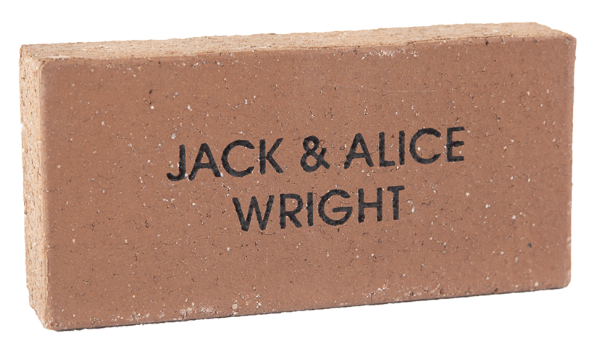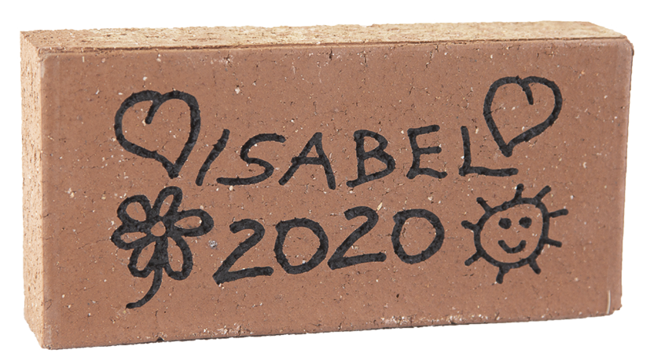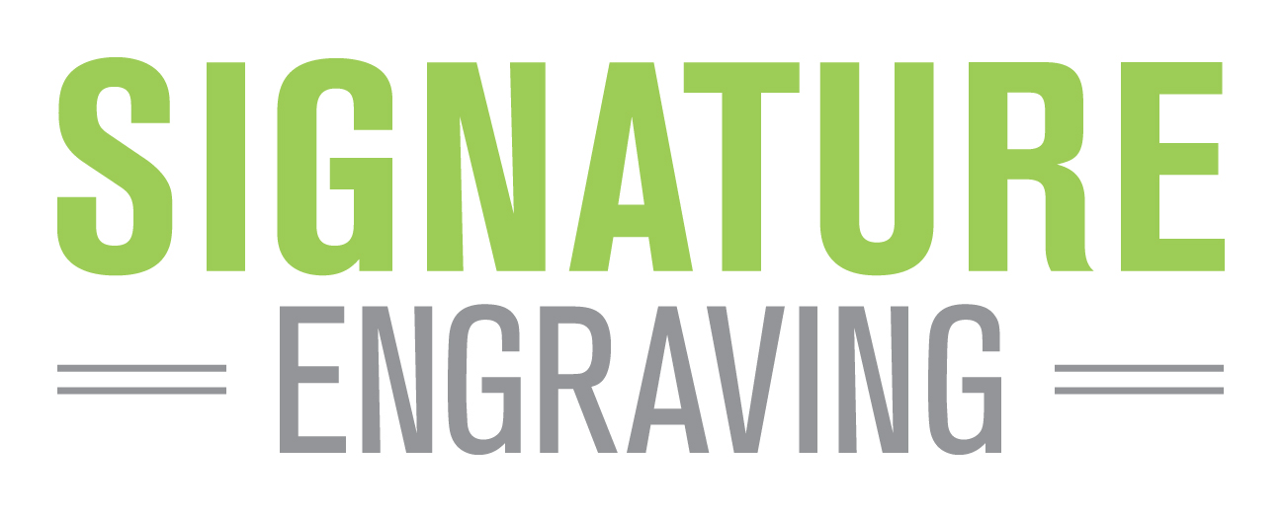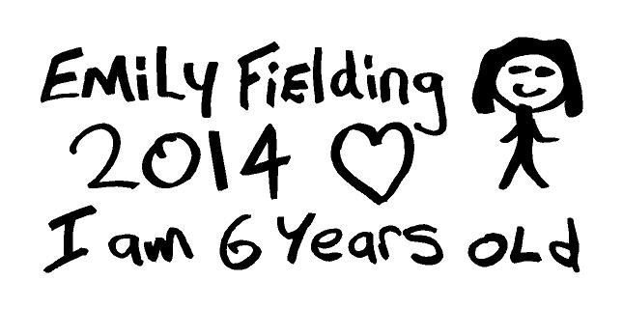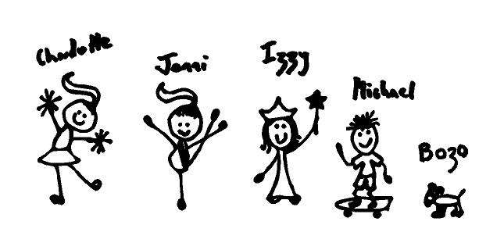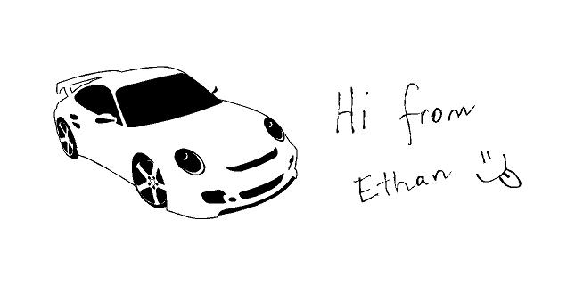

|  |  |  |  |  |  |
| --- | --- | --- | --- | --- | --- |
| Contact Name | | | | Phone | |
|  | | | |  | |
| Child’s name | | | | Class | |
|  | | | |  | |
| Email address | | | |  |  | |
|  | | | |
|  | |  |  |  | |
| **Offer 1** | **Offer 2** | I have made payment for my paver via Compass (tick once done) | |

Simply fill out this form and make payment for the paver via Compass School Manager <https://skipps-vic.compass.education/> following the steps described on the cover letter. Once payment has been made on Compass, please tick the box below and return this order form to the school office.

Please print clearly in block letters (CAPITALS) and always use the ampersand symbol (“&”). Each box represents a character (letter, number, punctuation mark or space). Max 16 characters per line, three lines per paver. See over the page for Hand Drawn Paver template.

NAME PAVER

Your donation of $50 or more entitles you to   
have your name engraved into a paver as a lasting   
record of your valued support. The paver will be permanently installed around our school playground proudly showing your donation

Size: 230 x 115 x 50mm *See page 2 for hand drawn template.*

© 2021 Signature Engraving - www.signature-engraving.com.au v3.0

Your donation of $50 or more entitles you to   
have your name engraved into a paver as a lasting   
record of your valued support. The paver will be permanently installed around our school playground proudly showing your donation

Size: 230 x 115 x 50mm

|  |  |  |  |  |  |  |  |  |  |  |  |  |  |  |  |  |  |  |  |  |  |  |  |  |  |  |  |  |  |  |  |
| --- | --- | --- | --- | --- | --- | --- | --- | --- | --- | --- | --- | --- | --- | --- | --- | --- | --- | --- | --- | --- | --- | --- | --- | --- | --- | --- | --- | --- | --- | --- | --- |
| **LINE 1** |  |  |  |  |  |  |  |  |  |  |  |  |  |  |  |  |  |  |  |  |  |  |  |  |  |  |  |  |  |  |  |
|  |  |  |  |  |  |  |  |  |  |  |  |  |  |  |  |  |  |  |  |  |  |  |  |  |  |  |  |  |  |  |  |
| **LINE 2** |  |  |  |  |  |  |  |  |  |  |  |  |  |  |  |  |  |  |  |  |  |  |  |  |  |  |  |  |  |  |  |
|  |  |  |  |  |  |  |  |  |  |  |  |  |  |  |  |  |  |  |  |  |  |  |  |  |  |  |  |  |  |  |  |
| **LINE 3** |  |  |  |  |  |  |  |  |  |  |  |  |  |  |  |  |  |  |  |  |  |  |  |  |  |  |  |  |  |  |  |

COMBINED SINGLE NAME PAVER & HAND DRAWN TEMPLATE

OFFER 2: $50

HAND DRAWN PAVER

OFFER 1: $50

INDIVIDUAL PAVER

**St Kilda Park Primary School is excited to offer the opportunity for students, parents, families and members of the wider SKiPPS community to become a lasting part of our amazing school** **by ordering a personalised paver which will be installed around the edge of our school playground**. The funds raised from the sale of these pavers will be used to help develop our classroom libraries – rich collections of literature in each learning space to inspire students and develop their reading and writing

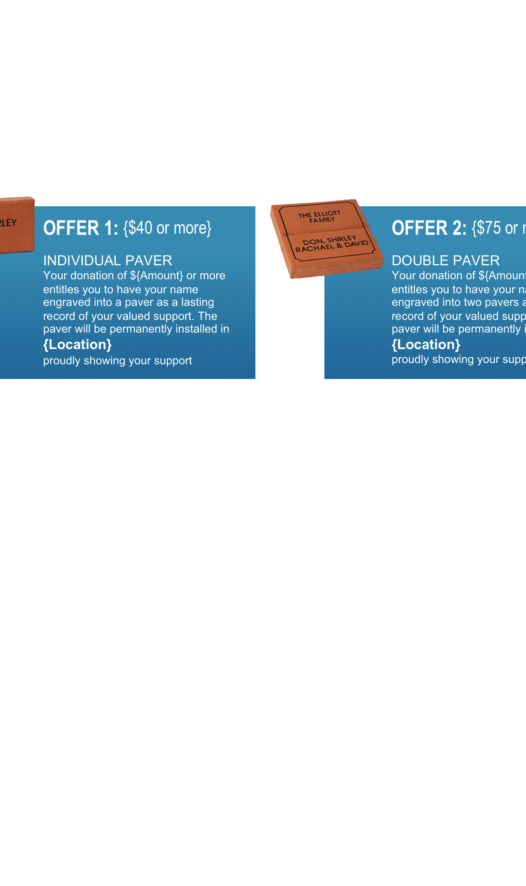

For engraving details please complete the form on the reverse.

Offer closes on Friday 27th August 2021

Please copy and pass on to any friends & family.

**We Need Your Support!**

**Offer 2**

**Offer 1**

St Kilda Park Primary School

PLEASE FOLLOW THESE SIMPLE STEPS WHEN CREATING YOUR IMAGE.

1. ONE NAME PER PAVER.

1. 2. Draw your image using a good quality medium thickness black marker pen (about 2mm thick).   
    eg Artline 70 ‘High Performance’ marker.  
    **Do not use a ballpoint pen, coloured texta or pencils!**
2. 3. Make sure you rub out any pencil lines as these will show up on the finished paver.
3. 4. Do not include computer-generated or pasted pictures.
4. The hand drawn image engraving process is set up to engrave hand drawn images only.

ENGRAVING DETAILS

HAND DRAWN

TEMPLATE

100mm high x 190mm wide

**SAMPLE 1**

**SAMPLE 2**

**SAMPLE 3**

THIS IS OK ✓

• Good clean writing

• Simple illustrations

THIS IS NOT OK ✗

• Too many names

• Illustrations too detailed

• Information gets lost

✗

✗

✗

THIS IS NOT OK ✗

• Do not include computer-generated or pasted pictures

• The process is set up to engrave hand drawn images only

✗

✗

**Administrator note: Please photocopy this page for your records, cut out the drawing below   
and send the ORIGINAL to Signature Engraving.**

**PHOTOCOPY THIS PAGE FOR EACH HAND DRAWN PAVER.**

**PLEASE ENSURE THAT YOUR DRAWING DOES NOT TOUCH OR GO OUTSIDE OF THE BORDER**