Parent Information

After receiving their unique School Saving Bonus code, parents can log-in to the School Saving Bonus (SSB) portal and choose to redeem the voucher either in-store or online. Funding will expire and can no longer be used after June 30th, 2025.

If choosing an online voucher, parents can request vouchers in $50, $100, $200, $300 or $400 increments.

Online Redemption:

* Parents will receive an email with an online voucher code after opting for online redemption.
* Our online store is found at www.beleza.com.au/online-store/ • Parents will enter their voucher code in the “Coupon” section at checkout.
* If they haven’t used the full voucher amount, the same voucher code can be used at a later date.

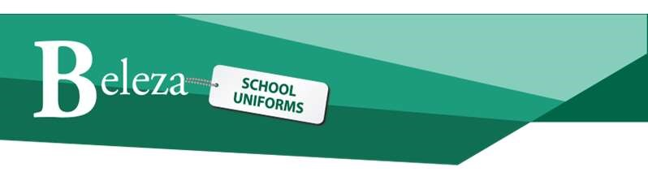

Beleza School Uniforms and School Saving Bonus (SSB)

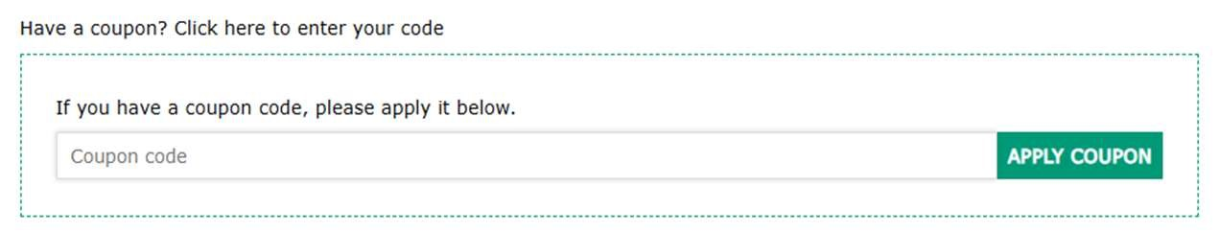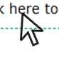

In-store Redemption:

* Parents will present their unique QR code or voucher code to staff, which can be found either in the Parent portal or in the email sent by the SSB team.
* Our team will log-in to the SSB supplier portal to verify the code and school information.
* Our team will generate an invoice to the school for the items, and submit the redeemed amount through the supplier portal.
* If there is a difference between the voucher amount and the transaction amount, this will be charged to the customer under their Beleza membership account.

# Terms & Conditions

* Once a decision is made between online or in-store redemption, unfortunately we cannot change this and the voucher is only valid for the chosen method.
* In-store vouchers can be redeemed at any Beleza store.
* Refunds will not be given for items purchased using School Saving Bonus funds. Items can be exchanged for items of the same or greater value, and any difference must be paid at the time of exchange.
* School Saving Bonus purchases will not receive seasonal discounts (e.g., our VIP 20% discount or Term 4 prep/year 7 10% discounts). Clearance discounts will apply.



Beleza School Uniforms and School Saving Bonus (SSB)

* Online vouchers cannot be redeemed in-store.
* Any balance owing after funding has been applied must be paid at the time of purchase.
* Funding will expire after June 30th, 2025. We cannot process sales using School Saving Bonus funds after this date.

Note – please allow extra time when shopping in-store as using SSB vouchers will add processing time.