CAREER NEWS Friday 19 September
 Dates to Diarise in Term 4
- Year 12 VTAC late applications – throughout 30 September – 31 October
- VTAC SEAS and Scholarship applications – throughout September and early October

 Reminder: VTAC 2026 Upcoming Key Dates
SEAS Applications | Friday 10 October 2025
VTAC Scholarships | Friday 10 October 2025
ATARs Released | Thursday 11 December 2025
Change of Preference (CoP) closes | Saturday 13 December 2025
December Round Offers | Tuesday 23 December 2025
January Round One Offers | Tuesday 13 January 2026
January Round Two Offers | Tuesday 27 January 2026
February Offer Rounds | Tuesday 3 February 2026 onwards
For a full list of cancelled, amended, and new courses, visit VTAC Course Updates.

The VTAC website is www.vtac.edu.au.

 Bachelor of Educational Studies
The Bachelor of Educational Studies allows students to take their first step towards teaching or other education-related fields. This course is a pathway for students who are passionate about becoming teachers but do not meet the admission rank for their desired pre-service teacher degree.
Eligible students who successfully complete their first year of study (subject to meeting certain progression and non-academic requirements) may apply for transfer into the second year of the Bachelor of Education suite of courses.
This 3-year degree allows students to gain the necessary knowledge to pursue a career in corporate training, educational consultancy, online learning, vocational and community education, curriculum writing, youth services or adult learning, but will not lead to early childhood, primary or secondary teacher registration in Australia. Should teaching be the end goal, students who complete the Bachelor of Educational Studies can progress to a postgraduate Initial Teacher Education qualification.
Find out more at Bachelor of Educational Studies.

 News from Monash University
- Experience Day Workshops
Calling all Year 10-12 students; explore your curiosity and creativity in Fine Art, Design and Architecture at Monash! Gain a better understanding of different art mediums, design thinking approaches, and architecture studios through our hands-on experience days at our Monash Caulfield campus.

Participants will find out what it is like to be a student for a day, meet the Monash staff and explore the workshop spaces students get to work in if they enrol at Monash. In these studio sessions, students will work on mini design briefs, experiment with materials, and collaborate with each other on built constructs. The experienced Monash staff will guide students to challenge and develop their technical skills, artistic perspectives, and design-thinking.

Tuesday 30 September, from 10.00am – 3.00pm: Fine Art folio-building. Register here.

Wednesday 1 October, from 10.00am – 1.30pm: Design and Architecture. Register here.

- Accounting Careers
An accounting degree from Monash Business School opens doors to diverse careers – from forensic accountant to CEO or cybersecurity analyst.
Student who enjoy studying accounting and are considering where an accounting degree might take them, are encouraged to read the following article titled Five Unique Jobs You Wouldn’t Expect from an Accounting Degree.

- Computer Science vs. IT
Students often ask about the difference between computer science, IT, software engineering and cybersecurity. Monash has a new animated video that explains each area to help them choose the right path. Watch the video here.

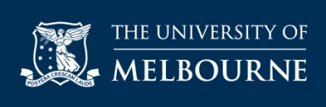 Diploma in General Studies (DiGS)
The Diploma in General Studies (DiGS) gives students a sample of various University of Melbourne degrees and provides a pathway to further tertiary study.
Open to domestic students, this one-year course provides students with the opportunity to study a wide range of subjects from Science, Commerce, Design and Agriculture - providing some students with guaranteed entry into a University of Melbourne degree based on their weighted average mark.
If eligible, successful completion of DiGS, could get guaranteed entry to one of the following:

- Bachelor of Agriculture
- Bachelor of Arts
- Bachelor of Biomedicine
- Bachelor of Commerce
- Bachelor of Design
- Bachelor of Science.

The VCE prerequisite for entry is Units 3 & 4: A study score of at least 20 in English/English Language/Literature or at least 25 in EAL, and the Lowest Selection Ranked ATAR for 2025 was 53.10.
Find out more at Diploma in General Studies (DiGS).

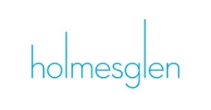 Open Day Thursday
Open Day is the perfect way to see what studying at Holmesglen is like. Enjoy campus tours, course information sessions, and a free BBQ with drinks.
The next Open Day Thursday is scheduled for Thursday 16 October and, depending on the study area session, begin from 4.00pm onwards.
Browse all sessions in their study area:

- Arts and Design
- Building and Construction
- Business and Finance
- Computing and IT
- English, Education and Teacher Training
- Hospitality, Tourism and Events
- Horticulture and Environment
- Nursing, Community and Health Services
- Sport, Fitness and Wellbeing

Find out more at Open Days at Holmesglen.

 ATARs for International Students
For any International Students who may be studying Year 12 in Australia, we now have a course search page aimed at showing them the required ATAR for their chosen study area.
RMIT has launched a very useful page where onshore International students can determine the ATAR selection rank applicable to the courses they are considering.
Visit ATAR for International Students Studying Year 12 in Australia - RMIT University.

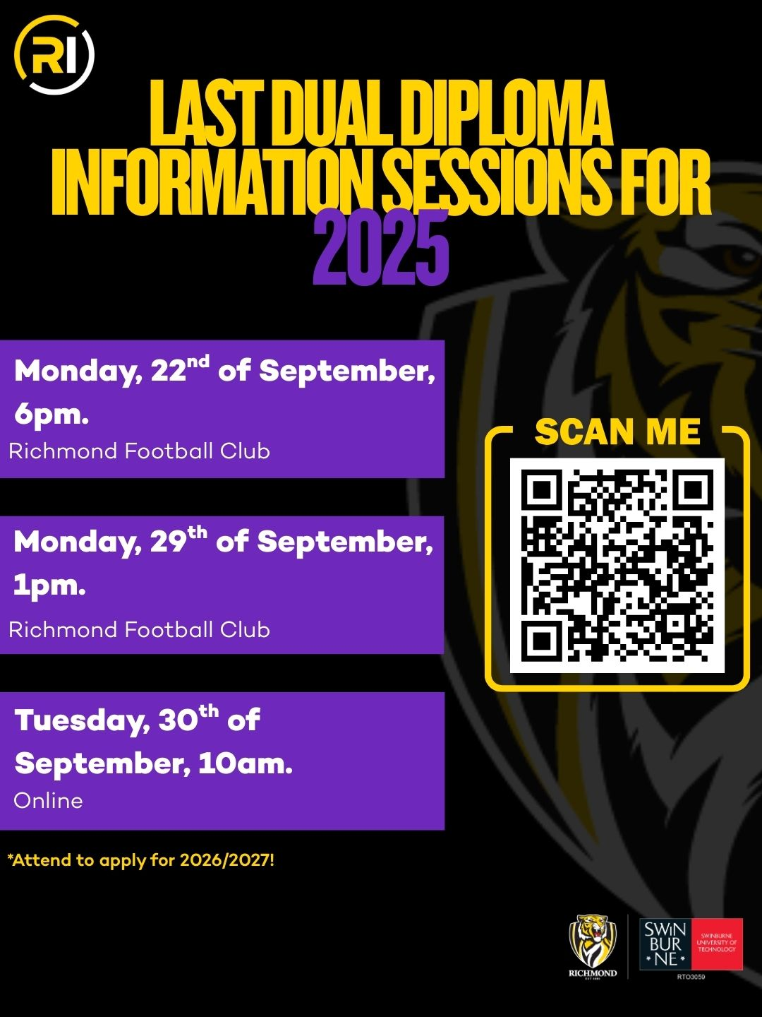

 Agriculture Degrees in Victoria in 2025
Growing enough food to sustain the world is one of the biggest challenges the world is facing in the 21st century. Below are several degrees that prepare students to become experts in the science of agriculture, so they can take on an advisory role in agriculture and farming practices.
For a comprehensive list of courses (including the many double-degree options) on offer at Victorian universities, TAFEs, and Private Providers, visit VTAC.
INSTITUTION | COURSE NAME | VCE PREREQUISITES | MAJOR STUDIES IN 2025
LA TROBE UNIVERSITY | Bachelor of Agriculture | Units 3 and 4: a study score of at least 25 in English (EAL) or at least 20 in English other than EAL; Units 3 and 4: a study score of at least 20 in any Mathematics. | Agribusiness, Animal science, Plant and soil science.
LA TROBE UNIVERSITY | Bachelor of Agriculture  (Agribusiness) |  | Agribusiness.
LA TROBE UNIVERSITY | Bachelor of Agriculture  (Plant and Soil Science) |  | Plant and soil science.
LA TROBE UNIVERSITY | Bachelor of Science  (Crop Science) |  | Crop science.
MARCUS  OLDHAM  Students applying for this course must have completed at least 12 months in an industry placement following the completion of year 12 or equivalent. | Bachelor of Business (Agriculture) | Successful completion of Year 12. Selection is based on the ATAR and an interview. | Agriculture, Farm Management and Agribusiness.
MELBOURNE POLYTECHNIC | Bachelor of Agriculture and Technology  (Agronomy Major) | Successful completion of Year 12. | Agronomy major.
MELBOURNE POLYTECHNIC | Bachelor of Agriculture and Technology  (Viticulture and Winemaking Major) | Successful completion of Year 12. | Viticulture and Winemaking major.
UNIVERSITY OF MELBOURNE  The Diploma in General Studies provides a pathway to the Bachelor of Agriculture.  Students might also like to study the Agricultural Sciences major in the Bachelor of Science | Bachelor of Agriculture | Units 3 and 4: a study score of at least 30 in English (EAL) or at least 25 in English other than EAL; Units 3 and 4: a study score of at least 25 in one of Maths: Mathematical Methods or Maths: Specialist Mathematics or at least 30 in Maths: General Mathematics. | Agricultural economics, Plant and soil science, Production animal science.

 Human Resources Courses in Victoria in 2025
The Good Universities Guide* states that Human Resources Officers provide administration services for the recruitment and employment of staff. In small organisations, Human Resources Officers are usually responsible for all staffing matters. In large organisations they may specialise in a particular area such as recruitment, wages and entitlements or staff training.
* Good Universities Guide - Human Resources Officer
Training to become a Human Resources Officer can take place at TAFE or university. Below are some of the courses offered in Victoria. Usually, human resource majors are offered in business and commerce courses at TAFE and university.
For a comprehensive list of all courses offering studies in human resources, including double-degree options, visit VTAC.

INSTITUTION | COURSE | MAJOR STUDIES IN 2025
ACU | Bachelor of Commerce (HRM and Management) | Human Resources, Management.
Charles Sturt University | Bachelor of Business  Also offered in the  Bachelor of Business Studies | Accounting and Financial Management, Advertising, Agribusiness, Entrepreneurship, Ethics and Social Responsibility, Finance, Human Resource Management, IT Management, Legal and Industrial Relations, Management and Leadership, Marketing, Marketing, Communication and Digital Media, Project Management, Psychology, Strategic Communication, Strategic Planning, Sustainability.
Deakin University | Bachelor of Commerce | Accounting, Business analytics, Economics, Emerging technology, Entrepreneurship, Event management, Finance, Financial planning, Global and social impact, Human resource management, International business, International trade, Management, Management information systems, Marketing, People management, Production management, Project management, Property investments, Recruitment and talent acquisition, Retail management, Sustainability and Development, Wealth management.
Deakin University | Bachelor of Human Resource Management (Psychology) | Human resource management, Psychology.
Federation University | Bachelor of Business (Management) | Behaviour in the workplace, Business strategy, Contemporary human resource management, Employment practice, Future of business, Human resource practice and strategy, Introduction to management, Leadership and change.
La Trobe University | Bachelor of Business | Agribusiness, Digital business, Economic, Enterprise, Event management, Finance, Human resource management, International business, Management, Marketing, Tourism and hospitality.
Monash University | Bachelor of Business | Accounting, Banking and finance, Business analytics and statistics, Business law, Business management, Business studies, Economics and business strategy, Financial econometrics, Human resource management, International business, Marketing, Sustainability and responsible management, Taxation.
RMIT University | Bachelor of Business  Also offered in the  Business Professional Practice Degree | Blockchain Enabled Business, Business Information Systems, Business and Technology, Economics, Entrepreneurship, Finance, Financial Planning, Global Business, Human Resource Management, Logistics and Supply Chain, Management and Change, Marketing, Social Impact, Strategy and Innovation.
Swinburne University | Bachelor of Business  Also offered in the Business Professional Degree | Accounting, Business administration, Business analytics and analysis, Entrepreneurship, Financial planning, Human resource management, Logistics and supply chain management, Management, Marketing, Sports management.
Victoria University | Bachelor of Business | Accounting, Analytics, Banking and Finance, Business Analytics, Event Management, Financial Risk Management, Human Resource Management, Information Systems Management, International Trade, Management and Innovation, Marketing, Supply Chain and Logistics, Tourism and Hospitality Management.
 Snapshot of CQU – Melbourne Campus in 2025
- Central Queensland University has a campus in Melbourne adjacent to Southern Cross Station
- CQUniversity Melbourne features modern open learning spaces, classroom and computer labs equipped with best-practice audio-visual equipment for teaching and tutorials, and dedicated space for student recreation.
- The campus facilities include -
- The latest presentation and audio-visual equipment
- High-tech multimedia labs
- State-of-the-art medical sonography labs with simulated clinic environment and the latest ultrasound equipment
- Campus library including access to extensive online databases across academic fields.
- CQU Melbourne offers a range of courses, including in business. Of particular note, is the Bachelor of Medical Sonography and Graduate Diploma of Medical Sonography.

