Before school care Menu and program

Program | Monday | Tuesday | Wednesday | Thursday | Friday
Breakfast upon arrival: 7:00 to 8:00am  Drinks: water, milk or milo | Green eggs and ham /Scrambled eggs and ham on toast.   | Pancake creations  Make your pancakes into to your Favorite shape and eat it with your Favorite spread or fruit.  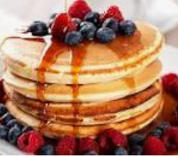 | Fruit kebabs toast and cereal  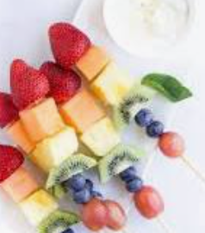 | Fruit and yogurt / fruit breakfast crumble.  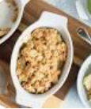 | Breakfast quiche or breakfast muffins 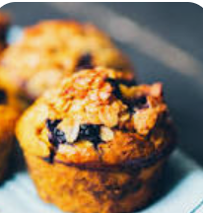
Indoor: 7:40am  Outdoor 8:10 am | Reading and dr Suess colour in’s or of children’s choice.  Scavenger hunt/ tag  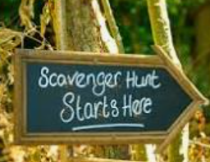 | Arts and crafts  Hamma beads or construction  Kick ball or football /soccer  Children choice  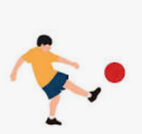 | Wacky Wednesday  Construction with Lego, Duplo, Box construction and more…  Tenis and badminton   | Trash and treasure    Creations, from recycled items, from jars, to boxes, to old pans and tools.  Basketball/ Soccer | Friendly Friday balloon faces friendship bracelet making or bag tag crafts.  games and giant tick tack toe or musical chairs in the hall  
pack up 8:30am  school 8:45 am | Pack up  Time for school | Pack up  Time for school | Pack up  Time for school | Pack up  Time for school | Pack up  Time for school

