List of Sponsors – St Mary’s Prom Gone Wrong 2022
Major Sponsors
• Victoria Racing Club (VRC)
• TheirCare
• Sebo Jewellery
• Sofitel Melbourne on Collins
• Three Birds Renovation
• The Cottage at Highfield Park (Fiona & Peter Ayres)
• Collingwood Football Club
• St Kilda Football Club

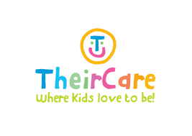
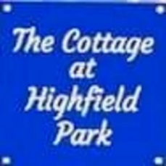
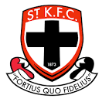
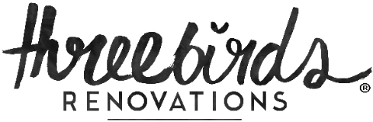
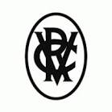
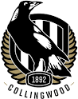

School Community Sponsors
Chris Varney - Wellness Chiropractic
Ronarongsanee Family - Fat Boy Thai Street Eatery
Grace Park - Park Bar
Andja Dedic – Mancini’s Hair
Kasia Dudek- Reddy – Sebo Jewellery
The Farrell Family – Signed Western Bulldogs Sherrin Football
Kathryn Toomey – Massage Therapist & Reflexology
The Tripolitano Family – Asahi Prize
Seung Ryu & Bao Mai – Mr Ryu Restaurant
Grade 1 Parents – Sofitel Accommodation
Grade 5 Parents – Wine Hamper

Other Key Sponsor Business Acknowledgements
- UBX Training  - Michael Avery School of Music  - Humming Puppy Yoga  - Cosi Restaurant  - Car Wash @ Malvern Central  - Albert Park Golf Club  - Boulder Project  - St Kilda Bowling Club  - Bunnings  - Dymocks  - Officeworks  - New London Jeans  - Leonard St.  - Smart Alec Hatters  - Zone Bowling  - Luna Park  - Miss Eyelash  - Yo-Chi  - Melbourne Bike Shop  - Chef’s Hat  - GESAC  - Jfahri | - The Esplanade  - Ballarat Miners  - Prahran Market  - The Dick  - Phoenician Café  - Palais Theatre  - Revitalising Beauty  - Arte & Frank  - Twelve Board Store  - Rus Kitchin Studio  - Lulu Design  - Calistags Plants  - James Said – Restaurant  - Eclectico  - Mike Stretch  - Rebel  - The Coffee Company  - Windsor Delicatessen  - iFly Melbourne  - Beechworth Tourism  - Mr Ryu  - Greville Records`  - Hunky Dory

